Reception Home Learning
Week 10
Day 1
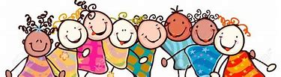

A big well done from all your Early Years Teachers!
We really are very proud of you for how hard you are working at home. A big thank you to your grown-ups too!
Keep up the good work
Remember, if you want to share any of the busy things you are doing at home with your Teachers, be sure to tag us on Twitter by using: @Pinkclass18 and @devrainbow and @Redclassdev
We’d love to see them!
Joke What do you call a boomerang that won't come back?

Answer a stick
Monday 8th June 2020
Reception Work to support your child at home PHONICS
Below are some examples of how you can support your child at home with their phonics knowledge.
Children learn best with daily practise and by repeating the learning.
You will need your phonic cards that were sent home in your pencil case.

Day 1 – Recap on sounds we have learnt before – or (for, fork, cord, port, born, horn, fort, storm, short, thorn, porch, torch, cor/net)

Learn the new sounds –ur (fur, burn, burp, curl, hurt, surf, turn, tur/nip)

Practise the tricky word – come (also practise words we have learnt before –
(they, one, me, to, you, go, he, she, her, we, are, all, said, when, do, some. so)
What does each word mean? Do you notice any patterns? (write a list to show which words have the ur sound at the beginning, middle and end).
This book is about staying at home. It helps explain why we are not going to school and a little bit about the pandemic.
Ask your grown up to read this book to you.https://www.andersenpress.co.uk/wpcontent/uploads/2020/04/STAYING_HOME_medium-res.pdf
Alphablocks is a great website to support with phonics and with how to pronounce the sounds
https://www.bbc.co.uk/cbeebies/shows/alphablocks
https://new.phonicsplay.co.uk/
You can log into phonics play for free using: Username: march20 Password: home
Monday 8th June 2020
Work to support your child at home- LITERACY
This week we are going to continue to focus on the story ‘The Town Mouse and the Country Mouse’. You can find the story by following this link: https://www.youtube.com/watch?v=BNexgokr4gw
Last week, our sentences were:
One cold night, a mouse heard a knock at the door. It was his friend Tony the town mouse. They decided to visit the busy town to get some food.

Day 1-
This week, we are going to write similar sentences, but this time we would like you to add in your own ideas-
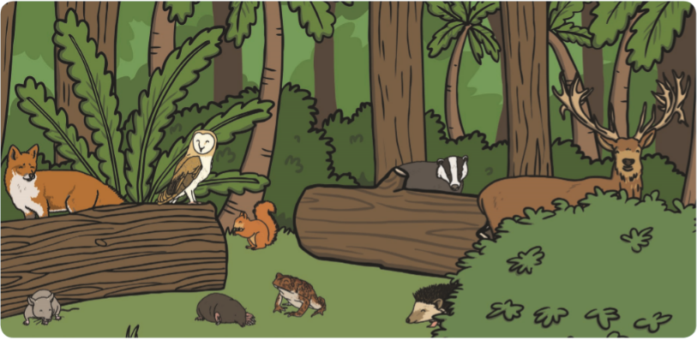

We would still like the animal who heard the knock at the door to be an animal that we may find in the Countryside, as that is our focus for this week in free-flow (see some examples in the picture above). The animal who knocks at the door and place that they go to get some food is completely up to you!
Here are some examples:
One… | a… heard a knock at the door. | It was his friend… | They decided to visit the… to get some food.
sunny morning, | fox | Jake the jungle monkey. | jungle
rainy afternoon, | hedgehog | Bella the sea crab. | sea
cloudy day, | squirrel | Amelia the arctic penguin. | arctic
warm evening, | badger | Dylan the desert snake. | desert
So, it may be that your new sentence is something like this:
One sunny afternoon, a fox heard a knock at the door. It was his friend Jake the jungle monkey. They decided to visit the jungle to get some food.

Today, your talking task is to:
- Practise saying the sentences- Put your actions to the sentences above as we do in class. Act out the sentences. Once you have practised saying the sentences together, see if your child can now remember the sentences and say them without your support. If they can, it means they are ready to write them tomorrow!
Monday 8th June 2020
Reception Work to support your child at home MATHS
This week we are going to investigate measure. Children begin by using language to describe length and height- the tree is tall the pencil is short. Encourage your child to use more specific mathematical language: length (longer, shorter) height (taller, shorter) and breadth (wider, narrower).
This week we are looking at measure -length, height and distance
Watch https://www.youtube.com/watch?v=5VpHj_SlRLo
Use a piece of paper and ask a grown up to draw around your foot. Use this footprint to find items that are longer, shorter or about the same size as your foot. Make a direct comparison.
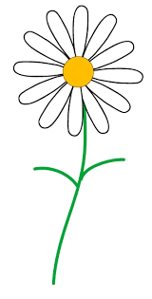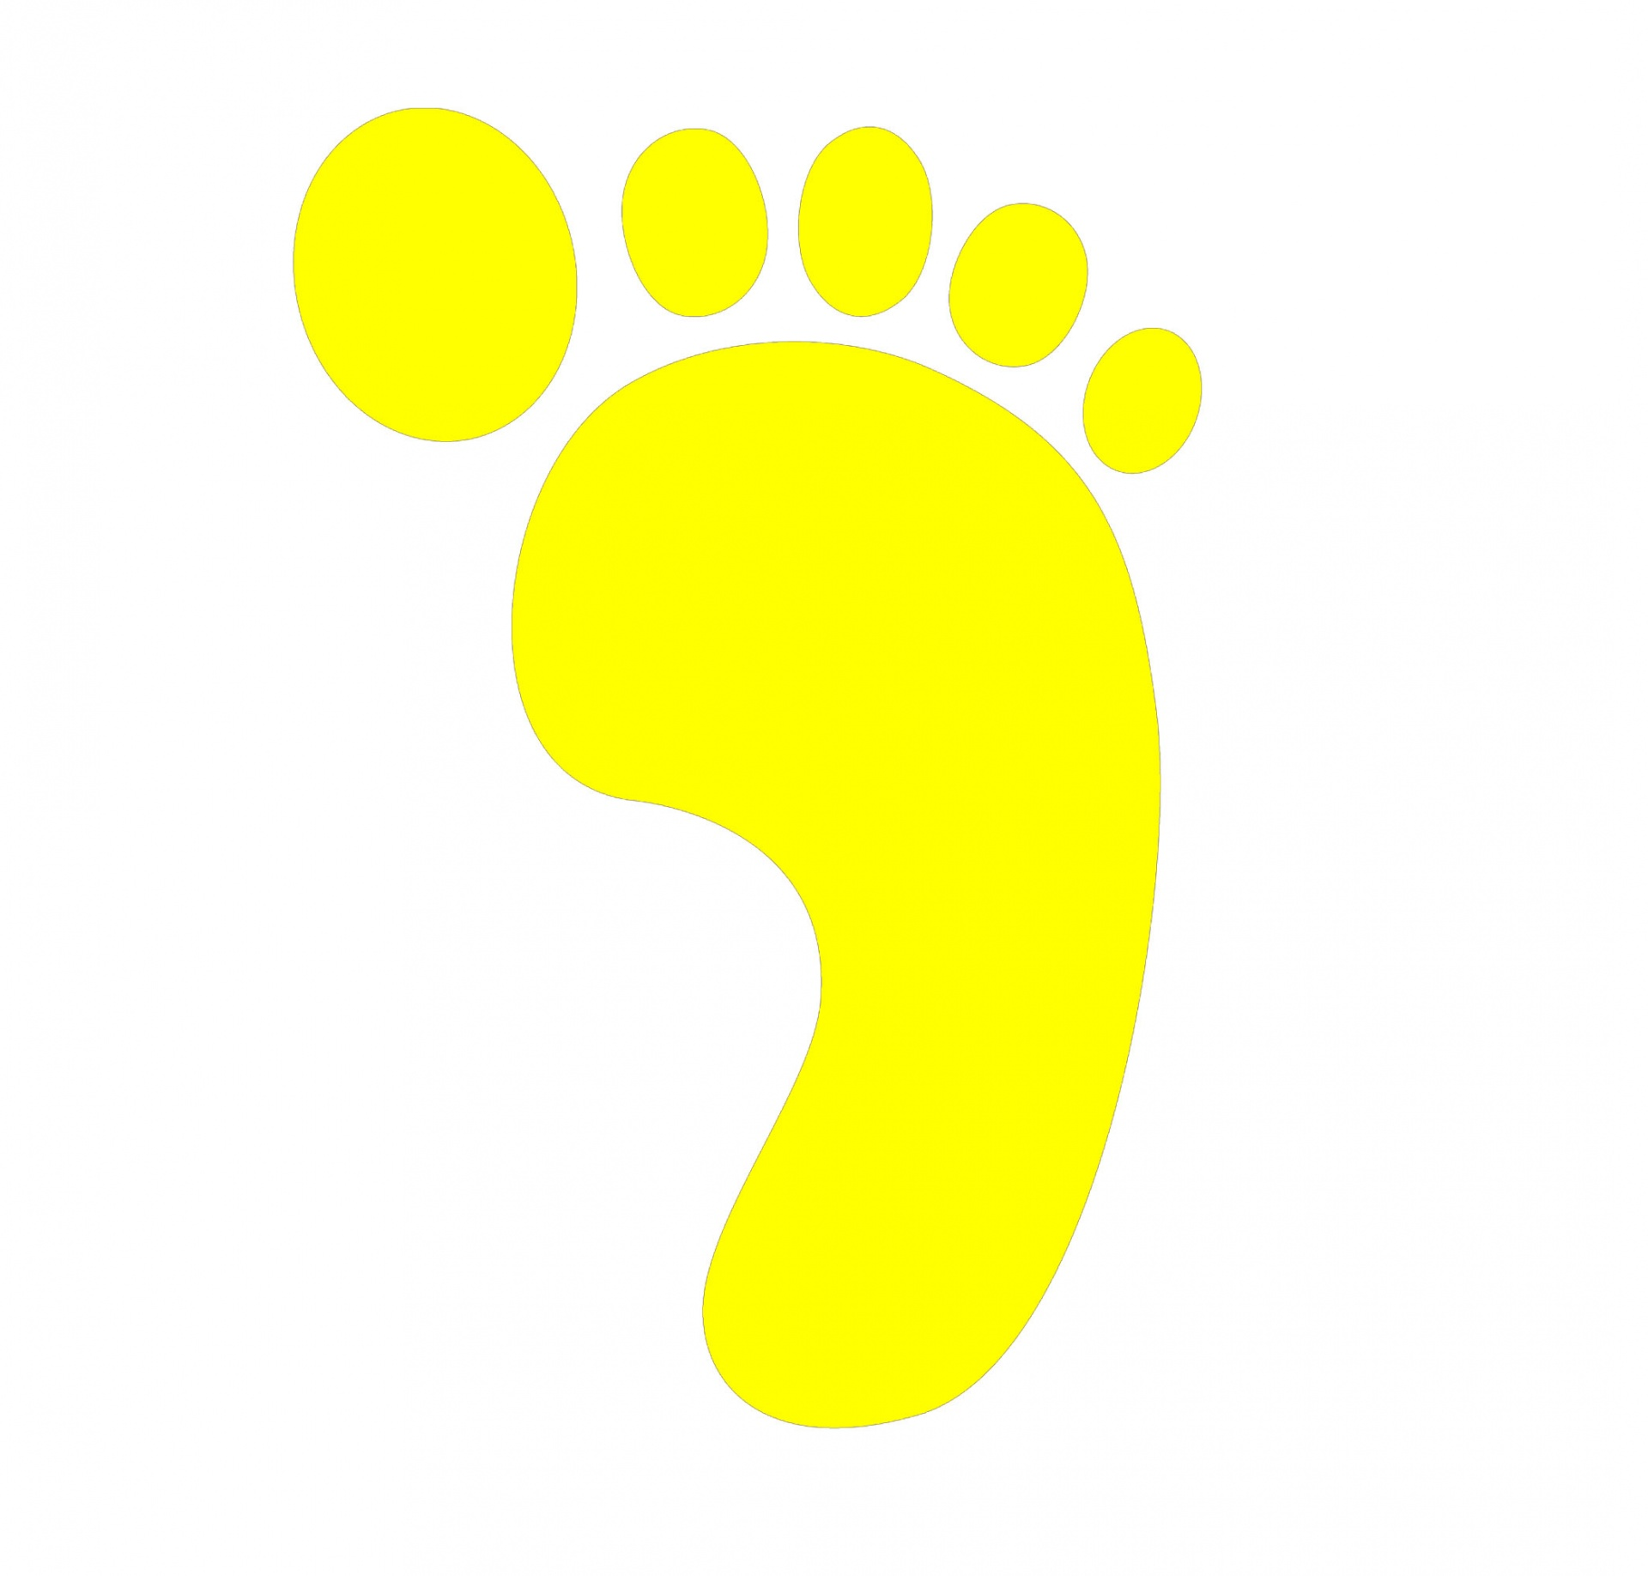

Ask other people in your house if you can draw around one of their feet. Arrange the footprints in size order by making a direct comparison.
Look at these two pictures. Which book is the narrow one?

Challenge – Find out who is the tallest person in your house?

Free-flow- Town and Country- Countryside week
Last week you learnt all about what a Town look likes and what you might find there.
This week, we’re going to focus on finding out about the Countryside!
The countryside is an open space, with lots of trees and green spaces like fields. It is not as busy and noisy as the Town.
Take a look at the video and pictures to find out more, and talk about what you can see! You could even write a list! What makes the countryside different to the town?
https://www.youtube.com/watch?v=PEunHPKLfKg
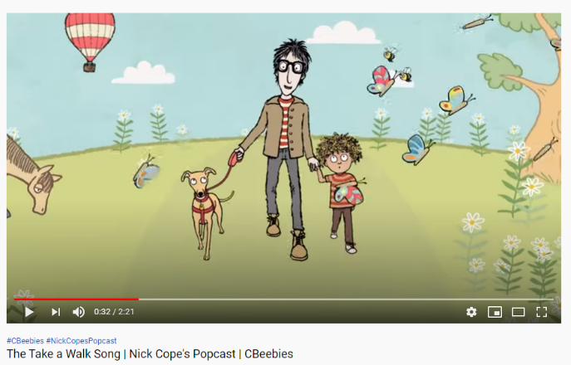

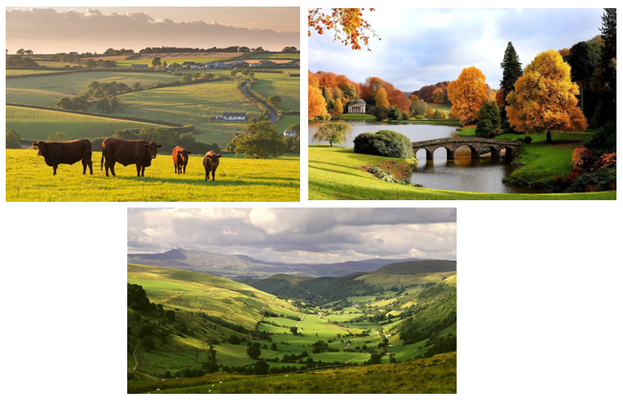
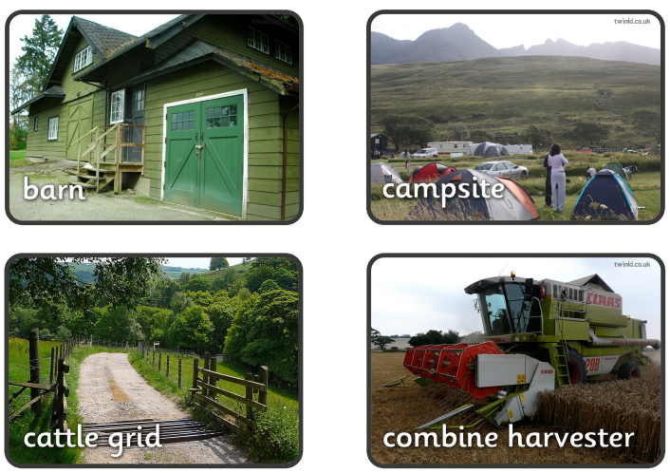
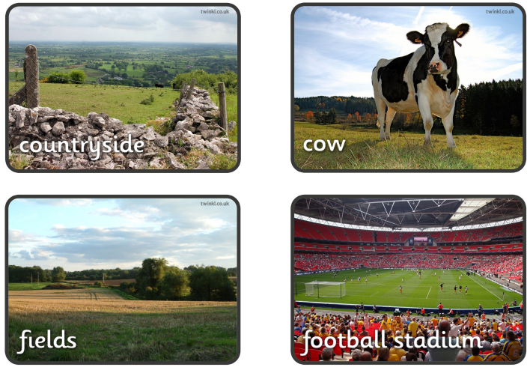
Have a look at the pictures below. Can you decide where you’re more likely to find each picture? In the town or in the countryside?
