Nursery Home Learning- Week Beginning 04/5/2020
Wednesday
Hello children and your grown-ups, we hope you are all well and staying safe at home. Below are your Nursery home learning tasks for today, including a special mission at the end for you to have a go at, if you want to. It’s great to see that some of you have been sharing your work on Twitter so if you’d like to share any examples of your work for your teachers or friends to see you can do this on Twitter by tagging @devnursery. Have another great day!
Phonics
Can you come up with a rhyming word to match with each of the words listed below (see how many different rhymes you can find for each word) :-
E.g. pig- wig pot- pop-
plug- pan- pit-
pink- pea- pear-
pin-

English - Read the poem below with a grown up and circle each p that you see.
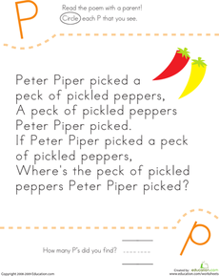
Maths
Oh no! These creatures have all lost their spots! Can you put 4 spots on each one?
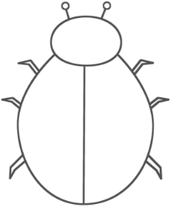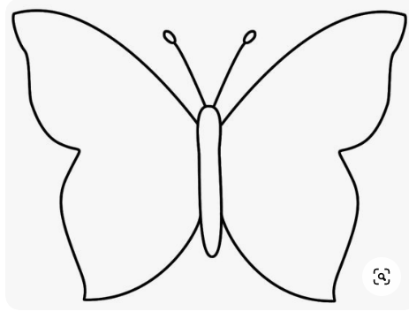
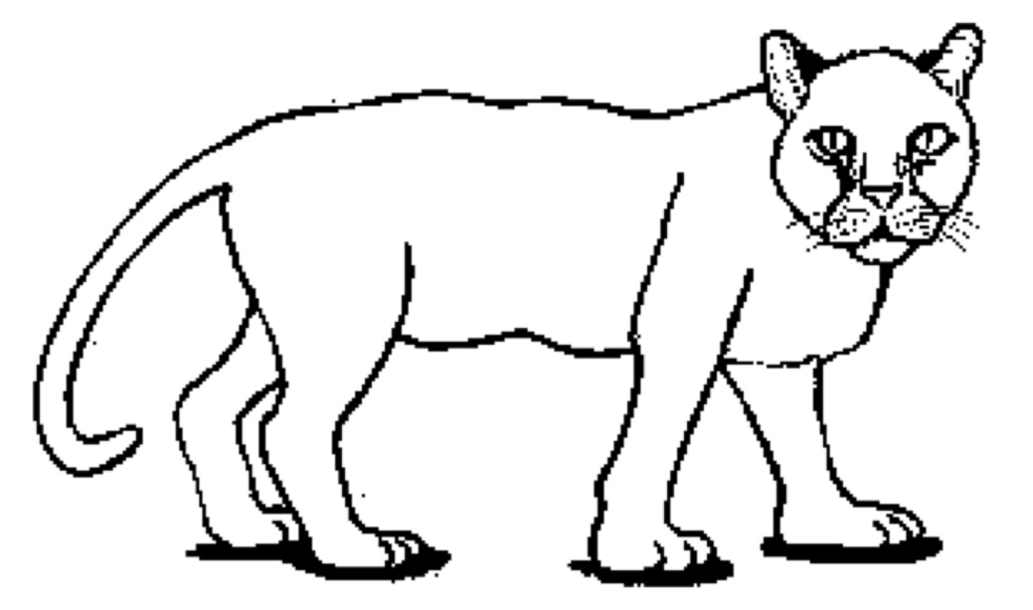
Special Mission – Can you help the pig to find his way to letter ‘p’? Maybe you could design and make your own maze afterwards?
