Important! COVID-19 message for parents

There has been a rapid rise in COVID-19 cases across Sandwell. The virus has NOT gone away. Please stick to social distancing and self-isolation guidance.

If you have to go out, maintain a distance of 2 metres from other people, wear a face covering, use hand sanitiser or wash your hands with soap and water regularly and as soon as you get home.

If you experience symptoms, you must self-isolate at home and get tested. Anyone in the household must also self-isolate. Doing this saves lives.

For more information: www.nhs.uk/coronavirus
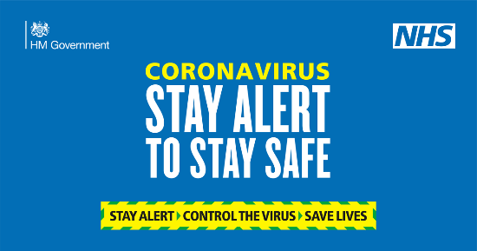 | Coronavirus (COVID-19) - NHS  Find out about the main symptoms of coronavirus and what to do if you have them. Get a test to check if you have coronavirus, understand your test result and find out what to do if you're contacted by NHS Test and Trace. Advice for people at higher risk from coronavirus, including older people ...  www.nhs.uk

