Reception Home Learning
Week 6
Day 4

A big thumbs up from all your Early Years Teachers!

We all hope that you are working hard and enjoying spending time at home.

Thursday 14^{h} May 2020
Reception Work to support your child at home PHONICS
Below are some examples of how you can support your child at home with their phonics knowledge.
Children learn best with daily practise and by repeating the learning.
Day 4 – Look at the long and short oo word sort board, read the words and then make a list of all the long oo words on one side of the page and a list of all the short oo words on the other side of the page.

Challenge yourself to try and write some sentences for some of the long and short oo words. Remember to start with a capital letter, leave finger space after each word and put a full stop at the end of the sentence. Read your sentences to check you have all the words in the right order.
Long oo words Short oo words

Alphablocks is a great website to support with phonics and with how to pronounce the sounds
https://www.bbc.co.uk/bitesize/topics/zvq9bdm/articles/z4tyt39
https://www.bbc.co.uk/cbeebies/shows/alphablocks
https://new.phonicsplay.co.uk/
You can log into phonics play for free using: Username: march20 Password: home

Thursday 14^{h} May 2020
Work to support your child at home- LITERACY
Day 4- It’s Tricky Word Thursday!
- Use your pencil case tricky words to practise spelling and writing them correctly.
Reminder: Adults- Below are the tricky words that your child has been taught so far in Reception
- Set 1 was taught first, then set 2 and now we are onto set 3 (set 3 is not in your pencil case yet).
- Please make sure your child is confident with spelling the tricky words (without you having to help them) in set 1 before moving onto set 2 and then you can move onto the set 3 words you will find below.
- Please make sure you focus on the tricky words that your child needs more practise with. With the words they need support with, show them the spelling and encourage them to write it. The more practise you do, your child will then no longer have to rely on you showing them the spelling, they will be able to spell it by themselves from memory

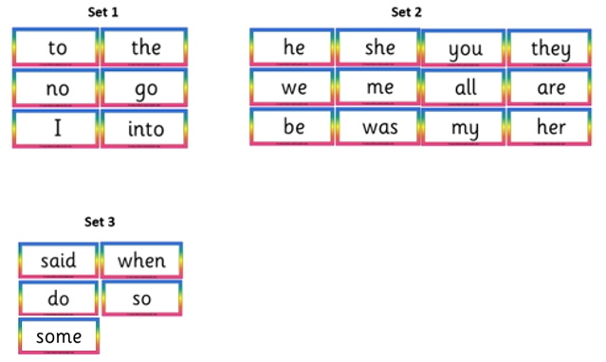

Thursday 14^{h} May 2020
Reception Work to support your child at home MATHS shape

Watch this together with your grown up. https://www.youtube.com/watch?v=hGD-omqAOPI
This week we have been looking at the different parts of simple 3D shapes. Just like we name the different parts of our body we can name the different parts of a 3-D shape. These are called the properties of the shape.
Using the objects that you found which matched the 3D shapes below from yesterday. Choose 3 items and look closely at your objects draw it on a piece of paper and name the 3-D shape which it matches.
Can you say how many faces, corner and edges it has?
See the example below.
Cone Sphere. Cuboid
1 flat 1 curved face. 1 curved face. 6 flat faces
1 curved edge no edges. 4 longer edges
1 point 8 shorter edges
8 corners

Free flow – What food do we grow in the United Kingdom?

This is your 2 week free-flow challenge- do a little bit each day!

Think about the different fruit and vegetables we eat.
How much of these are we able to grow in the United Kingdom?
What is the difference between a fruit and a vegetable?
What vegetables and fruit grow on top of the ground and what fruit and vegetable grows underneath the ground?

Can you make a poster for your grown up on what food we grow in the United Kingdom. Group all the vegetables together and then all the fruit together on your poster. Add pictures and captions or your own sentences to give it a personal touch. Use the questions above to help you.

REMEMBER: This is a 2 week challenge so don’t rush it. Use what you have in your home and be as creative as you like. Enjoy!!

