Nursery Home Learning- Week Beginning 6/7/2020

Friday

Happy Friday children and your grown-ups, we hope you are all well and staying safe at home. Below are your Nursery home learning tasks for today, including a special mission at the end for you to have a go at, if you want to. Don’t forget to check Twitter for helpful tips and ideas @devnursery. Have another brilliant day and a great weekend!

Phonics
In school we like to play I SPY games to help us recognise our letters and practise saying our sounds. Here are 2 links to I Spy games, remember to pause the video to give you extra time to look for the sound they have asked for. The first link covers S A T P I N, however the second one covers a few more letters for you to try and has a lot more pictures. If you enjoy these games why not look for more online games to play with you grown-up, cBeebies is always a great place to start. Good Luck!
https://www.youtube.com/watch?v=gzUz41TjAmg
https://www.youtube.com/watch?v=n4YaF-jXWuY

English
Our book this week is Spot Goes to School. You can watch it on YouTube https://www.youtube.com/watch?v=Y_CApWy7f6g or see Mrs Patton reading it on Twitter @devnursery.
Spot goes to many different places in his books but I bet the most exciting adventure he has had is going to school. You have already learnt lots of new skills during your time in Nursery. Let’s make a list (with your grown-up) of all the positive skills you now have that you will use in your new class. Here are a few to start you off.
I can take off and put on my own coat.
I can hold a pencil.
I can say please and thank you.
I know my colours.
Remember these are positive statements so begin them with I can, I am able to or I know…….
After you have made the list, say each line with your grown up. Are you surprised by how many different things you can do? Think about how you can use these skills in your new class, for example, I can hang up my coat by myself on my new peg, or even, I can show my new teacher that I have good manners by always saying please and thank you.

Maths
It is important to know our numbers and the order they go in. Have a go at these dot to dot pictures, the numbers go in order so that the line you make will complete the picture. The first 2 will help you with numbers 1 to 10 but the large picture goes all the way up to 20! Do you think you can do it? Yes? Good, give it a try.
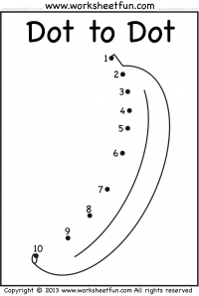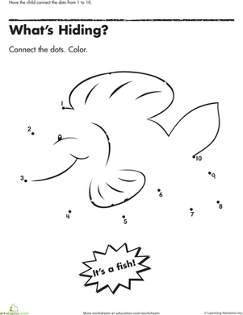
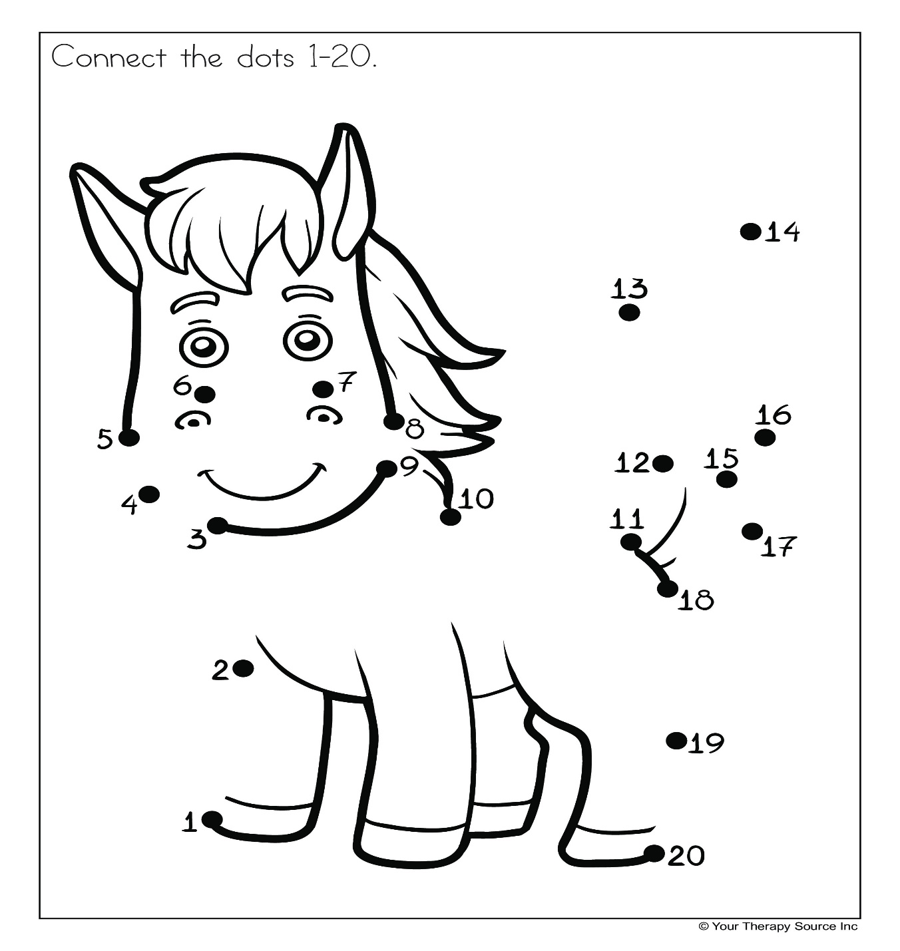
Special Mission
Your very special mission this weekend is to make your very one scrapbook of memories from the past 3 months and the home learning you have been doing. The scrapbook can be as simple or decorative as you wish, it will be something for you to keep and look at to see how well you did during this very different time for us all. You can record your memories with drawings, picture or even pieces of work you have done. How did you feel during this time away from school? What did you do differently? What nice things did you do with your family? Did you enjoy the home learning? At the end you could maybe write about what you are looking forward to most after the summer holidays.

Happy making!

