Nursery Home Learning- Week Beginning 29/6/20

Thursday

Hello children and your grown-ups, we hope you are all well and staying safe at home. Below are your Nursery home learning tasks for today, including a special mission at the end for you to have a go at, if you want to. Remember to share on Twitter if you can @devnursery. Have another great day!

Phonics

We are learning the letter ‘C’ this week. Down below I have found some objects that begin with the ‘C’ sound. Can you circle the items that begin with ‘c’? When you are done why not practice writing the sound for this week.

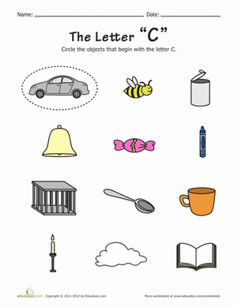

English

This week the book that we are looking at is called Billy and the Big New School. With the help of your grown up you can search the story on Youtube and listen to it. https://www.youtube.com/watch?v=HBghQZLzkUQ or you can see Mrs Patton reading it on Twitter.

In September you will be going into Reception, you will have new teachers and make new friends in your new classes. Some of you will even go to a new school. Talk with your grown up about what you are looking forward to doing and learning in your new classes. Have a go at drawing a picture of you and your teacher in your new class.

Maths

We are learning the number 10 this week. Can you cut out the numbers and stick them in the correct places on the train with help from your grown up?

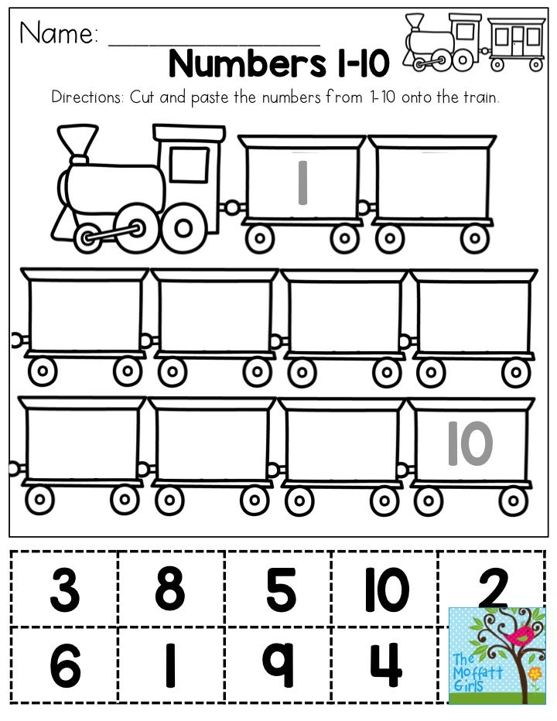
If you are unable to print the above activity out can you do the actions below -

Can you JUMP 10 times?

Can you HOP 10 times?

Can you show 10 FINGERS?

Can you CLAP 10 times?

Can you WRITE the number 10?

Can you COUNT to ten?

Awesome work, well done!
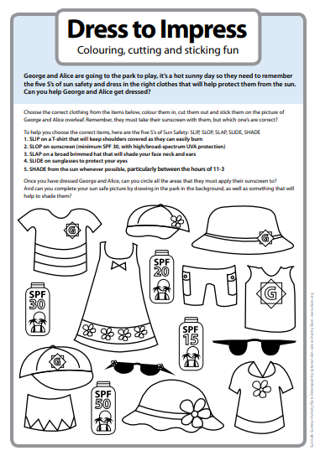
Special Mission

