Nursery Home Learning- Week beginning 15/6/2020
Wednesday
Hello children and your grown-ups, we hope you are all well and staying safe at home. Below are your Nursery home learning tasks for today, including a special mission at the end for you to have a go at, if you want to. We just want to say well done to everyone who has been working so hard at home, you are all amazing! Please do share your work with us on Twitter @devnursery if you can and have another great day!
Phonics
This week we are learning the sound ‘g’. Practice writing the letter and saying the sound out loud, use Mrs Patton’s Twitter videos to help if you need them @devnursery, then see if you can join the dots below to make the gloves and decorate them with lots of lovely ‘g’s all over.
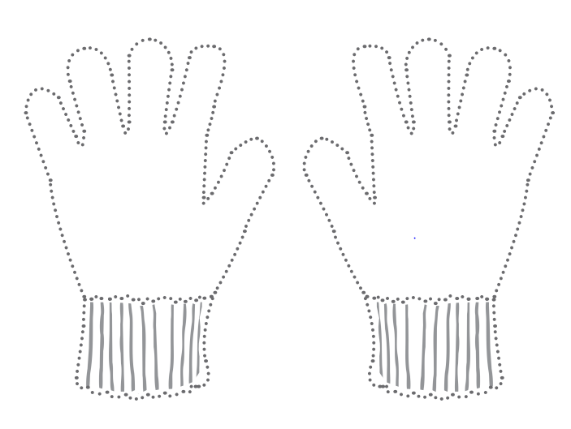

English
Today we would like you to go on a scavenger hunt! Have a look at the list of treasure below that we would like you to try and find on your bookshelf:
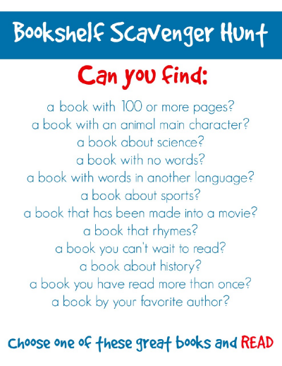
Maths
Today we are practicing writing the number 8. Number 8 is a very curly number, and a tricky one to write so you might have to praictce this one a little bit more than usual until you get it right. Have a go first and then seeif you can complete the activity below:
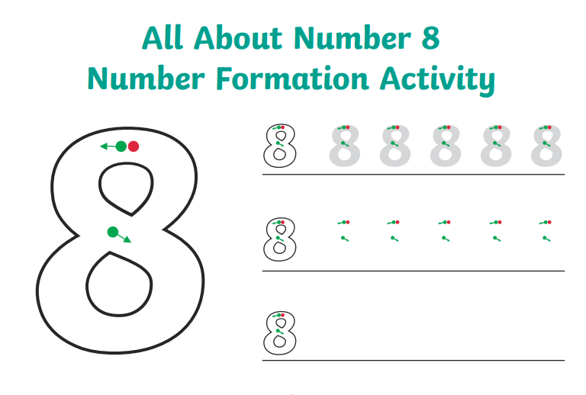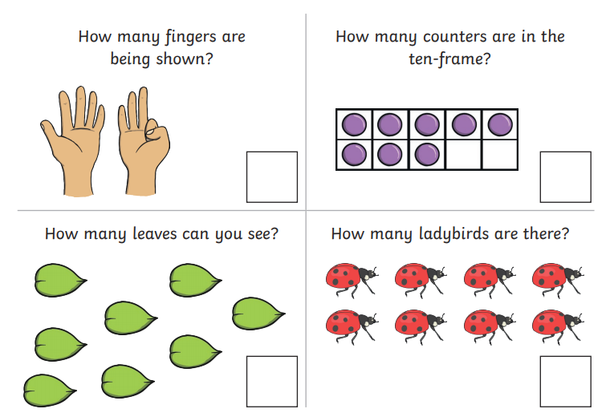

Special Mission
Lets have fun with this snakes and ladders game, all you need is a die. If you don’t have one then do not worry, there is a template at the end, have a go together and enjoy!
