Nursery Home Learning-Tuesday 16th June 2020
Hello children and your grown-ups, we hope you are all well and staying safe at home. Below are your Nursery home learning tasks for today, including a special mission at the end for you to have a go at, if you want to. It’s great to see that some of you have been sharing your work on Twitter so if you’d like to share any examples of your work for your teachers or friends to see you can do this on Twitter by tagging @devnursery. Have another great day!
Phonics
We are learning the new letter ‘G,g’ this week. Have a look at the letters down below and see if you can spot all the ‘g’s. If you can, colour the capital G’s in one colour and the lower case g’s in another colour.
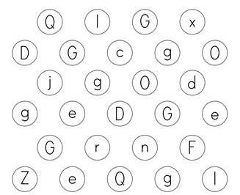
English
This week the book that we are looking at is The Lonely Giraffe. You can find it on YouTube here: https://www.youtube.com/watch?v=z7IrkVTv44Y or you can see Mrs Patton reading it on Twitter @devnursery.
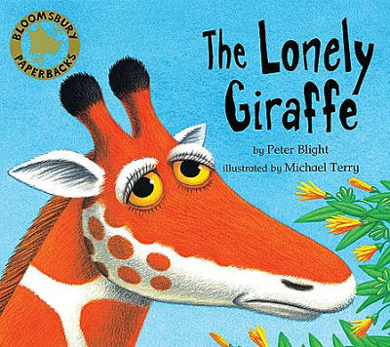
In the story the animals are frightened of the giraffe because they haven’t got to know him yet. Sometimes it can be scary to meet someone new until you get to know them. Right now you might be a bit scared because you will be meeting new people when you go into Reception so let’s do a “get to know me” activity. Below is an All About Me sheet for you to try filling in with your grown-up (or you can make up your own). Enjoy thinking about your favourite things together and remember that everyone feels a bit scared about new things and new people so take a deep breath, be brave and get to know someone, you may find a new best friend!
If you do have a go at this activity, please hold on to it and bring it into school (or take it to your new school if you are going somewhere else in September) the next time you are in. This is a great place to start with your new class and can help you to break the ice and make new friends.
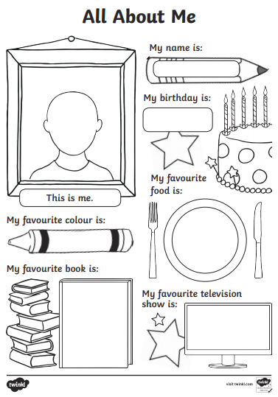
Maths
We are learning the number 8 this week. Can you count carefully and put the right amount of items on each of the pictures below. Take your time and use your finger to touch and count to help you.

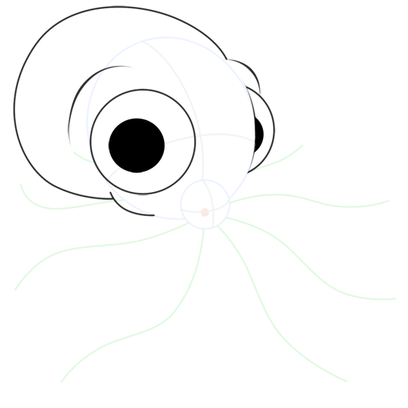

Can you put 8 legs on the octupus?

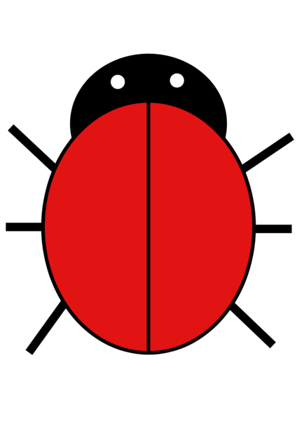

Can you put 8 spots on the ladybird?

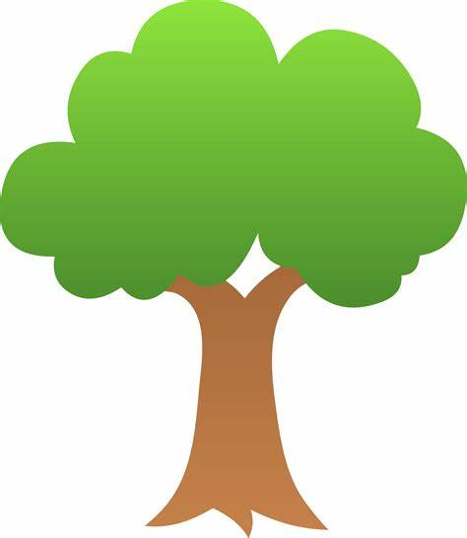

Can you put 8 apples on the tree?

Can you put 8 legs on the spider?

Can you put 8 spiky hairs on the man’s head?

Special Mission
Your special mission for today is to cut out the picture below (or get a grown-up to help you to make your own) and make your own giraffe, giraffe is a funny word because it starts with a g but it makes a j sound, how strange! Give your giraffe a name and re- tell the story of The Lonely Giraffe.
