Nursery Home Learning- 08/06/2020
Tuesday
Hello children and your grown-ups, we hope you are all well and staying safe at home. Below are your home learning challenges for today, including a special mission for you to try. As always, Mrs Patton has put videos on Twitter to help with this week’s home learning so check out @devnursery for support, she also retweets what you wonderful children have been up to, so take a look and you might spot some of your friends. Have another great day!
Phonics
This week we are learning our new sound ‘d’. Can you circle or colour in the ‘d’s below? It also looks like this when it is a capital letter: D. See if you can remember all the different sounds when you read them in the grid below:
d | s | P | i | t
d | D | a | s | d
m | n | d | p | S
s | d | M | N | i
s | I | d | m | p
English
This week we are looking at the story Lost and Found. You can find a read along version on YouTube here: https://www.youtube.com/watch?v=hnSwij0VKzo which will let you see the words as the man reads the story, you can even have a go at spotting the words boy, penguin and lost as he reads. Or you can see Mrs Patton reading it on Twitter @devnursery or on the school website in the story time section. 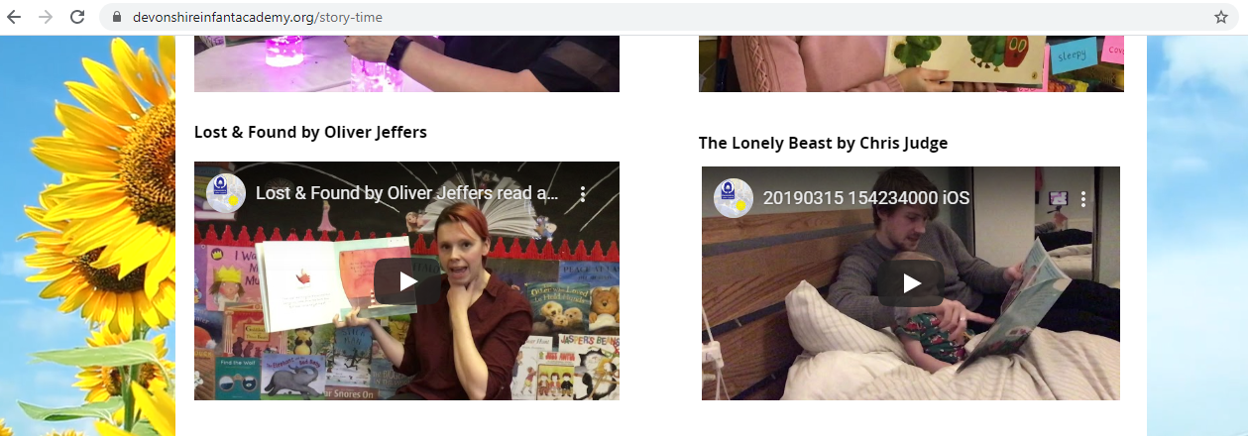
Today we would like you to have a go at making a lost penguin poster, you can use the frame below or create your own. You will need to draw and describe the penguin so people know what it looks like. Have a go and really challenge yourself to try writing some of the sounds you know in your work.
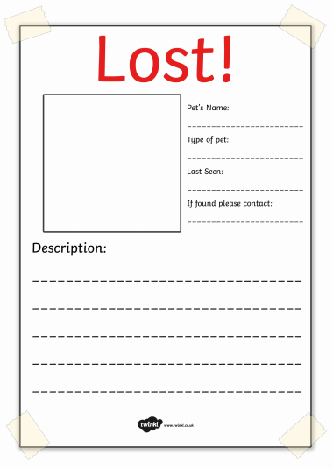

Penguin
Penguin
On my doorstep

The Boy

Maths
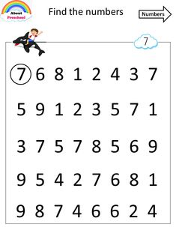

Special Mission
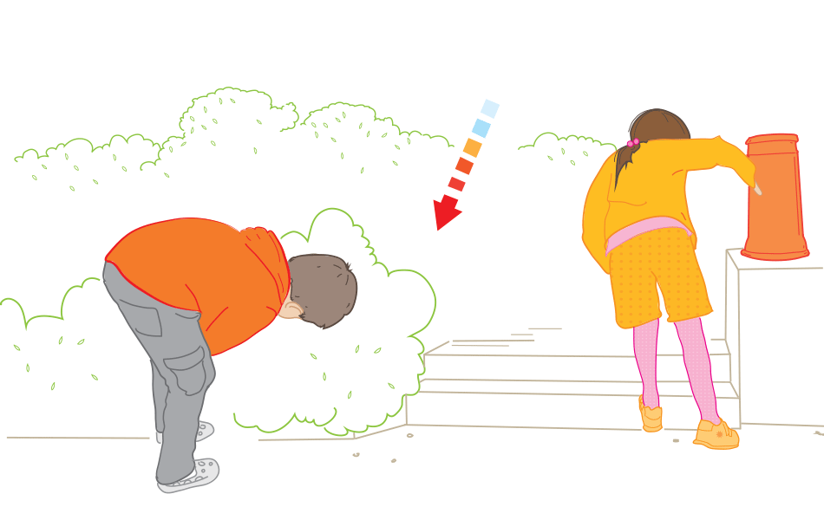
Today we would like you to try playing the Hot and Cold game. Hide your favourite cuddly toy and get your grown up to find it by using the hot and cold rules- if you are closer to the toy it means you are hot and if you further away way you say cold. You can play this game with a musical instrument too, use the instrument and make it louder as the person gets closer and quieter if they are further away.

