Nursery Home Learning- Week Beginning 6/7/2020
Wednesday
Hello children and your grown-ups, we hope you are all well and staying safe at home. Below are your Nursery home learning tasks for today, including a special mission at the end for you to have a go at, if you want to. It’s great to see that some of you have been sharing your work on Twitter so if you’d like to share any examples of your work for your teachers or friends to see you can do this on Twitter by tagging @devnursery. Have another great day!

Phonics
We are learning the letter ‘k’ this week and ‘k’ is for key. I found a magic key today that opens this door. Inside are lots of things beginning with ‘k’, what do you think is inside? Maybe you could draw a picture or collect together some objects beginning with ‘k’, let your imagination run wild…
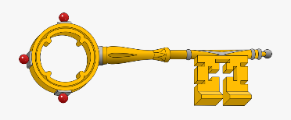
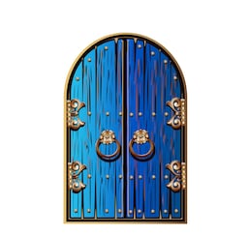

English
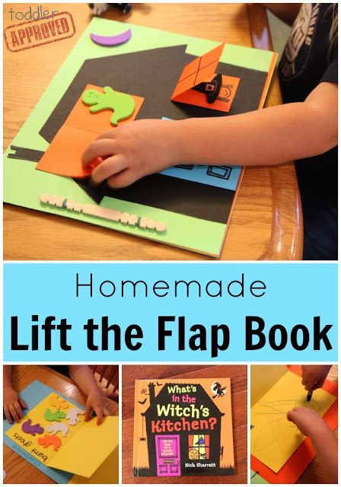
Our book this week is Spot Goes to School. You can watch it on YouTube https://www.youtube.com/watch?v=Y_CApWy7f6g or see Mrs Patton reading it on Twitter @devnursery. This is a lovely book with lots of lift the flaps in it. Today we would like you to have a go at making your own lift the flap picture (or even book if you want a challenge!)
To do this draw a picture and then use another, smaller piece to cover up part of your drawing. You could even get a grown up to help you to write a sentence about what you have drawn. If you do have a go we would love you to share your pictures on Twitter @devnursery. Have a go!

Maths
We are recapping the numbers from 1- 10 this week. Have a go at counting below and writing how many of each sea creature there are below.
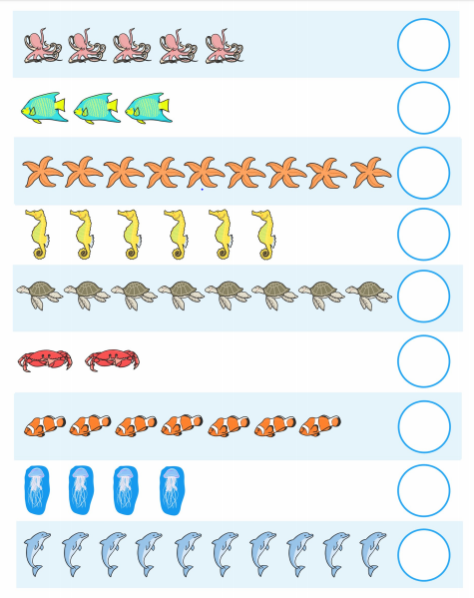

Special Mission
K is for kite so your special mission for today is to make a kite! Have a look at the website below for some ideas on ways you can do this at home: https://www.thesprucecrafts.com/kite-crafts-for-kids-4126872

