Nursery Home Learning- Week Beginning 11/05/2020
Thursday
Hello children and your grown-ups, we hope you are all well and staying safe at home. Below are your Nursery home learning tasks for today, including a special mission at the end for you to have a go at, if you want to. It’s great to see that some of you have been sharing your work on Twitter so if you’d like to share any examples of your work for your teachers or friends to see you can do this on Twitter by tagging @devnursery. Have another great day!
Phonics
Can you find the odd one out in each group of 3:- for example
salad onion
table

Talk about the groups below and decide which one is different each time:
cheese tomato chair
lettuce bread phone
fork butter jam
cucumber banana spoon
ham pencil marmalade
Then ask your grown up to make us some more for you. This is a great game to get you thinking and talking about why things are the same or different.

English
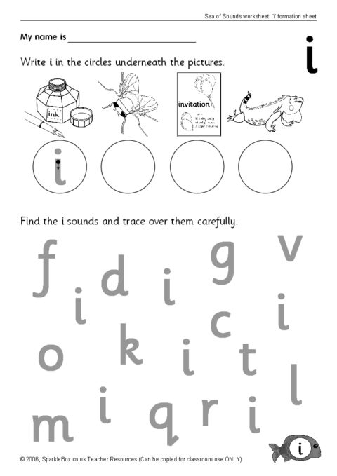

Maths
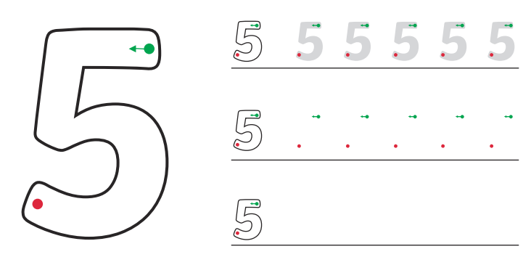
Have a go at writing the number 5, remember to use your ducky grip on your pen and pencil and check on Twitter for tips with Mrs Patton @devnursery.

Special Mission
Just like in our story The Lighthouse Keeper’s Lunch, can you make your own sandwich with the help of an adult? Grown-ups can you help your child to spread on some spread, add our preferred ingredients and then cut the sandwich up. These are all great physical skills to practice and are great life skills too!
