Reception Home Learning
Week 13
Day 4

A big well done from all your Early Years Teachers!
We really are very proud of you for how hard you are working at home. A big thank you to your grown-ups too!
Keep up the good work
Remember, if you want to share any of the busy things you are doing at home with your Teachers, be sure to tag us on Twitter by using: @PinkClass18 and @devrainbow and @redclassdev
We’d love to see them!

Thursday 2nd July 2020
Reception Work to support your child at home PHONICS
Below are some examples of how you can support your child at home with their phonics knowledge.
Children learn best with daily practise and by repeating the learning.
Day 4 – Have a spelling competition using the words you have learnt with the ow and oi sounds.
Get your grown up to put a 5 minute timer to see how many you can say.
Challenge yourself and see how many of the words that your remembered and write them all down in five minutes.
Now try and write all your tricky words in five minutes.
How did you do?

How many words did you remember?

How many did you write in five minutes?

How many tricky words can you now write independently?

Can you say a sentence using the tricky word ‘there’ and some of the ow and oi words that you have wrote?
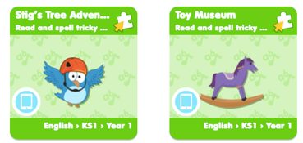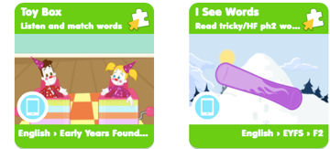 Use Education City. Tricky Word Homework.
Alphablocks is a great website to support with phonics and with how to pronounce the sounds
https://www.bbc.co.uk/bitesize/topics/zvq9bdm/articles/z4tyt39
https://www.bbc.co.uk/cbeebies/shows/alphablocks

Thursday 2nd July 2020
Work to support your child at home- LITERACY
Day 4- It’s Tricky Word Thursday!
- Practise spelling the tricky words you find most challenging
Reminder: Adults- Below are the tricky words that your child has been taught so far in Reception
- Set 1 was taught first, then set 2 and now we are onto set 3 (set 3 is not in your pencil case yet).
- Please make sure your child is confident with spelling the tricky words (without you having to help them) in set 1 before moving onto set 2 and then you can move onto the set 3 words you will find below.
- Please make sure you focus on the tricky words that your child needs more practise with. With the words they need support with, show them the spelling and encourage them to write it. The more practise you do, your child will then no longer have to rely on you showing them the spelling, they will be able to spell it by themselves from memory

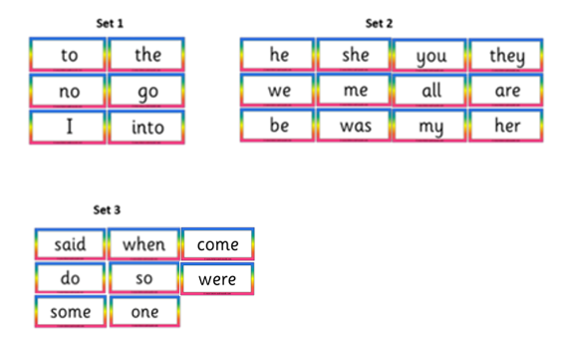

Thursday 2nd July 2020
Reception Work to support your child at home MATHS
Day 4- Geometry – exploring Patterns.
Watch with your grown up
https://www.youtube.com/watch?time_continue=18&v=_BRXLyyximA&feature=emb_logo
Using outside or inside.
Now create your own patterns. What patterns can you make using two colours and two shapes? Describe your pattern to your grown up.
Make different patterns using objects you can find both inside and outside.
Look at these patterns, What do you notice? Can you create a similar pattern?

Create a clapping pattern and see if your grown up can follow it correctly. Now follow you grown up in a movement pattern or play head, shoulders, knees and toes, with a difference see if you can tap a repeated pattern out on your body.

Head, head, knees, knees, tummy, tummy, head, head.

Thursday 2nd July 2020
FREE-FLOW ACTIVITES Friday 3rd July 2020
Watch with your grown up https://www.youtube.com/watch?v=Ut-HbauKzDw
TRANSPORT
Have fun today making your own vehicle using boxes and material that you can find in your home.

You could make a boat , tractor, car or lorry like these if you choose to.

