Reception Home Learning
Week 11
Day 2

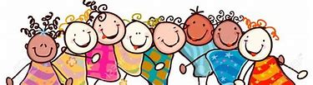

A big well done from all your Early Years Teachers!
We really are very proud of you for how hard you are working at home. A big thank you to your grown-ups too!
Keep up the good work
Remember, if you want to share any of the busy things you are doing at home with your Teachers, be sure to tag us on Twitter by using: @pinkclass18 and @devrainbow and @redclassdev
We’d love to see them!

Tuesday 16th June 2020
Reception Work to support your child at home PHONICS
Below are some examples of how you can support your child at home with their phonics knowledge.
Children learn best with daily practise and by repeating the learning.
Day 2 – Practise the ow sounds and words. Say each word and say if the sound is at the beginning, middle or end of each word.
Practise making words with these sounds in using your sound cards from your pencil case.
n | ow
ow | l

D | ow | n
c | r | ow | n

t | ow | n

Can you write the ow sound to complete the words. You can use the pictures to help you. Remember to say the words and say where the ow sound is in each word.
l
d |  | n

c

c | l |  | n

What does each word mean? Do you notice any patterns?

Alphablocks is a great website to support with phonics and with how to pronounce the sounds
https://www.bbc.co.uk/bitesize/topics/zvq9bdm/articles/z4tyt39
https://www.bbc.co.uk/cbeebies/shows/alphablocks
https://new.phonicsplay.co.uk/
You can log into phonics play for free using: Username: march20 Password: home
Tuesday 16th June 2020
Work to support your child at home- LITERACY
- This week we are focusing on the story ‘Farmer Duck’. You can find the story by following this link: https://www.youtube.com/watch?v=qaPrR_IWmog
Day 2-
Please draw some lines in your child’s writing book and encourage them to sit their writing on the line.
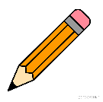
Today’s writing task:
- Can you write our new sentences?

The words in green are tricky words and children are expected to spell these correctly. This week’s sentences to learn are:

There once was a duck and a lazy farmer. First, the duck got the cow from the field. Then, the duck got the sheep from the hill. After that, the duck was sleepy. Finally, all the animals made a plan.
Please note:
Use of commas (,)
- You can talk generally about what a comma is (a short pause between parts of a sentence) but do not worry about your child using this in their writing at this point. Focus on making sure they use full stops correctly.

Remember when writing:

- Use your actions to help you know what word comes next. Use your sounds to spell the words. Remember: form letters correctly, capital letters, finger spaces and full stops.

- Adults please remember to let the children use their own phonics knowledge, please do not spell the words for them. Your role is to remind them about capital letters, to say their words slowly to hear each sound they need to write, finger spaces and full stops. You can support children with spelling the tricky words correctly if they need support.

- Yesterday, we practised saying our new sentences

Tuesday 16th June 2020
Reception Work to support your child at home MATHS TIME

Sing our days of the week song or watch this clip.
Watch with your grown up Days of the week song https://www.youtube.com/watch?v=mXMofxtDPUQ&vl=en

You will need paper, pencil or crayons and scissors.
Fold your paper into 8 equal parts. In your first square write Days of the week.
Then in each square write Monday, Tuesday, Wednesday, Thursday, Friday, Saturday and Sunday. Draw a picture that will help you to remember what day it is.

Cut out your cards and then mix them up. Can you put them back in the right order? Ask a grown up to check.
What day comes before Tuesday?
If Friday is day five what day is day 3?
How many days in a week?
What day are the days in the weekend?

Free Flow – Tuesday 9th June 2020
Town and Country- Farm Animals
Yesterday we watched a video link about farm animals. Today can you be creative and make an animal mask of your choosing.

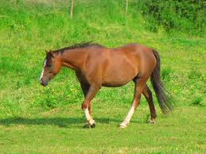
Horse

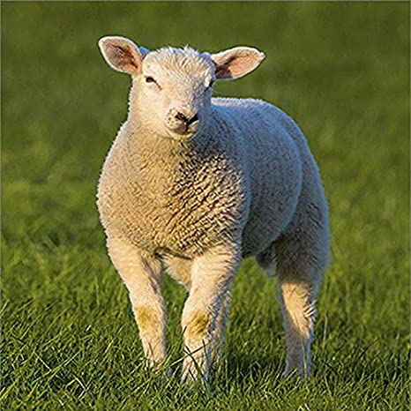
Sheep

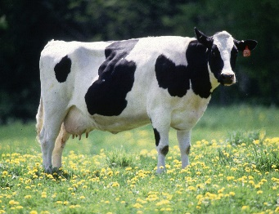
Cow

Here is an example of a farm animal that you can make into a mask.

