Nursery Home Learning- Week Beginning 8/6/2020
Thursday
Hello children and your grown-ups, we hope you are all well and staying safe at home. Below are your home learning challenges for today, including a special mission for you to try. As always, Mrs Patton has put videos on Twitter to help with this week’s home learning so check out @devnursery for support, she also retweets what you wonderful children have been up to, so take a look and you might spot some of your friends. Have another great day!

Phonics
This week we are learning our new sound ‘d’. Today let’s play a guessing game, your grown up will read out the clues and let’s see if you can guess the words that begin with sound ‘d’. I have added some pictures to help if you get stuck. If you enjoy this guessing game why not try making up your own. Remember all these words begin with the sound ‘d’. Have fun!
1) I am an animal that barks and wags my tail, what am I?
2) You walk through me to get into your home, what am I?
3) I am a bird that quacks, what am I?
4) I am an instrument that you can hit, what am I?
5) Sometimes princesses like to wear me, what am I?

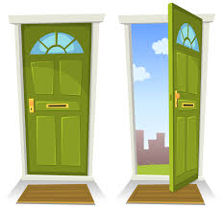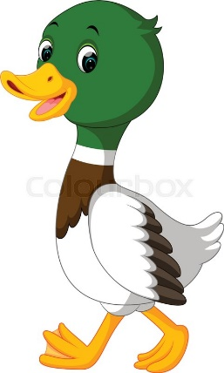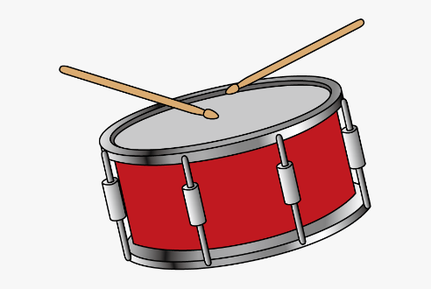
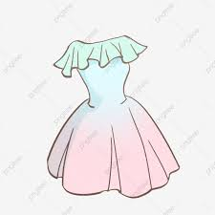
English
This week we are looking at the story of Lost and Found, we hope you have enjoyed it. I wondered if your lovely grown up would look at the cover picture of this book. It is a beautiful picture! There is a well-known saying “a picture tells a thousand words” how interesting! What does this picture tell you about the story? Please look together and talk about:-
1) The characters – who are the characters of this story, what does this picture tell you about them? How are they feeling?
2) The location – where do you think they are? Why do you think they are there?
3) The colours – what colours can you see in this picture? Do you like these colours, what colours would you have used?
4) The items – The boy is holding a case, why do you think he is holding a case? Why do you think they are standing in an umbrella?
5) The title – “Lost and Found” - what does this mean? What does it tell you about what the story could be about? Would you give this book a different name?
Reading books and talking about them is SO FUN, I could talk about them for hours! I hope you have enjoyed talking about the cover of this lovely story together!

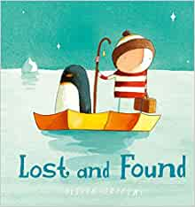

Maths
Let’s focus on our shape this week, we are learning all about CYLINDERS. Our number this week is 7, so can you find or think of 7 types of cylinder in your house?
Now have a go at the maze below to help the dog:
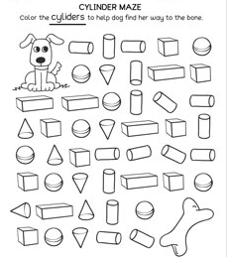
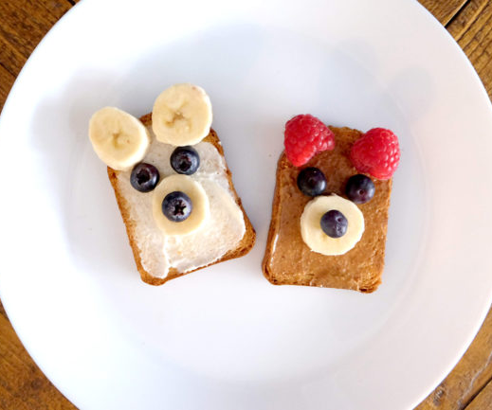
Special Mission
We’re sure you have worked up a hunger with all of this awesome home learning you are doing. I wonder if you can reward yourself by making these super cute, super tasty snacks.

Teddy bear toasts
This one wins the cutest snack award. And it combines fruit with protein and wholemeal toast, so it scores high on nutrition, too.
- You’ll need: Polar bear – white toast, soft cheese, banana and blueberries.
Brown bear: Wholemeal toast, peanut butter*, raspberries, banana and blueberries
*Leave off the peanut butter if your child is allergic to nuts. The bread is brown anyway.
Method:
- Toast the bread and help your child to smooth on the spread.
- Give them a child’s knife so they can cut segments of banana.
- Then assemble the bears using the fruit.
If you can spare a moment to take a picture before you gobble them all up, why not share what you’ve created on Twitter @devnursery, we would love to see what you’ve created.

