Nursery Home Learning- Week Beginning 27/4/2020
Wednesday
Hello children and your grown-ups, we hope you are all well and staying safe at home. Below are your Nursery home learning tasks for today, including a special mission at the end for you to have a go at, if you want to. Don’t forget to check Twitter for helpful tips and ideas @devnursery. Have another brilliant day!

Phonics
Today we would love you to have a go at some tongue twisters. Tongue twisters are a fun way of practicing sounds and mouth movements, they are best done with a partner or in a mirror so you can really see how someone’s mouth moves when they say all the funny words. Here are some good ‘t’ tongue twisters:
Two toads totally tired trying to trot to Tewksbury.
A tutor who tooted the flute tried to tutor two tooters to toot.
Said the two to the tutor, is it harder to toot or to tutor two tooters to toot?
I thought a thought but the thought I thought, wasn’t the thought you thought I thought.
Twelve twins twirled twelve twigs.
You can find more here: https://www.mykidstime.com/things-to-do/20-popular-tongue-twisters-for-kids-to-recite/ or you could even try to write your own. If you do, send it to Mrs Patton or Twitter @devnursery and she will make a video trying to read it! Remember to watch your mouth and lips as you make the different sounds and words and have fun, they’re so silly!

English
Today can you try practicing writing the letter ‘t’. Warm up by practicing the straight line handwriting jingle, then you can you write with your finger first it in the air, on the floor and on your hand. After that you can try writing it on the guide below and to extend your learning can you write it independently without tracing. Can you find different ways of writing the letter ‘t’?
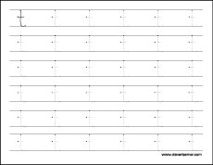
Maths
Using a ball can you catch, bounce, throw, roll or kick it three times? Remember to count and stop at the number 3.

Special Mission
Follow the colour code to colour the butterfly with the correct colours.
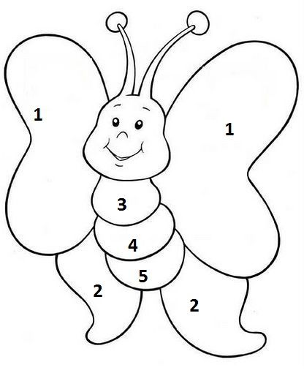
1 yellow 2 blue 3 green
4 red 5orange
Can you make your own butterfly picture too?

