Reception Home Learning
Week 12
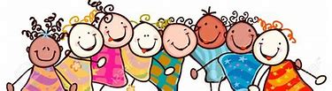
Day 1

A big well done from all your Early Years Teachers!
We really are very proud of you for how hard you are working at home. A big thank you to your grown-ups too!
Keep up the good work

Remember, if you want to share any of the busy things you are doing at home with your Teachers, be sure to tag us on Twitter by using: @PinkClass18 and @devrainbow and @redclassdev
Joke. How do you make toast in the Jungle?
Answer. Put it under a grilla
Monday 22nd June 2020
Reception Work to support your child at home PHONICS
Below are some examples of how you can support your child at home with their phonics knowledge.
Children learn best with daily practise and by repeating the learning.
You will need your phonic cards that were sent home in your pencil case.

Day 1 – Recap on sounds we have learnt before – ow (now, down, owl, cow, how, bow, pow, row, town, towel and powder)

Learn the new sounds –oi (coin, foil, boil, soil, toil, spoil, join, joint, void, and loin)
Practise the tricky word – have (also practise words we have learnt before –
(they, one, me, to, you, go, he, she, her, we, are, all, said, when, do, some. So, come, were)
What does each word mean?
Do you notice any patterns? Where is the oi sound in each word?
Choose a book from Bug Club use either the red or yellow band.
Can you look at the front cover and talk about what you think might happen in the story?
Does this book remind you of any other stories you know?
Which tricky words did you read in your book?
Alphablocks is a great website to support with phonics and with how to pronounce the sounds
https://www.bbc.co.uk/cbeebies/shows/alphablocks
https://new.phonicsplay.co.uk/
You can log into phonics play for free using: Username: march20 Password: home
Bug club and also Education City can enhance your child’s learning

Monday 22nd June 2020
Work to support your child at home- LITERACY
This week we continuing to focus on the story ‘Farmer Duck’. You can find the story by following this link: https://www.youtube.com/watch?v=qaPrR_IWmog
Last week, our sentences were:
There once was a duck and a lazy farmer. First, the duck got the cow from the field. Then, the duck got the sheep from the hill. After that, the duck was sleepy. Finally, all the animals made a plan.
Day 1-
This week, we are going to write similar sentences, but this time we would like you to add in your own ideas-
Here are some examples:
There once was a … and a lazy farmer. | First, the __ got the … from the field. | Then, the __ got the … from the hill. | After that, the __ was …
goat | donkey | rabbit | grumpy.
horse | goose | cat | fed up.
chicken | dog | turkey | upset.
Finally, all the animals made a plan.

So, it may be that your new sentence is something like this:
There once was a goat and a lazy farmer. First, the goat got the donkey from the field. Then, the goat got the rabbit from the hill. After that, the goat was grumpy. Finally, all the animals made a plan.

Today, your talking task is to:
- Practise saying the sentences- Put your actions to the sentences above as we do in class. Act out the sentences.

- Once you have practised saying the sentences together, see if your child can now remember the sentences and say them without your support. If they can, it means they are ready to write them tomorrow!

Monday 22nd June 2020
Reception Work to support your child at home MATHS Recap
Your child should be at the stage of counting in the correct order up to 10 and then beyond to 20. Once your child can count confidently provide opportunities to start to match the quantity to a given number. Prompt your child to recognise (as you count) that the number is one more than the previous one, creating a staircase.
https://www.youtube.com/watch?v=TNZMsXSOlEU Watch with your grown up.
Activities
Play with your grown up I count, you count. Start from 0 and count up a number of times then the next person takes over the counting and adding and extra 1 on, repeat. Eg: 0,1,2,3,4. First person 5 ,6 ,7, 8, 9, 10. Next person Now back to the first person 11,12, 13, 14. 15,16,17. Then change 18 19 and so on. The winner is the person who avoids the saying 20. Repeat but start at a different number than 0.
Use the number line to help you

Make some flash cards from 0 to 10. Pick a card then represent the number by the amount of objects, a shape with the same amount of sides and find the Numicon which represents the number. Extend to number to 20.
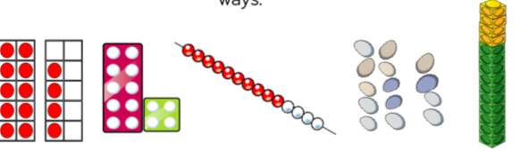
Using your flash cards can you place them in the correct order. Turn over one and then say what the number is. Alternatively say the number that is one large and one smaller.

Day 1 Free-Flow Activity.
Monday 22nd June 2020
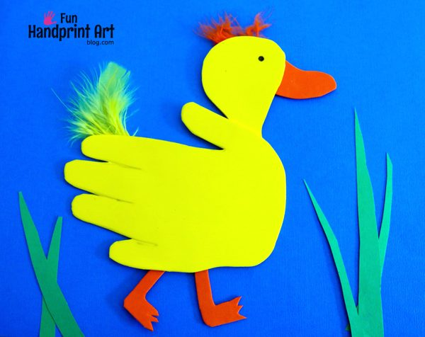
This week we will continue to be creative and learn more about farm animals.
Remember the story of Farmer Duck and all of the characters in the story. Now you can make your own animal. By using your hand, make a handprint and see what you can make.
Above there is an example of an animal made from a hand print.

