Nursery Home Learning- Week Beginning 15/6/2020
Thursday
Hello children and your grown-ups, we hope you are all well and staying safe at home. As always, Mrs Patton has put videos on Twitter to help with this week’s home learning so check out @devnursery for support, she also retweets what you wonderful children have been up to, with the chance of getting a Star of the Week certificate for those who have been busy home learning, so check it out. Have fun!
Phonics
This week we are learning the new sound ‘g’. Here is a fun activity which links our sound and counting out! Using the grid below choose 1 word from each column and then draw a picture to match the description you created. For example 2 green gloves, or 5 gold goats. See how many mix and matches you can do and create the pictures to match, have fun, it can get a bit silly!
1 | green | goats
2 | gold | geese
3 | grey | gloves
4 | grand | girls
5 | gloopy | ghosts
6 | glamorous | grannies
7 | glittery | gorillas
8 | goofy | giraffes

2 glittery gorillas!
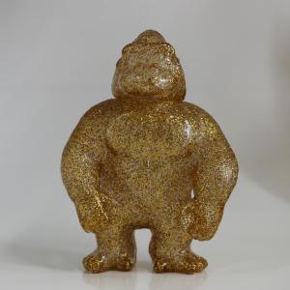

English
This week we are reading The Lonely Giraffe. You can find it on YouTube here: https://www.youtube.com/watch?v=z7IrkVTv44Y or you can see Mrs Patton reading it on Twitter @devnursery.
Giraffes are such interesting animals; don’t you think? To find some really interesting facts about giraffes have a look here: https://kids.sandiegozoo.org/animals/giraffe.
Today we would like you to make a poster about an animal beginning with ‘g’- you could learn about the giraffe, goat, gorilla or gila monster, (or any others you can think of) it’s up to you!
To make a poster, start by drawing your animal in the middle, then add facts around the edge from the things you have learnt, the San Diego Zoo site above is a great place to start but you could use Encyclopedias or fact books if you have them at home or do a search online for “(animal name) facts for kids”. Get a grown up to help you with the writing if you need it. We’d love to see what you have learnt so please share on Twitter @devnursery.
Giraffe Facts
Did you know…?

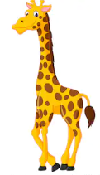

Maths
Today we are going to work on the number 8 again and we are going to have our first try at making some number sentences. (For a demonstration of this activity, please see Mrs Patton’s Twitter @devnursery)
Start by counting out 8 toys/items you are going to work with today.
Next split these into 2 groups (having 2 circles marked out might help here to show where you put the toys).
Now count and record how many are in each of the circles, as we’ve shown below:

5 + 3 = 8
5+3=8
Then repeat, changing how many are in each circle, but remember that the total will always stay the same, 8. See how many different ways of making 8 you can find and then be very proud, you’ve just written your first number sentences! Well Done!!

Remember that there are lots of other lovely number games you can play here: https://www.topmarks.co.uk/maths-games/3-5-years/counting which are great fun and will help with all our numbers now we are working up to 10.

Special Mission
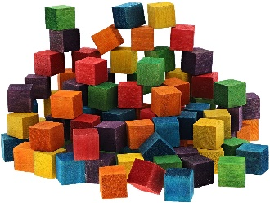
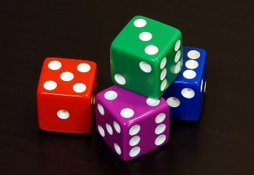
This week’s shape is the cube, there is an introduction to the cube here: https://www.youtube.com/watch?v=n9FpKvVFQpg or look on Mrs Patton’s Twitter @devnursery. There are 2 great toys that can be cube shaped, dice and building blocks. See if you can find some cube blocks and build the tallest tower you can, or get out your dice and play some games together. Whichever activity you choose; remember you are playing with cubes!

