Nursery Home Learning- Week Beginning 29/6/20
Wednesday
Hello children and your grown-ups, we hope you are all well and staying safe at home. Below are your Nursery home learning tasks for today, including a special mission at the end for you to have a go at, if you want to. It’s great to see that some of you have been sharing your work on Twitter so if you’d like to share any examples of your work for your teachers or friends to see you can do this on Twitter by tagging @devnursery. Have another great day!

Phonics
This week we are learning the sound ‘c’ practice writing the letter and saying the sound out loud. See if you can find objects around the house and garden that begin with this letter and ask your grown for help if you need it.
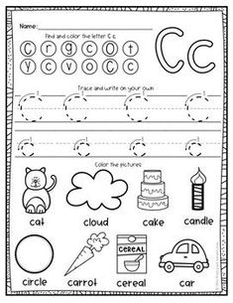

English
We are looking at the story of Billy and the Big New School. Watch the story then talk to your grown up and see if you can answer the questions below.
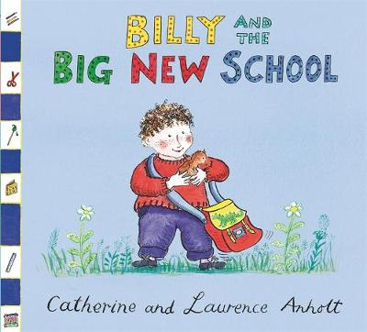
https://youtu.be/HBghQZLzkUQ
- How did Billy feel about going to his new big school?
- Can you remember any of the birds’ names?
- Who did Billy talk to about his school?
- What things did Billy’s mum got ready for his new school?
- What did he do with the bird he found?
- Can you remember the names of the animals that the children had?
- What did Billy tell his teacher?
- How do you think Billy felt at the end of the story? Why?

Maths
Today we are going to use your 10 frame to explore number bonds to 10. That means pairs of numbers that add up to 10. Today you will need your 10 frame and your 10 items again and some paper to write down your number sentences. (see Mrs Patton’s Twitter @devnursery if you need help with activity and to see the actions for the number bond rhyme)
Start by putting 1 item in your 10 frame, then count the empty spaces and work out how many more you would need to make 10. Write it down like this:
1 + 9 = 10
Then try 2, then 3 etc and try to record all your number bonds. Wow, what an amazing maths investigation!

Here is a great action rhyme to help you to learn these number bonds:
10 and 0, you’re my hero
9 and 1, we’ve just begun
8 and 2, look at you
7 and 3, look at me
6 and 4, shut the door
5 and 5, I’m alive!
4 and 6, pick up sticks
3 and 7, down to Devon
2 and 8, shut the gate
1 and 9, I feel fine
0 and 10, let’s start again!

Special Mission
Why don’t you make a memory game and play with your grown up or with a friend?
What you need
a paper
scissors
pen/pencil
What you need to do
Cut the paper into matching squares or rectangles (8 is an easy start, or any even number to about 20, add more as you go for a challenge)
Write pairs of sounds or numbers on them. (whatever you need to practice the most!)
How to play the game
Lay the cards out with the writing facing down.
Then pick 2 cards only and see if you can find a matching pair.
If you find a pair you keep them, if you don’t the next person has a try, keep going until all the pairs are found and count to see who found the most!
Remember to say the sounds or numbers out loud as you turn them, and try to remember where they are hiding!
Have fun!
