Information Videos about returning to school on September 7th

English - https://www.youtube.com/watch?v=2_18eU7WTuw
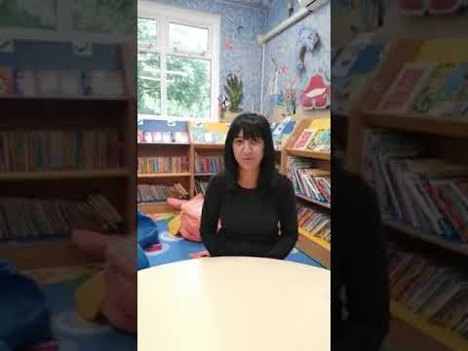 | Information about returning to school- language English  Returning to school Sept 2020. Information for parents in English  www.youtube.com

Punjabi https://www.youtube.com/watch?v=rm58y5hQbBs
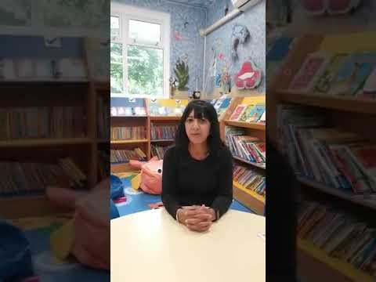 | Information about returning to school- language Punjabi  Returning to school Sept 2020. Information for parents in Punjabi  www.youtube.com

Bengali- https://www.youtube.com/watch?v=mxF2iXiFIVo
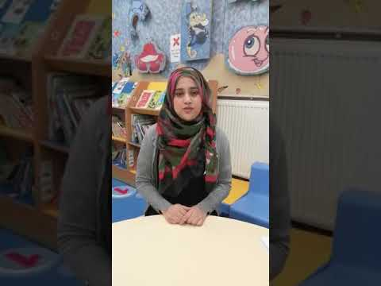 | Information about returning to school - language Bengali - YouTube  Returning to school Sept 2020. Information for parents in Bengali  www.youtube.com

Urdu/Mirpuri- https://www.youtube.com/watch?v=aeHjP1XQEBA

Romanian - https://www.youtube.com/watch?v=nEqUiuNx2GY

