Nursery Home Learning- Week Beginning 27/4/2020
Friday
It’s Friday children and your grown-ups! We hope you are all well and staying safe at home. Below are your Nursery home learning tasks for today, including a special mission at the end for you to have a go at, if you want to. These home learning tasks are so exciting Mrs Patton is going to try some with her little boy, I think they may last us all weekend! Don’t forget to check Twitter for helpful tips and ideas @devnursery and there’s even Mrs Patton singing the Friday song on there if you’d like to teach it to your family and friends. Have another brilliant day and a great weekend!

Phonics
Today we would like you to make….. a nursery rhyme obstacle course! You could do this indoors or out and you can use anything you like but the idea is to choose between 3 and 5 nursery rhymes you know and love and create an action/task to match it (I’ll give some examples below) Then you have a go at doing the full obstacle course, making sure you say the full rhyme at each stop. Maybe you could race your family?
Row row row the boat- climb into a washing basket and row (with arms or ‘oars’) while you sing.
Jack and Jill- climb the stairs holding a bucket (cup) while you sing.
Twinkle Twinkle- do star jumps on the spot while you sing.
The Grand Old Duke of York- put on a crown/hat and march while singing.
Wheels on the Bus- if you have a large car you could get in or you could push a small one around a track while you sing.
Three Blind Mice- put on a blindfold and walk a short distance while singing.
The options for this are endless, have fun and come up with as many crazy and fun ideas as you can, just stay safe. I know Mrs Patton will be doing this one! Ready, Steady, GO!

English
Today we are going back to our story, Oliver’s Vegetables, you can watch it on YouTube here: https://www.youtube.com/watch?v=BTYoaJY7k-Q
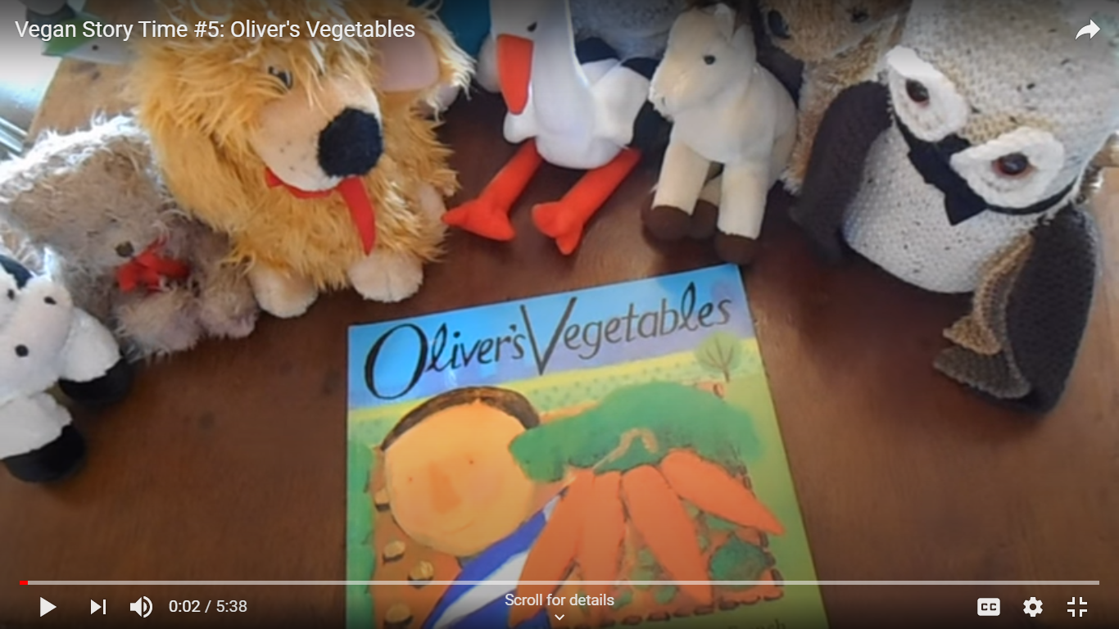
Today we would like you to think about what your favourite vegetable is. When you have chosen you could draw it and write a label too. Why not ask all your family what their favourite is and add it to your picture? I wonder if anyone likes the same as you?

Maths
Today we would like you to collect up some sticks, rocks etc (you could do this on a daily walk if you don’t have a garden) and use these to make some shapes. How many different shapes can you make?
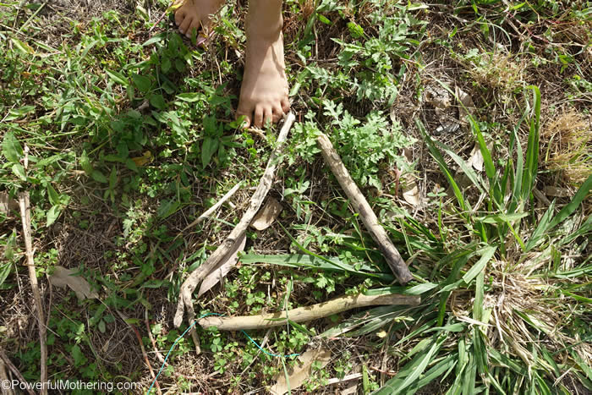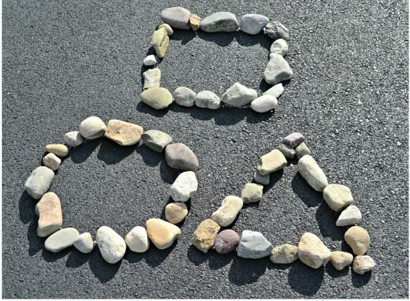
Special Mission
In our story this week Oliver tries lots of new vegetables at his Grandpa’s house and finds out that he enjoys them. This weekend I would like you to try something new to eat, if your grown up says it is ok to. It is very brave to try something for the first time and sometimes this can be yucky, but often you find something new to enjoy. This could be a new vegetable like in the book or it could be something else, you might even find you like it! Just make sure a grown-up has checked that this is ok first!

