Reception Home Learning
Week 7
Day 3

A big pat on the back from all your Early Years Teachers!
We all hope that you are working hard and enjoying spending time at home.

Joke Q. What do elves learn at school?
The elf-abet.

Wednesday 20th May 2020

Reception Work to support your child at home PHONICS
Below are some examples of how you can support your child at home with their phonics knowledge.
Children learn best with daily practise and by repeating the learning.
Day 3 –Read each sentence below, find the ar sound in each sentence and write the words with these sounds. How many words did you find? Can you write your own sentences using the same words.

Challenge yourself to think of some different words with this sound and have a go at writing them or clap them to your grown up.
For example – car would be two claps for the sounds you say c ar

I can start the red car!

I want the one with stars please?

My dog barks when he plays in the garden.

We can pull the wooden cart in the farm.

The long stick is very sharp.

He cannot see in the dark.

The arch in the garden has got flowers on it.

Read your reading book or a favourite book from home and see if you can find any ar words. Did you find any tricky words?
Alphablocks is a great website to support with phonics and with how to pronounce the sounds
https://www.bbc.co.uk/cbeebies/shows/alphablocks
https://new.phonicsplay.co.uk/
You can log into phonics play for free using: Username: march20 Password: home
Wednesday 20th May 2020
Work to support your child at home- LITERACY
This week we are going to focus on the story ‘The Lighthouse Keeper’s Lunch’. You can find the story by typing into youtube ‘The Lighthouse Keeper’s Lunch’ or by following this link: https://www.youtube.com/watch?v=FwBkv-rNPvw
- Yesterday you wrote sentences about the story.
Day 3-
The story is based around lunchtime. Today, we would like you to write a list of food you might have in the morning, afternoon and evening. Name your lists with however you choose to name these times, for example: breakfast, lunch, dinner.
Breakfast | Lunch | Dinner

Wednesday 20th May 2020
Reception Work to support your child at home MATHS shape
https://www.youtube.com/watch?v=vs8F_g3MGtM Watch and sing along with your grown up
https://www.youtube.com/watch?v=DY4l0DcFStw This is number time on exchanging coins to 10p. please watch with your grown up.
Play this game it has three different levels use sort 1 coin.
Ordering with one coin.
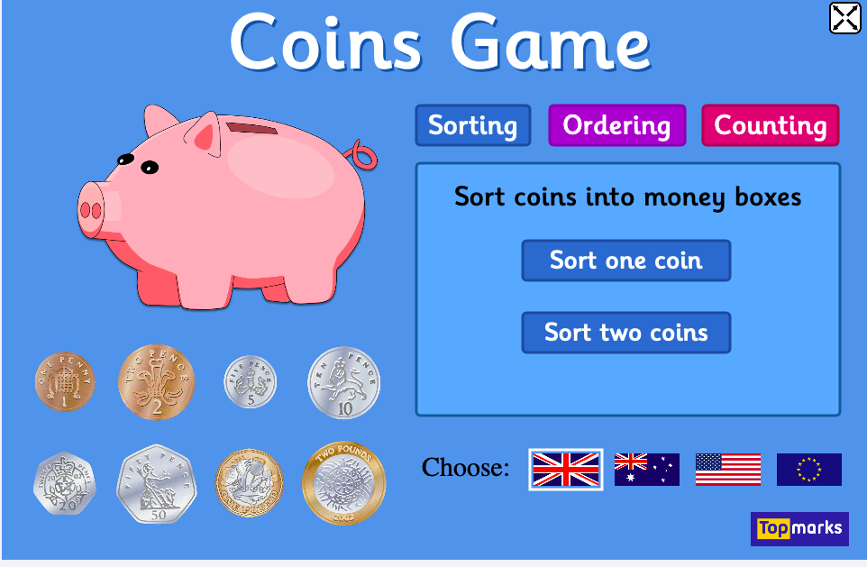

Use the counting game up to 10p Start with one coin then with two coins.
With your coins see if you can find one coin which equals these coins doubled together?
1p + 1p =. 2p + 2p =. 5p + 5p =.

10p + 10p =

Free flow – Food from the sea?

Use the internet or books to find out what kind of food we can eat from the sea. You might be surprised just what you can eat.

Draw a picture on the plate one of the things that we can eat that can be caught or found in the sea.

