Reception Home Learning
Week 5
Day 4

A big Hi from all your Early Years Teachers!

We are missing you all lots!
If you want to share any of the busy things you are doing at home with your Teachers, be sure to tag us on Twitter by using: @pinkclass18 and @devrainbow and @redclassdev

Thursday 7th May 2020
Reception Work to support your child at home PHONICS
Below are some examples of how you can support your child at home with their phonics knowledge.
Children learn best with daily practise and by repeating the learning.
Day 4 – Use the roll and read board to play a game and see how many words you can read and write.

6
6
Roll a dice and if you roll a number 1 read the first word and write it down. Keep on rolling the dice and reading and writing the words. If you roll a number 1 again read the next word and write it down. For example the first word if you roll a number 1 is too, you read it and write it. If you roll a number 1 again the next word is zoo then you read it and write that. You carry on until you have read and wrote all the words on the roll and read board. If you have not got a dice don’t worry, you can make some number cards with the numbers 1 to 6 on them. So each card has a number. Place the cards facing downwards and then pick a number card and read and write the word for the number you picked.

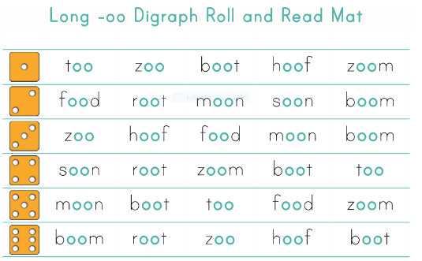

Boom root zoo hoof

too zoo
Can you say a sentence using the tricky word ‘so’ and some of the long oo words that you have wrote? Challenge yourself and try and write some sentences that you say for the oo words.
Alphablocks is a great website to support with phonics and with how to pronounce the sounds
https://www.bbc.co.uk/bitesize/topics/zvq9bdm/articles/z4tyt39
https://www.bbc.co.uk/cbeebies/shows/alphablocks
https://new.phonicsplay.co.uk/
You can log into phonics play for free using: Username: march20 Password: home

Thursday 7th May 2020
Work to support your child at home- LITERACY
Day 4- It’s Tricky Word Thursday!
- Use your pencil case tricky words to practise spelling and writing them correctly.
Adults- Below are the tricky words that your child has been taught so far in Reception
- Set 1 was taught first, then set 2 and now we are onto set 3 (set 3 is not in your pencil case yet).
- Please make sure your child is confident with spelling the tricky words (without you having to help them) in set 1 before moving onto set 2 and then you can move onto the set 3 words you will find below.
- Please make sure you focus on the tricky words that your child needs more practise with. With the words they need support with, show them the spelling and encourage them to write it. The more practise you do, your child will then no longer have to rely on you showing them the spelling, they will be able to spell it by themselves from memory

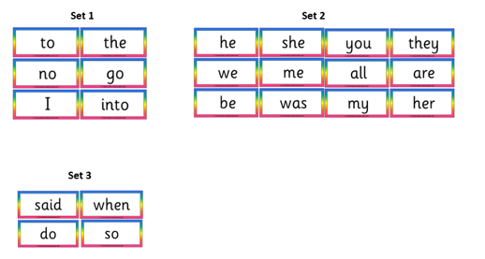

Thursday 7th May 2020
Reception Work to support your child at home MATHS
This week we have been learning all about simple 2D shapes. Using the shapes from Wednesday’s lesson, talk to your grown up about what you know about each shape. How many sides does it have? How many corners? Is the shape flat?

This game is all about using the shapes to order and sequence shapes. While you are doing this name the shape you will use to your grown up.

https://www.topmarks.co.uk/ordering-and-sequencing/shape-patterns
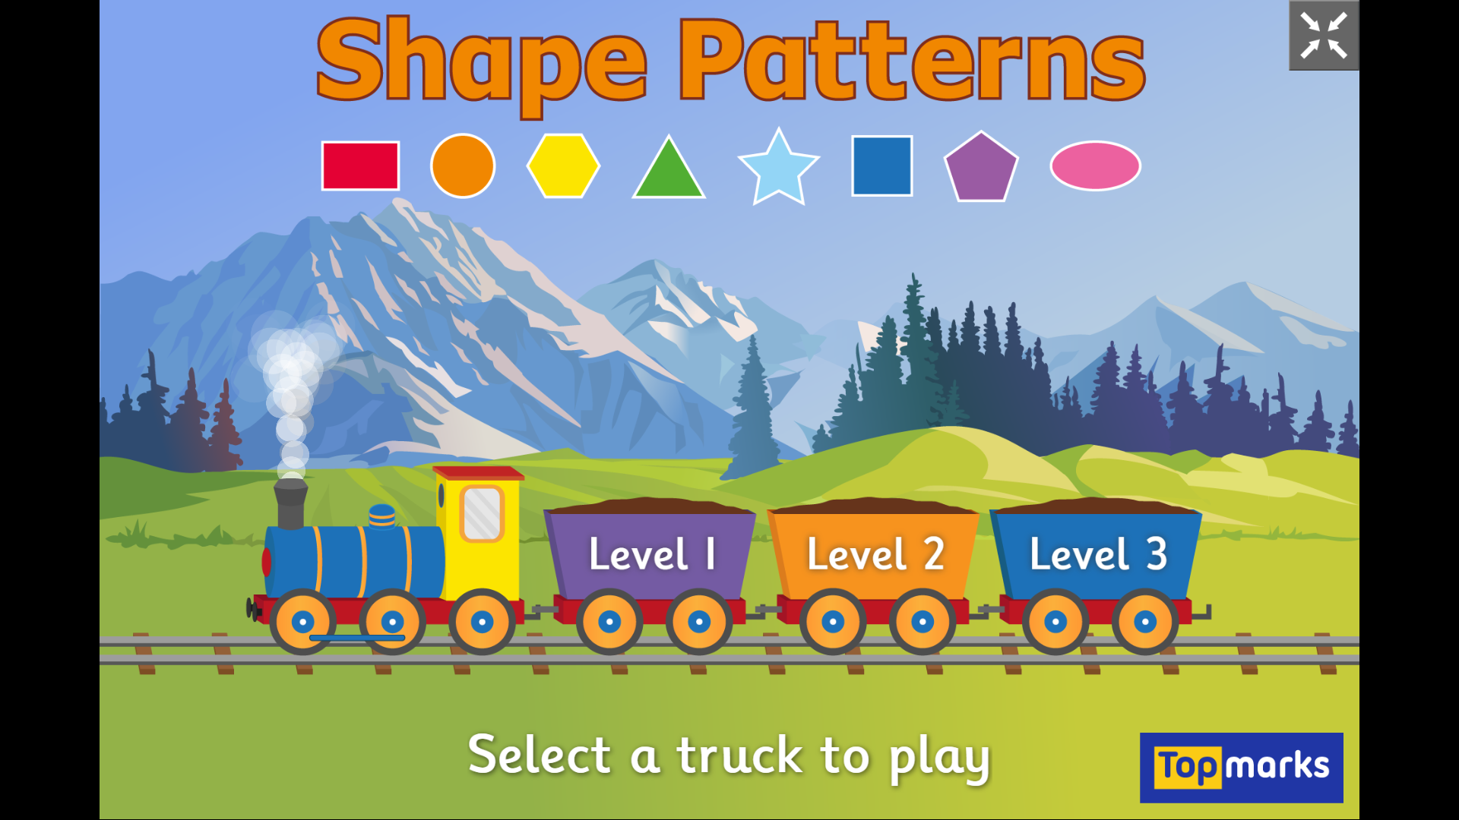

Free flow – What food do we grow in the United Kingdom?

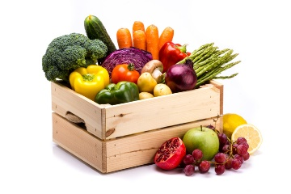
This is your 2 week free-flow challenge- do a little bit each day!

Think about the different fruit and vegetables we eat.
How much of these are we able to grow in the United Kingdom?
What is the difference between a fruit and a vegetable?
What vegetables and fruit grow on top of the ground and what fruit and vegetable grows underneath the ground?

Can you make a poster for your grown up on what food we grow in the United Kingdom. Group all the vegetables together and then all the fruit together on your poster. Add pictures and captions or your own sentences to give it a personal touch. Use the questions above to help you.

REMEMBER: This is a 2 week challenge so don’t rush it. Use what you have in your home and be as creative as you like. Enjoy!!

Extra free flow activities- Oliver’s Vegetables
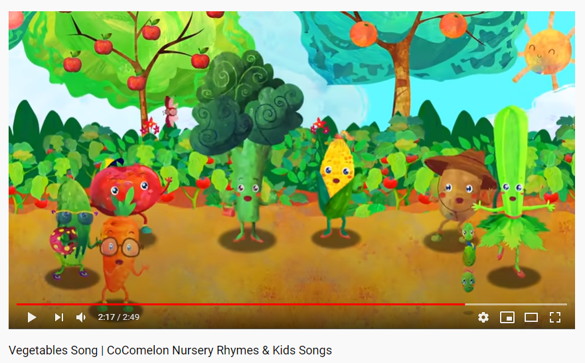
- Enjoy singing and dancing along to https://www.youtube.com/watch?v=BCBketJ6Ug8
- Keep a diary of how many vegetables you eat today.
- How many did you eat?
- What was your favourite? Why?
- What shapes and colours were your vegetables?
- Any vegetables you are learning about that you would like to try eating this week?

So far this week:
- Which day did you eat the most amount of vegetables (biggest number in your diary)
- Which day did you eat the least amount of vegetables (smallest number in your diary)
- Have you tried any new vegetables? Did you like them?

