Nursery Home Learning- Week Beginning 1/6/2020
Monday
Hello children and your grown-ups, we hope you are all well and staying safe at home. We are into our last half-term as nursery and there’s still lots of lovely learning to do! Below are your home learning challenges for today, including a very special mission for you to try. As always, Mrs Patton has put videos on Twitter to help with this week’s home learning so check out @devnursery for support, she also retweets what you wonderful children have been up to, so take a look and you might spot some of your friends. Have a great day!
Phonics
This week we are learning a new sound ‘m’. Check out Mrs Patton’s Twitter for tips on saying the ‘m’ sound and how this is different from ‘n’. As this is a new sound we need to get used to hearing and saying it lots. Below are some pictures, take some time to say what each picture is with your grown up, then mark the ones which begin with ‘m’.
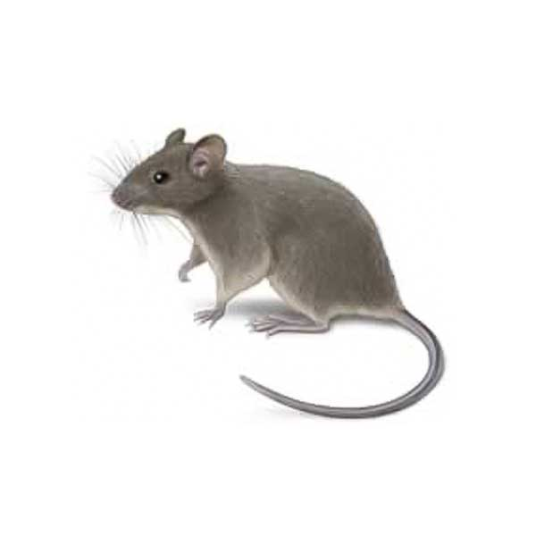
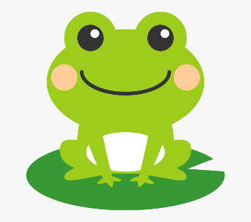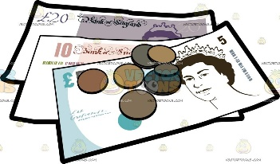

English
This week we are looking at the story of Augustus and His Smile, which you can find on YouTube, read by the author here https://www.youtube.com/watch?v=a-FBhbYtedU. In the story the lovely tiger Augustus starts off really sad, but then he remembers all the lovely things that make him happy and these make him smile. Today we would like you to think about the things that make you happy and find a way to represent them. You might draw a picture of 1 thing that makes you smile, or lots of things that make you smile, you might ask a grown up for help writing a list of the things that make you smile or you could really challenge yourself and try to write labels for your own drawings. Whatever you choose to do, we’d love to see it so ask a grown-up to put it on Twitter and tag @devnursery so your teachers and friends can see.
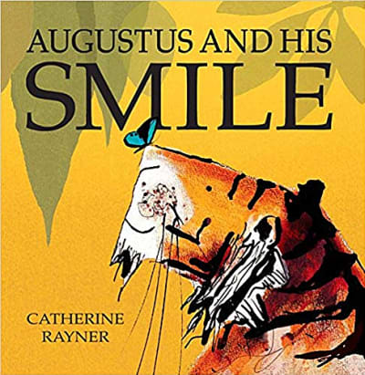

Maths
This week we are starting to work on number 6. Today we would like you to have a go at representing the number 6 without writing the numeral (we will be doing that tomorrow) So you might draw 6 dots, or draw 6 pictures, you might count out 6 toys, or crisps or even count 6 family members! However you choose to show the number 6, remember to carefully count the things out and stop at number 6.
Remember that there are lots of lovely number games you can play here: https://www.topmarks.co.uk/maths-games/3-5-years/counting which are great fun and will help with all our numbers now we are working up to 10.
You can also look at the Numberblocks 6 episode here: https://www.bbc.co.uk/iplayer/episode/b08pgksd/numberblocks-series-2-six to help you too. 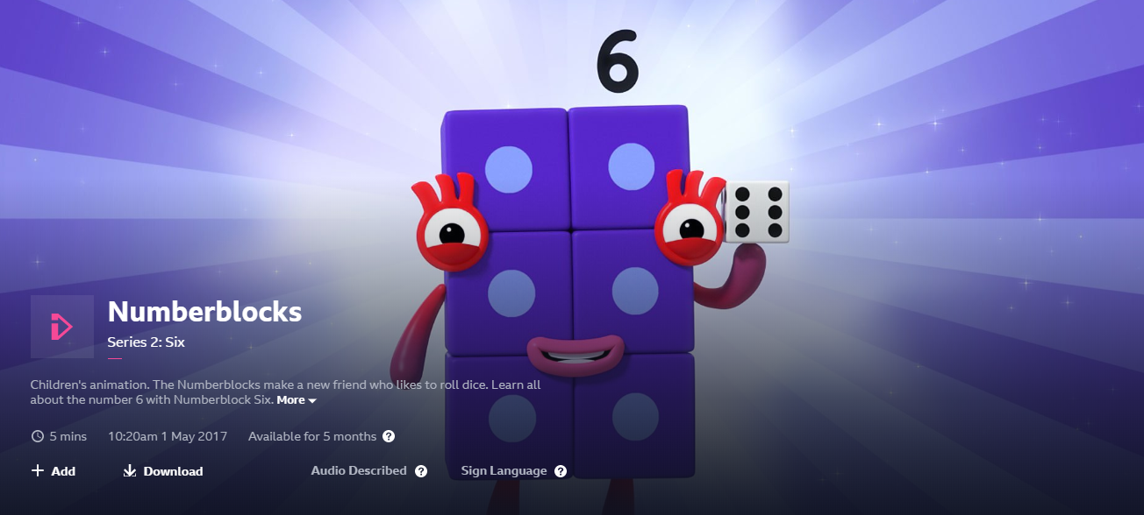

Special Mission
Augustus and His Smile is a book all about emotions, so we would like you to have a think about your emotions this week too. Let’s start by recognising what our emotions look like. This game can be played in front of a mirror or with a partner. Label about different feelings and then pull the face to match eg happy and show a big smile, sad and pull a frowny face etc. You and your partner should try to pull matching faces or you can look in the mirror to see how your face looks when you are feeling a certain way. Here are some different emotions to show:
happy sad angry tired surprised scared
nervous hungry excited calm

Have a go at pulling some faces and talking about the different emotions, then get your partner to pull a face and see if you can say how they are feeling.
