Nursery Home Learning- Week Beginning 8/6/2020
Friday
Hello children and your grown-ups, we hope you are all well and staying safe at home. Below are your Nursery home learning tasks for today, including a special mission at the end for you to have a go at, if you want to. Don’t forget to check Twitter for helpful tips and ideas @devnursery. Have another brilliant day!

Phonics

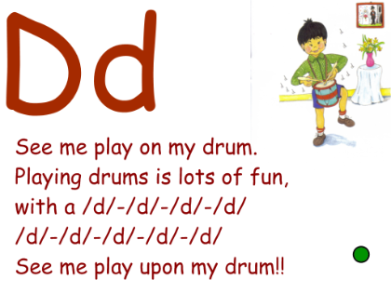
See if you can use the ‘d’ sound to make the tune of your favourite nursery rhyme, i.e. replace each word in the song/rhyme with the ‘d’ sound. See if anyone can guess the song/rhyme.

English
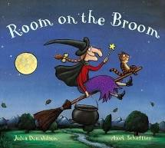
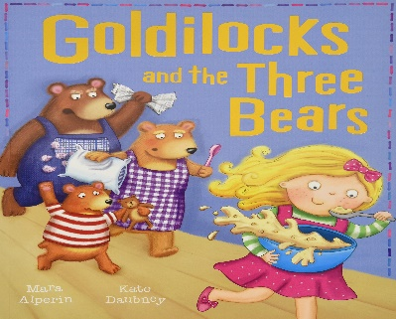
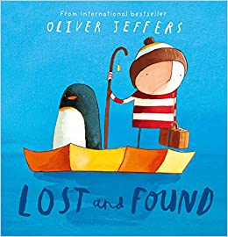
You will have noticed that there are many different emotions in this week’s book, Lost and Found. Think about the emotions felt by other characters in books, how did Goldilocks feel? What about the three bears, were they happy? Sad? Angry? Look at your favourite story and think about how many different emotions the main characters may feel throughout the story.

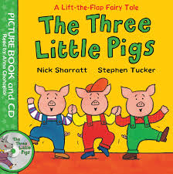
Maths
Cylinders make great telescopes or join 2 together to make your own binoculars. Don’t forget to have fun decorating them. What can you spot with your new telescope or binoculars?

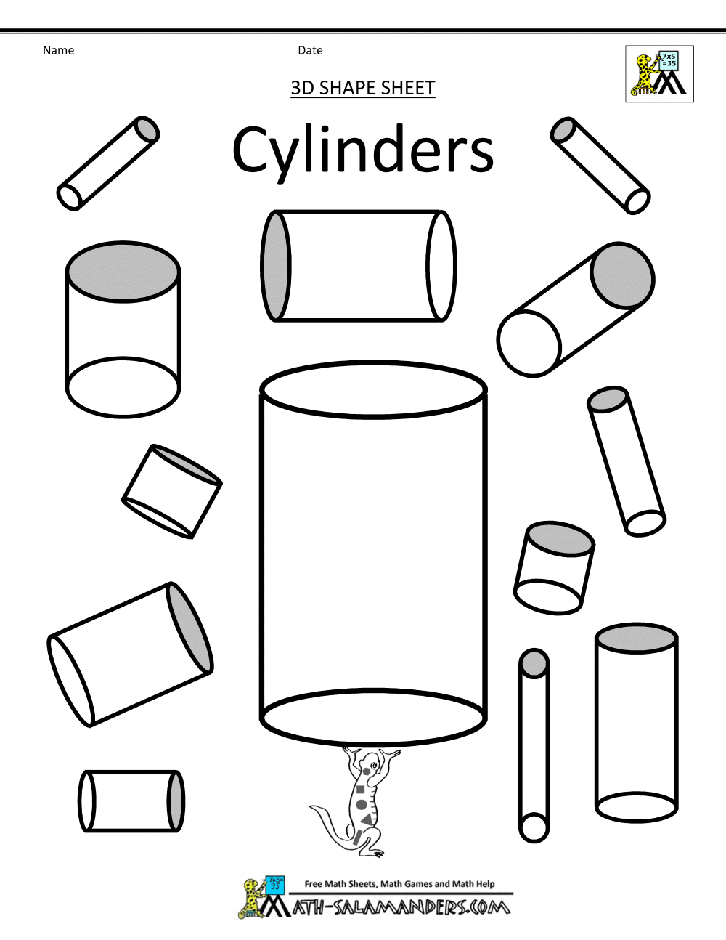

Special Mission
Some Friday fun activities.
Where is Wally?
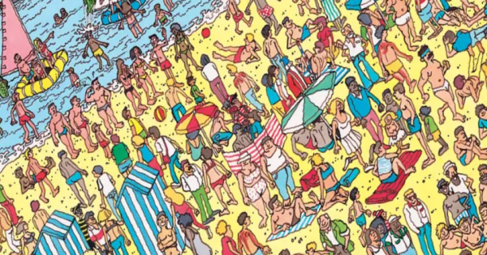

Find the object from the shape at the bottom.
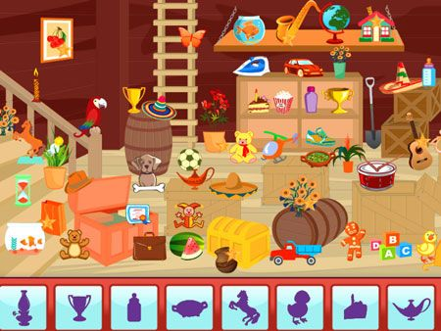

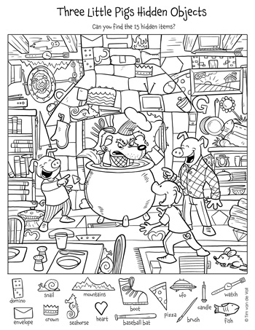

GOOD LUCK!!

