Nursery Home Learning- Week Beginning 13/7/2020

Wednesday

Hello children and your grown-ups, we hope you are all well and staying safe at home. Below are your Nursery home learning tasks for today, including a special mission at the end for you to have a go at, if you want to. Don’t forget to check Twitter for helpful tips and ideas @devnursery.

Phonics
Learning the days of the week is useful ready for Reception. You can use the song (see Mrs Patton on Twitter for the Makaton signs @devnursery) or you can use a weather report to help too.
The weather can change so much every day. One day it can be hot and sunny and the next it is windy and rainy. I would like you to have a look at the weather today, talk about it with your grown up. Is it a hot day or a cloudy day, a windy day or a rainy day? Talk about what the weather is like and what clothes you should wear for the weather today and why it is a good idea to wear it. Why not try and draw a picture of the weather each day and talk about it with your grown up. What is your favourite type of weather?
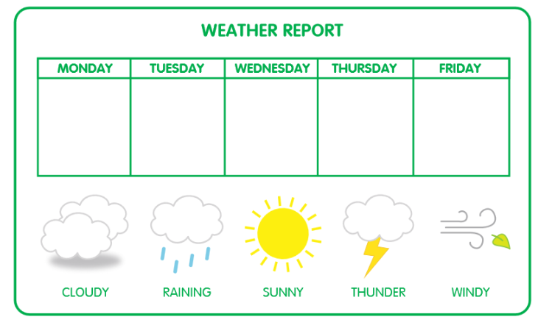

English
You are getting so good at writing your name and this will really help you in September when you go into Reception. I wonder how many letters there are in your name? Have a go at writing your name, count the letters in your name and circle that number. Have fun!
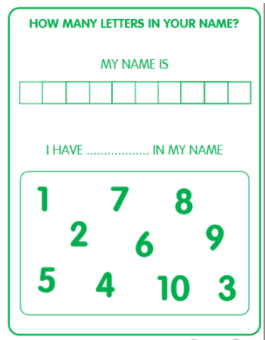

Maths
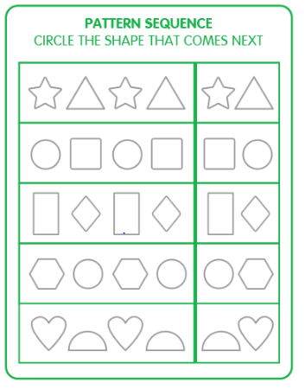
You have learned about lots of shapes this year and can now identify and name them. Have a look at the shape patterns below, can you circle the shape that will come next in each pattern? Have fun!

Special Mission
Creative Cardboard Creatures
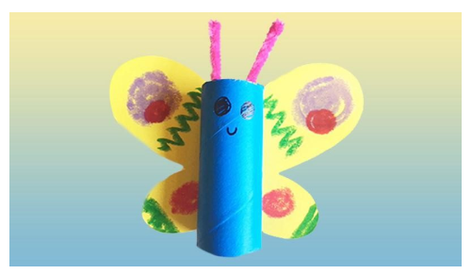

How to Make a Butterfly
You will need...
- Cardboard tube
- Coloured paper
- Pipe cleaner
- Scissors
- Crayons
- Paint
- Paintbrush
- A pen or pencil
- Glue

Instructions -
- Paint your cardboard tube blue and leave to dry
- Fold your yellow paper in half and draw a butterfly wing from the centre fold
- Cut the wing out and open up to make a set of wings
- Use crayons to decorate your wings however you choose
- Glue your cardboard tube to the middle of the wings to make a body
- Stick two pieces of pipe cleaner or card into the tube to make antennae and draw on two beady eyes and a smile.
- Gently press the butterfly wings at the back to make your flying little friend come to life
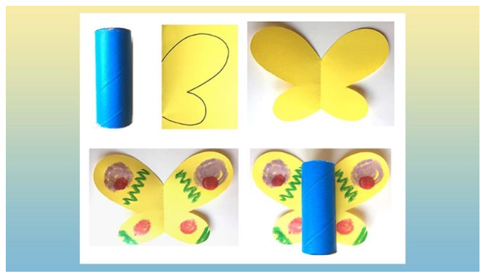

To make more cardboard creatures please take a look at the link below -

https://www.bbc.co.uk/cbeebies/makes/make-your-own-cardboard-tube-animal-with-evie

