Nursery Home Learning- Week Beginning 6/7/2020

Thursday

Happy Thursday children and your grown-ups, we hope you are all well and staying safe at home. Below are your Nursery home learning tasks for today, including a special mission at the end for you to have a go at, if you want to. Don’t forget to check Twitter for helpful tips and ideas @devnursery.

Phonics
We are focusing on the ‘k’ sound this week. Below you will find lots of things inside the ‘k’ sound. Can you colour in the objects that begin with the ‘k’ sound. Have fun!
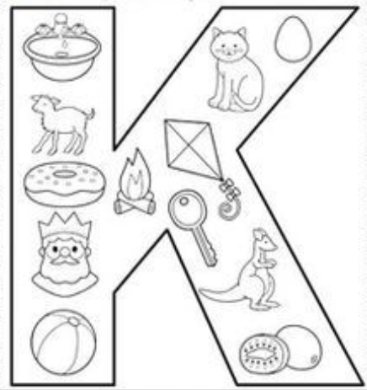

English
Our book this week is Spot Goes to School. You can watch it on YouTube https://www.youtube.com/watch?v=Y_CApWy7f6g or see Mrs Patton reading it on Twitter @devnursery.

There are lots of fun things that Spot got to do at school, can you remember 3 things that Spot did? Lots of us have been away from school for a long time, what are you looking forward to doing when you go to Reception? Talk to your grown up about some things that you ae looking forward to doing/trying in Reception. Sometimes it can be a little scary joining a new class and some of you will be going to a new school, is there anything that you may be worried about? Talk to your grown up about this, it’s okay to feel like that, everybody feels nervous sometimes. We know that you’re going to be amazing in your new class!

Spot did some painting when he was in school, why don’t you have a go at colouring him in.

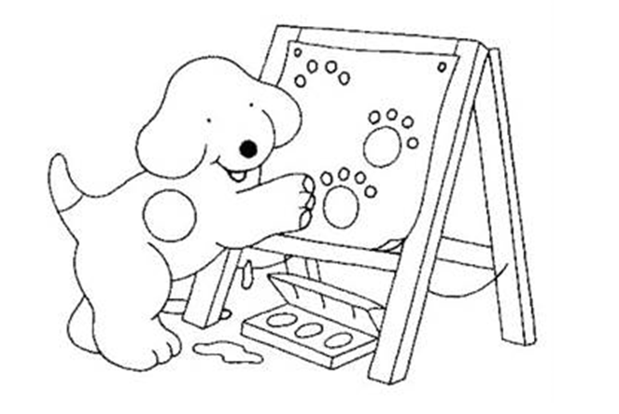

Maths

This week we are looking at numbers 1-10, you are fantastic at counting now so have fun following the instructions below.

Can you draw 3 circles? | How many fish?  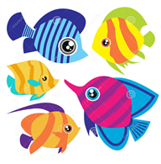 | How many dogs?  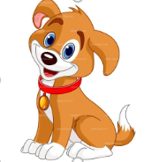
Can you draw 4 faces? | How many apples can you count?  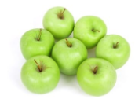 | Can you draw 6 squares?
How many hearts? | How many cups can you count?  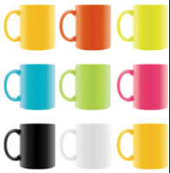 | Can you draw 10 circles?

Special mission

If you look out of your window into your garden or go for a walk in the park, you will be able to find lots of beautiful wildlife. This time of year there are lots of different types of birds if you look for them. I wonder if you could have a go at making your very own bird feeder. The full instructions are on the link below. Grown-ups this is your chance to get stuck in to and you will love the beautiful wildlife that you will be able to attract from these simple feeders. ENJOY!

https://www.bbc.co.uk/cbeebies/makes/bird-feeder

