Nursery Home Learning- Week Beginning 1/6/2020
Friday
Hello children and your grown-ups, Happy Friday! Below are your home learning challenges for today, including a special mission for you to try over the weekend. As always, Mrs Patton has put videos on Twitter to help with this week’s home learning so check out @devnursery for support, she also retweets what you wonderful children have been up to, so take a look and you might spot some of your friends. Have another great day!
Phonics
This week we have been learning our new sound ‘m’.
For today’s activity we would like you to try and make something beginning with ‘m’. You could make a mouse, a monkey, a mountain. Whatever you choose and however you choose to make it is up to you.
There are lots of simple ideas to start you off here: https://www.themeasuredmom.com/letter-m-crafts-preschoolers/ we especially liked the different monsters! Have a go and see what you can create, just remember to focus on the letter ‘m’.

English
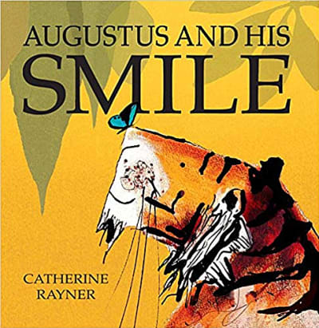
Today we are finishing off looking at the story of Augustus and His Smile, which you can find on YouTube, read by the author here https://www.youtube.com/watch?v=a-FBhbYtedU or you can see Mrs Patton reading it on Twitter @devnursery.
In the story Augustus realises he is happy at lots of different times, so today we would like you to think of the end of the sentence
I am happy when….
Take a moment to think about when you are happy and come up with the end of your sentence, then get a grown up to help you to record it. You could do this on a phone or tablet and record your voice, you could write it down using the sounds you know or draw a picture and write a caption for it.

Maths
Today we would like to introduce you to a new shape-
A sphere

A sphere is a 3D shape, which means it is solid and you can hold it. It has 1 curved face all around. Balls are spheres but there are other things which are spheres too, see how many different spheres you can find in your house and your garden.
Here is a nice rhyme to help you learn about spheres:
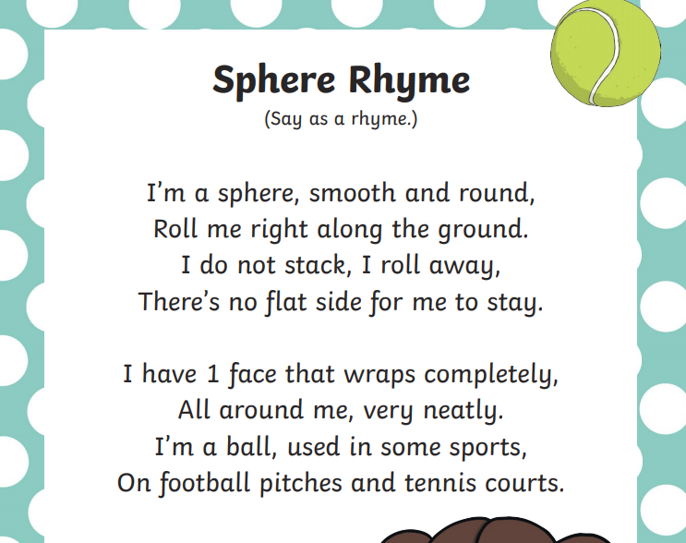

As we are thinking about shapes today, there is a simple game for recapping our 2D (flat) shapes here: https://www.topmarks.co.uk/early-years/shape-monsters
Grown ups, there is a really useful video here: https://www.youtube.com/watch?v=A42KBXGSAUM which helps to explain the difference between 2D and 3D shapes and introduces the basic 3D shapes which we will be looking at this half term.

Special Mission
This weekend’s special mission is linked to our shape, the sphere. We would like you to practice using a ball in different ways.
Can you roll a ball?
Can you kick a ball?
Can you throw a ball?
Can you catch a ball?
Have a go at all these different things and why not make them into a game to play too. Make sure you play safely and aren’t at risk of breaking anything! Mrs Patton has done a video for this week demonstrating these different skills so check it out @devnursery. Have a great weekend!

