Nursery Home Learning- Week Beginning 1/6/2020
Thursday
Hello children and your grown-ups, we hope you are all well and staying safe at home. Below are your home learning challenges for today, including a special mission for you to try. As always, Mrs Patton has put videos on Twitter to help with this week’s home learning so check out @devnursery for support, she also retweets what you wonderful children have been up to, so take a look and you might spot some of your friends. Have another great day!
Phonics
This week we are learning our new sound ‘m’.
For today’s activity you will need some bits of paper (around 10) and a pen and a ball or something else you can throw safely, like a beanbag. What you need to do is get a grown up to write the letter m on some of the bits of paper and some other letters on the other pieces, 1 letter on each sheet (you might like to use the letters s a t p i n that we already know) and spread them around in front of you or stick them up to a wall.
Children then you have to take your ball or throwing toy and try to hit the letters, sounding whichever letter you hit. Remember to try and only hit the ‘m’ papers but say the other sounds if you hit them too! Have fun practicing your throwing and your sounds, you could even make it a game and take turns.
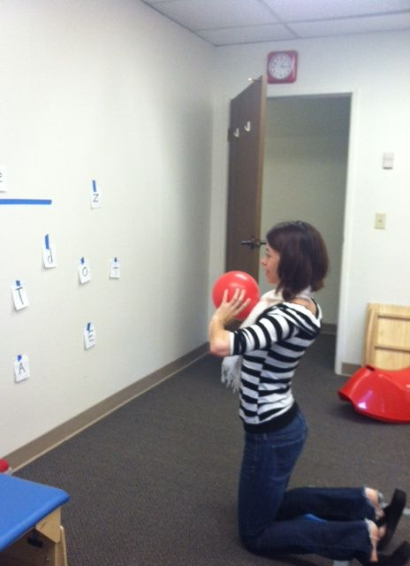

English
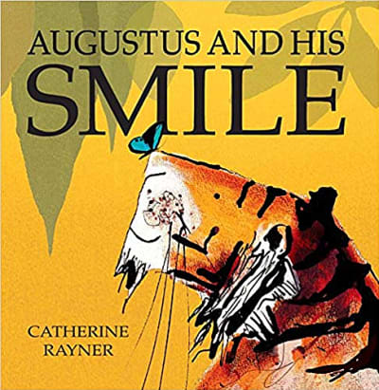
This week we are looking at the story of Augustus and His Smile, which you can find on YouTube, read by the author here https://www.youtube.com/watch?v=a-FBhbYtedU or you can see Mrs Patton reading it on Twitter @devnursery.
In Mrs Patton’s video, she makes sounds to match to the story, which is what we would like you to try and do today. Using your lovely story maps to help you, see if you can make sounds with your mouth or your body to match to the different parts of the story. Then you can practice saying the story aloud and using your sounds to add to your story. For a real challenge you could add some of that lovely alliteration from yesterday to your story telling too. Make your story nice and noisy and keep practicing until you know it without needing the story map, then you’ll have another story stuck in your head that you can keep forever!

Maths
This week we are working on number 6. A great way to practice numbers up to 6 is by using a die, as they have 6 sides. Take a die and roll it, then count how many you have rolled. You could use this to then play a board game or to count out a number of actions to do (jumps, twirls etc). After a while, children should recognise the number of spots without having to count them. This is a very important skill, ready for when children start solving number problems. So crack out a die (or use the template below to make one, if you don’t have one already) and get playing.
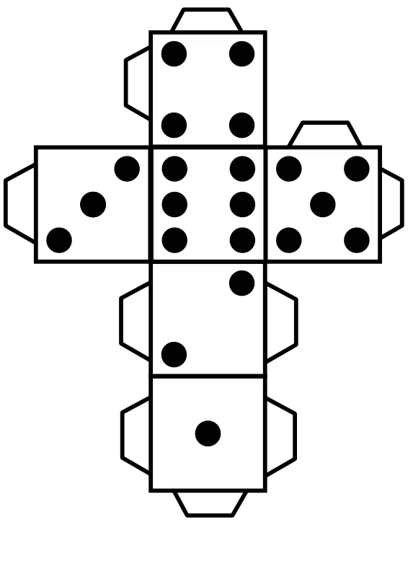

Remember that there are lots of lovely number games you can play here: https://www.topmarks.co.uk/maths-games/3-5-years/counting which are great fun and will help with all our numbers now we are working up to 10.

You can also look at the Numberblocks 6 episode here: https://www.bbc.co.uk/iplayer/episode/b08pgksd/numberblocks-series-2-six to help you too.

Special Mission
Today we would like you to have a go at making a mask with a smile! You might like to make a tiger mask, like Augustus in the story, or you could make an ‘m’ creature, like our sound for the week, it’s up to you, just make sure to give your mask a great big smile!
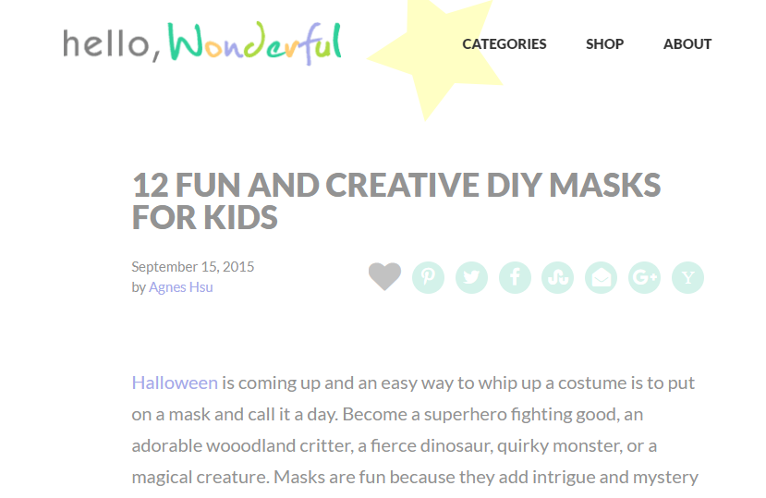
There are lots of different ways you can make a mask here: https://www.hellowonderful.co/post/12-fun-and-creative-diy-masks-for-kids/

Have fun and don’t forget to share your creations on Twitter @devnursery, we really do love to see what you have been up to!

