Nursery Home Learning- Week Beginning 22/6/2020
Tuesday
Hello children and your grown-ups, we hope you are all well and staying safe at home. Below are your Nursery home learning tasks for today, including a special mission at the end for you to have a go at, if you want to. It’s great to see that some of you have been sharing your work on Twitter so if you’d like to share any examples of your work for your teachers or friends to see you can do this on Twitter by tagging @devnursery. Have another great day!

Phonics
We are learning the new letter ‘o’ this week. Remembering the handwriting jingles; can you hold your finger in the air and go round and round like stirring the pot. Have a go and do big and small movements with your arms, get your grown ups to join in.
What words can you think of that begin with the letter ‘o’? To help you get started I have put some pictures for you to match with the correct words. Say them aloud and then think, do they begin with an ‘o’?
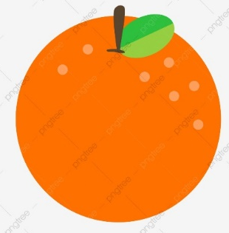 | Pencil
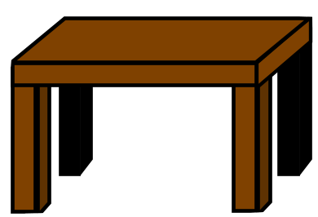 | Octopus
 | Table
 | Orange
With your adult see how many more words that beginning with the letter ‘o’. Put on your thinking hats and have fun!

English
This week the book that we are looking at is called Tell Me Something Happy Before I Go To Sleep. Please watch the story being read on Youtube with your child or you can see Mrs Patton reading it on Twitter @devnursery.
https://youtu.be/uvON7-mazJs

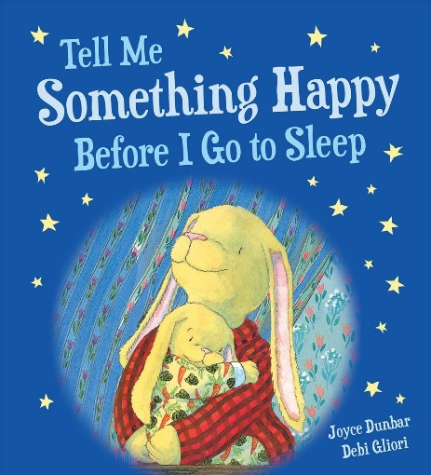

Did you like the story? Willa needed help from her big brother to think of happy thoughts before going to bed. Can you think of 5 things that make you happy before you go to bed? Write them down or draw a picture.

1

2

3

4

5

Maths
We are learning the number 9 this week. Can you practise writing and counting the number. It may help you to use something to count the numbers up to 9 like beads, blocks or toys.

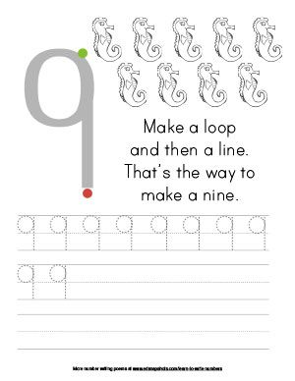

Special Mission
Your special mission for this week is to cut the images out down below and put them in order for your own bed time routine. (you don’t have use all the pictures and you can draw you own picture if it is not listed below).

