Reception Home Learning
Week 14
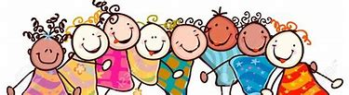
Day 1

A big well done from all your Early Years Teachers!
We really are very proud of you for how hard you are working at home. A big thank you to your grown-ups too!
Keep up the good work

Remember, if you want to share any of the busy things you are doing at home with your Teachers, be sure to tag us on Twitter by using: @pinkclass18 and @devrainbow and @redclassdev

Monday 6th July 2020
Reception Work to support your child at home PHONICS
Below are some examples of how you can support your child at home with their phonics knowledge.
Children learn best with daily practise and by repeating the learning.
This week we are going to practise sounds we have learnt and try and write some words using the sounds we know! Each day there will be a set of sound for you to practise saying, writing words and reading.
Set 1 and set 2 sounds: S, a, t, p, i, n, m, d
Say each sound in the words to help you read them.
Challenge - can you say each word in a sentence?
An even bigger challenge, can you write a sentence using each of the words you read?
s, a, t, p | at, a, sat, pat, tap, sap, as
i | it, is, sit, sat, pit, tip, pip, sip
n | an, in, nip, pan, pin, tin, tan, nap
m | am, man, mam, mat, map, Pam, Tim, Sam
d | dad, and, sad, dim, dip, din, did, Sid

You need to practise these tricky words every day so that you can read and write them:-
the, to, I, go, no, he, she, we, me, be
Alphablocks is a great website to support with phonics and with how to pronounce the sounds https://www.bbc.co.uk/cbeebies/shows/alphablocks
https://new.phonicsplay.co.uk/
You can log into phonics play for free using: Username: march20 Password: home

Monday 6th July 2020
Work to support your child at home- LITERACY
This week we are going to practise our handwriting! Each day there will be a set of letters for you to practise writing.
- On the next page you will find some letters from the ‘curl family’. Use the red dot and arrow to remind yourself where to start forming the letter. If you cannot print off the pages, do not worry- ask your adult to draw lines in your book or a piece of paper and practise forming your letters there- remember to sit your letters on the line and keep practising the letters you find challenging!

The C curl family The C curl
c | Start at the top – but not too high up!  Curl round to sit on the line
o | Make a C curl  And curl to join it up
a | Make a C curl  Back up to the start  Down to the line and flick
d | Make a C curl  Straight up to the top  Back down to the line and flick
g | Make a C curl  Back up to the start  All the way down to a long curly tail
q | Make a C curl  Back the start  All the way down to a long straight tail and flick
s | Make a squashed C curl  Curl back again to sit on the line
e | start with a line  curl it round into a C curl

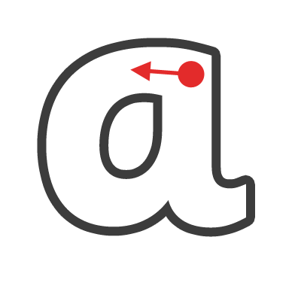
Curly loop letters

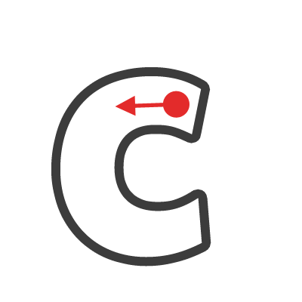

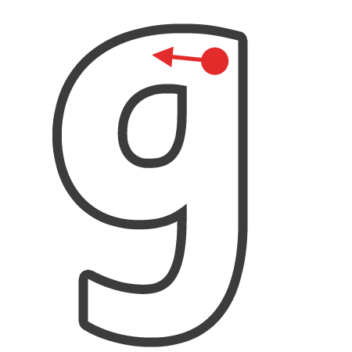

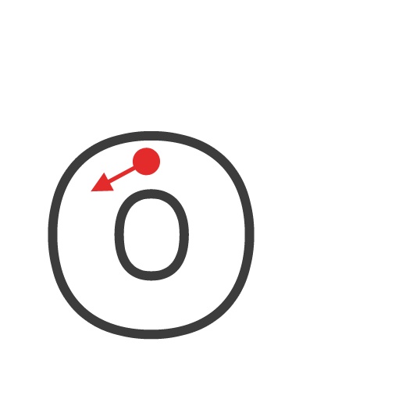

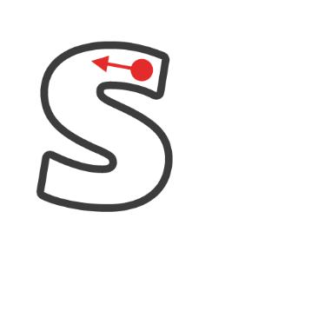
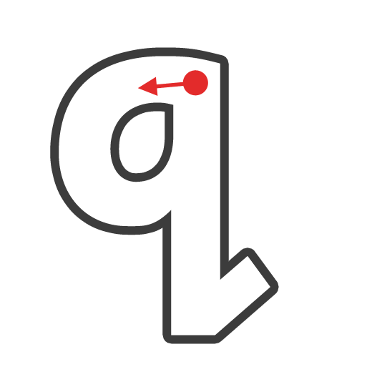

Monday 6th July 2020
Reception Work to support your child at home MATHS- addition
This week we are going back to look at addition +. Your child has been working on this strategy throughout their time in Reception. Now we are using them to start problem solving.
https://www.youtube.com/watch?v=uQmOuL64D_E
Please watch with your grown up. This is the story of Mr Gumpy’s Outing.

First today you must build a boat to create your own First, then and now story. You can make it out of any recycled material you can find.
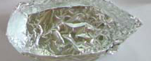 You could make it out of foil like this one.

Create your very own first, then and now stories as different groups of characters climb aboard. Count your character at each stage of the journey.
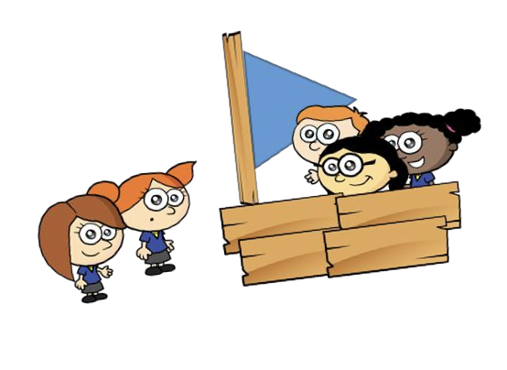
First there were 3 children in the boat, then another 2 joined them. Now there were five children in the boat. Now try writing the number sentence for the story.
3 + 2 = 5
Try again with a different amount of characters

FREE FLOW -ACTIVITES PSED Monday 6th July 2020

INSIDE OUT

This is the start of a new week and we will be focussing on our emotions. Emotions are how we feel, it’s all about having different feelings.
Click on the link below and see if you guess the different types of emotions.

https://www.youtube.com/watch?v=dOkyKyVFnSs

Have you felt some of these emotions?

Draw a picture to show one of these emotions that you have had.

Remember it is okay to feel different emotions when things happen, sometimes they can make you happy and sometimes they can make you sad.

Think of time you felt a happy emotion.

Think of a time you felt a sad emotion.

What emotion are you feeling right now?

