Reception Home Learning
Week 15
Day 5

A big well done from all your Early Years Teachers!
We’ve made it to the last week of home learning! Thank you to you and your grown-ups for working so hard at home and for making the time we did have together in Reception so much fun.
We hope you have a great Summer Holiday
From your Reception Teachers
x
We thought this song summed up the message Reception staff want to send to all the children we’ve had this year in Reception click the link below to listen
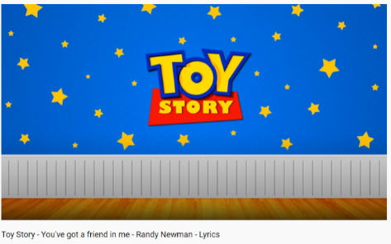
https://www.youtube.com/watch?v=Zy4uiiy0qgA

Friday 17th July 2020
Reception Work to support your child at home PHONICS
Below are some examples of how you can support your child at home with their phonics knowledge.
Children learn best with daily practise and by repeating the learning.
Can you say these sounds and then read the words in the table below: igh, oa, oo, ar, or, ur, ow, oi
night | boat | book | car | fork
cow | dark | boil | brown | fright
cook | fur | light | moat | star
cork | moon | turn | start | burn
goat | coil | far | roof | toad
coin | might | spoon | fight | frown
bark | now | coat | soil | took
How many words can you write without looking at them?
Can you say some sentences using some of the words in the table?
This is our last phonic sounds practise for the term but don’t forget to continue to practise over the summer to help you remember!
Friday 17th July 2020
Work to support your child at home- LITERACY
Day 5- Practise spelling the tricky words you find most challenging
Reminder: Adults- Below are the tricky words that your child has been taught so far in Reception
- Set 1 was taught first, then set 2 and now we are onto set 3 (set 3 is not in your pencil case yet).
- Please make sure your child is confident with spelling the tricky words (without you having to help them) in set 1 before moving onto set 2 and then you can move onto the set 3 words you will find below.
- Please make sure you focus on the tricky words that your child needs more practise with. With the words they need support with, show them the spelling and encourage them to write it. The more practise you do, your child will then no longer have to rely on you showing them the spelling, they will be able to spell it by themselves from memory

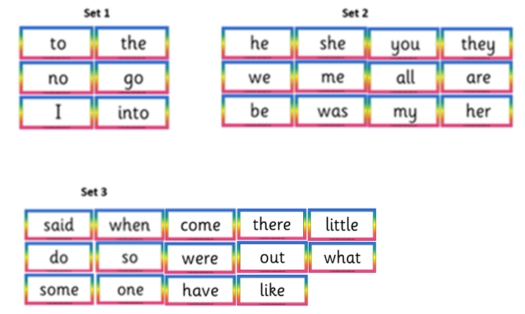

This is our last tricky word practise for the term but don’t forget to continue to practise over the summer to help you remember!

Friday 17th July 2020
Reception Work to support your child at home MATHS
Day 5 –
Today we are going to practise your number formation.
Look Say Cover Write Numbers 0 - 20

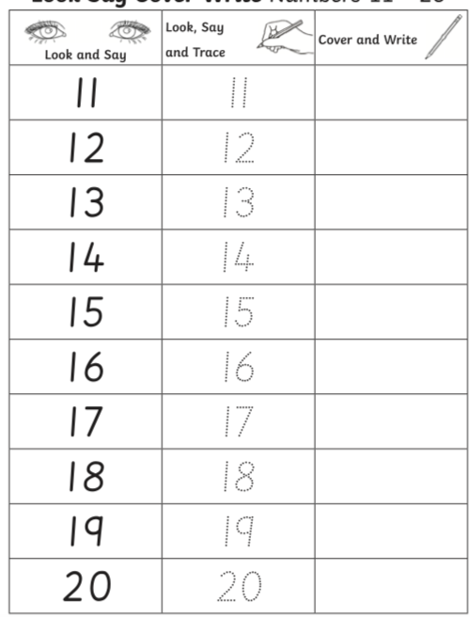

FREE FLOW ACTIVITIES. 17^{7H}/7/2020
PSED
Shall we end the week with a feel-good song that we sing together in school ‘Sunshine in my heart’
After you have enjoyed singing the song think of something that makes you happy and have ago at drawing it.

https://www.youtube.com/watch?v=-e8QOHmilSU
Out on the street there is sunshine,
When two friends meet there is sunshine,
When life is sweet there is sunshine,
Sunshine in my heart. (Repeat)
Sunshine, sunshine, sunshine in my heart.
Sunshine, sunshine, sunshine in my heart.
Doot doo doo doo doot, doot doo doo.
Doot doo doo doo doot doot.
Doot doo doo doo doot, doot doo doo.
Doot doo doo doo doot doot.

Out on the street there is sunshine,
When two friends meet there is sunshine,
When life is sweet there is sunshine,
Sunshine in my heart.
Sunshine, sunshine, sunshine in my heart.
Sunshine, sunshine, sunshine in my heart.
Out on the street there is sunshine,
When two friends meet there is sunshine,
When life is sweet there is sunshine,
Sunshine in my heart.
Sunshine in my heart.
Sunshine in my heart.

