Reception Home Learning
Week 13
Day 5

A big well done from all your Early Years Teachers!
We really are very proud of you for how hard you are working at home. A big thank you to your grown-ups too!
Keep up the good work

Remember, if you want to share any of the busy things you are doing at home with your Teachers, be sure to tag us on Twitter by using: @PinkClass18 and @devrainbow and @redclassdev

Friday 3rd July 2020
Reception Work to support your child at home PHONICS
Read this story with your grown up then answer the que
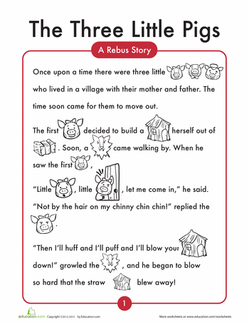

Comprehension questions
Listen to the question then tell your grown up your answer.

- How many little pigs were there?

- Where did they live?

- Who did they live with?

- What did the first little pig use to build a house?

- Who came walking by?

- What did the wolf do?
Friday 3rd July 2020
Work to support your child at home- LITERACY
Day 5-
Enjoy watching this alphablocks episode to remind yourself of the sounds ‘oi’, ‘or’ and ‘ur’
- Can you write some sentences about the words that they make?
For example:

I got some popcorn from the shop.

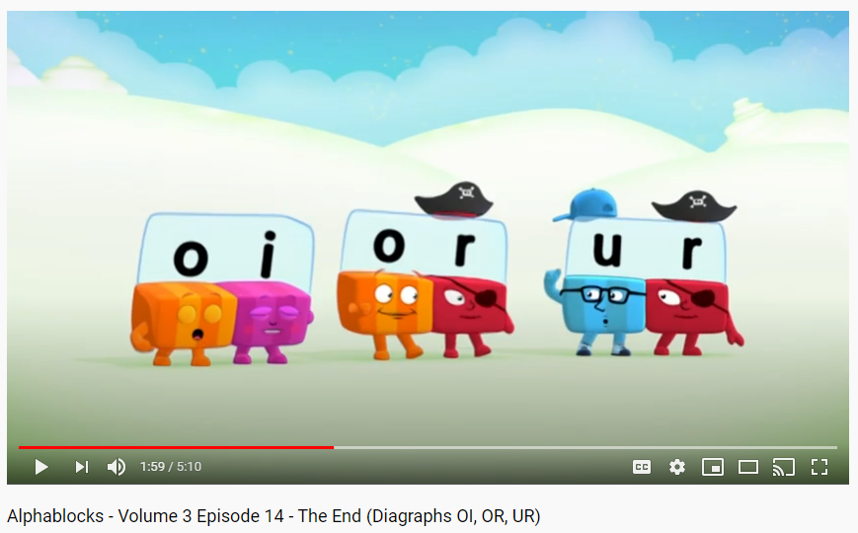
https://www.youtube.com/watch?v=9f4KYUD0LMk

Friday 3rd July 2020
Reception Work to support your child at home MATHS
Day 5 – Geometry – exploring Patterns.
Watch with your grown up
https://www.youtube.com/watch?v=hisZ9PLKWbM&list=PLXMWgHsuBe8PxogibVfs3VdsCdw7MjMMo&index=10&t=0s&app=desktop
Which pattern fits?
Use the frames below. Build a pattern around the edge putting one letter in each space. Using these patterns investigate which will fit around the frame exactly and which won’t. Write the letters on a different piece of paper and then cut them up so that you can place them onto the frame.
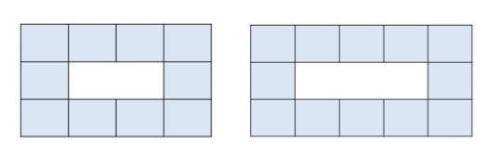
Are there any patterns which fit exactly around both frames?
How many more spaces did you need for a pattern that wouldn’t fit?
Can you test some of your own patterns in the frames?
Which of your patterns fitted exactly and which didn’t fit?

B
Aç

Test your new knowledge out on these Education City Games.
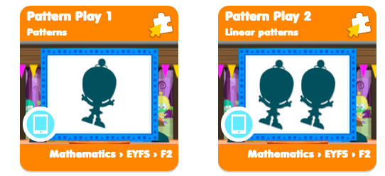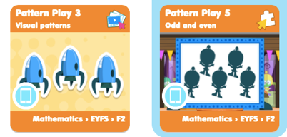
FREE-FLOW ACTIVITES Thursday 2nd July 2020

TRANSPORT

Lets get creative and paint the car using the same colours as the car below.
