Reception Home Learning
Week 4
Day 2

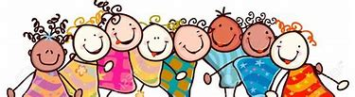

A big Hi from all your Early Years Teachers!
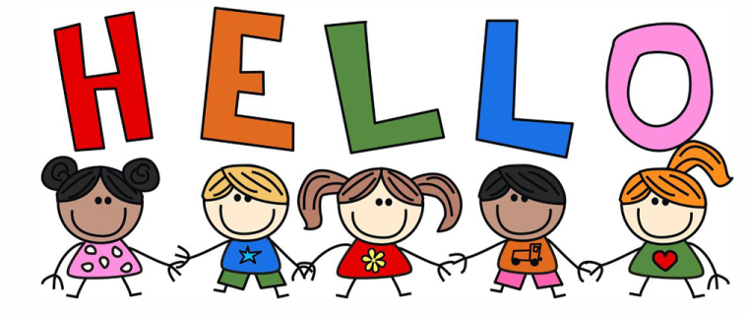

We all hope that you are working hard and enjoying spending time at home.

Tuesday 28th April 2020
Reception Work to support your child at home PHONICS
Below are some examples of how you can support your child at home with their phonics knowledge.
Children learn best with daily practise and by repeating the learning.
Day 2 – Practise the sounds oa again and practise igh and ee.
Practise making words with these sounds in using your sound cards from your pencil case.
c | oa | t
g | oa | t
f | l | oa | t

t | oa | s | t

Can you write the correct sounds oa, igh, or ee to complete the words. You can use the pictures to help you.
t | r
b |  | t

r |  | d

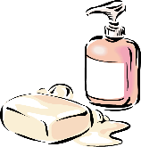
s |  | p
n |  | t

What does each word mean? Do you notice any patterns? (oa sound comes at the beginning or in the middle of the word, never at the end). Remember we don’t use the capital letter O if we hear it in the middle of the word.
Alphablocks is a great website to support with phonics and with how to pronounce the sounds
https://www.bbc.co.uk/cbeebies/shows/alphablocks
https://new.phonicsplay.co.uk/

Tuesday 28th April 2020
Work to support your child at home: LITERACY
This week we are going to continue to focus on the story ‘Mr Gumpy’s Outing’. Remember, you can find this story by typing into youtube: Mr Gumpy’s Outing or following this link: https://www.youtube.com/watch?v=Mi_DV_DWN8M
- Yesterday, you thought of your own ideas to create new sentences to change the ‘Mr Gumpy’s Outing’ story.
Day 2-
Please draw some lines in your child’s writing book and encourage them to sit their writing on the line
Today’s writing task:
- Can you write your new sentences?

Remember when writing:

- Use your actions to help you know what word comes next. Use your sounds to spell the words. Remember: form letters correctly, capital letters, finger spaces and full stops.

- Adults please remember to let the children use their own phonics knowledge, please do not spell the words for them. Your role is to remind them about capital letters, to say their words slowly to hear each sound they need to write, finger spaces and full stops. You can support children with spelling the tricky words correctly if they need support

EXAMPLE SENTENCE:

One sunny day the man went out on his scooter. He let the cat and the dog come with him.

- The words in green are tricky words and children are expected to spell these correctly. The tricky words ‘one’, ‘out’ and ‘come’, we would expect children to need extra support with spelling at this point.

Tuesday 28th April 2020
Reception Work to support your child at home MATHS -halving
Day 2 -Using you part, part whole. and 4 small objects (if you can’t find small objects use screwed up paper balls) place them in the larger circle. Say “I am going to share them into 2 equal groups, half on one circle and half on the other.”
Only when there is the same amount on each smaller circle can you say the amount has been halved.
Explain this is called halving. Halving is putting an amount of objects into 2 equal groups with nothing left.

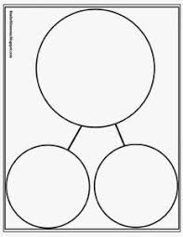

Repeat with 2, 6, 8 and 10 objects. Make sure each time your child understands that the same amount needs to be in each smaller circle.

Free flow – Over the Hills and Faraway
Yesterday you drew a picture of yourself and your family on the beach. Today you are going to draw all the things you would pack in a suitcase for a summer beach holiday. Talk to your grown up about what types of things you would need to take.
Below is an empty suite case. Draw a picture of all the things you would take for your beach holiday.

