**Class texts*-*** *whole class reading, extracts, thematic books*

Avocado Baby

Oliver’s Vegetables

Huge Bag of Worries

How Full is Your Bucket?

Have You Filled Your Bucket Today?

Hugo Makes a Change

In the Woods

***Challenge Pack***

***Change for Life***

**Public Outcome –** *How will this demonstrate learning?*

*The Children will come up with ideas for a nonfiction film about healthy living.*

*It will be shared with the wider community through a film premiere.*

**Thinking and learning skills and tools –***We use Building Learning Power and some thinking organisers (like mindmaps) to help us be good learners. We learn how to work independently and not give up even when we face a challenge.*



**Hooks or memorable experiences**

A film maker will visit school and take residence for two weeks.

***Learning Challenge***

Can we produce a film about healthy living?

So that we can share it with our families and friends

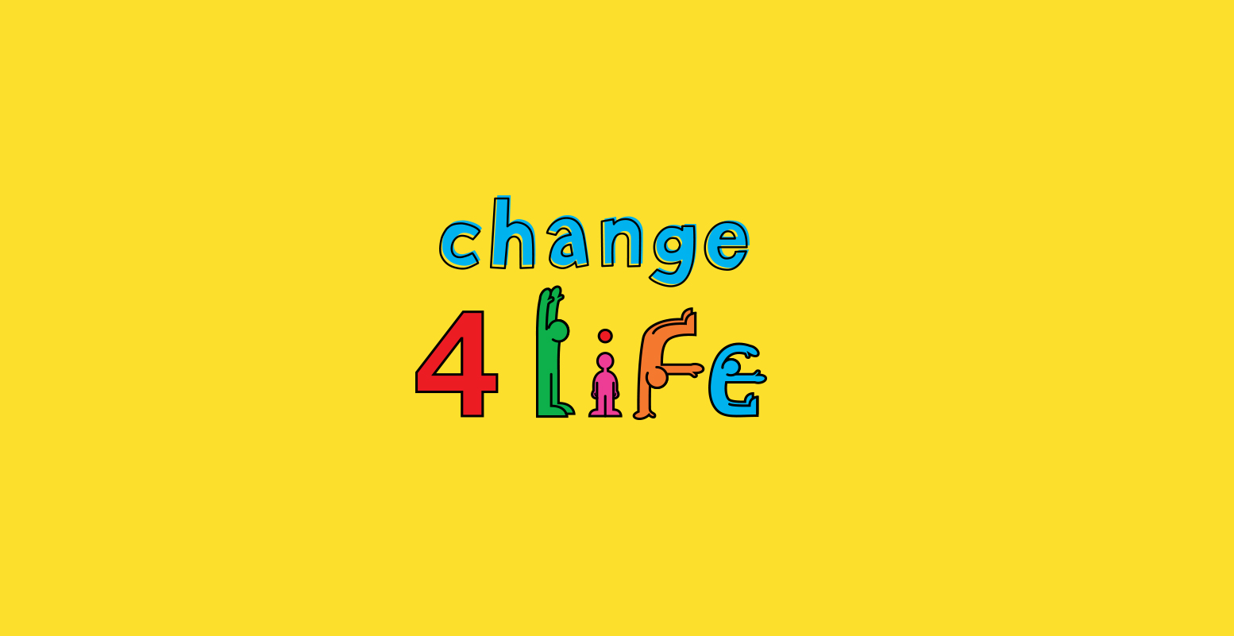

**Concept Questions*-***

Should we always avoid fat in our diets?

Do we have to exercise in a gym to stay healthy?

If fruits and vegetables are so good for us, should we eat only them? What would happen?   
What do you think makes a healthy lifestyle? Why?

Why do you think a Gurdwara has a kitchen?

**Key** **Questions** *those asked to measure understanding of pupils at key milestone points during the term*

Can you describe a healthy balanced meal?

Where does our food come from?

How do you know when you have exercised your body?

How could I manage my own feelings if I was starting to lose control?

If I exercise, do I still have to diet?

What foods would be affected if we suddenly ran out of milk or flour?

How do we know which foods are healthy?

|  |  |  |  |  |  |  |
| --- | --- | --- | --- | --- | --- | --- |
| **Year Group** | **2** | **Term** | **Summer 1 and 2** | Challenge pack | Change for life | |
| **SUBJECT FOCUS** | | **Declarative knowledge**  Children will learn about… | | **Procedural knowledge**  Children will know HOW To…? | Prior learning **(Schemata)** | Vocabulary |
| History | | **Change makers- Famous people in history who made a difference to how people live.**  **How do we know what happened in the past? What sources can we use? What does living memory and beyond living memory mean? Which of our famous people are within living memory and beyond living memory? What was happening in the world when our famous person was alive? How did life change because of the work these people did locally, in our country, in our world?**  **Explorers**  **What is an astronaut? How has space travel changed the way we live today? Space race and competition.  Can you name some famous astronauts?** Neil Armstrong, Buzz Aldrin, Michael Collins, Helen Sharman, Tim Peake  **A sailor of the stars - why would people use this term?** Link to early explorers- someone who travels or explores space. Compare with Christopher Columbus  **What did people know about the world in his time? Why was exploration important?**  **Medicine**  **How did Florence Nightingale and Mary Seacole’s nurses help soldiers during the Crimean War? How did this change hospitals then and now?** Cleaned hospitals and encouraged good hygiene.  **Engineering**  **What did engineers like Brunel, and local engineers Mathew Boulton and James Watt, do to change the way we live today and our local area? What obstacles did they have to overcome? What has engineering achieved today?** | | Use knowledge learned in previous term and incorporate it into the films.  Being healthy and clean- Discussing what Florence and Mary did during the Crimean War.  Use knowledge to recap during the leaver’s assembly. Children to dictate what they want to tell the parents about. | **Year One** Ourselves (sequence and describe events in our own lives and beyond living memory)  Timelines, facts about knights and comparing now & then, past/present. (sequence artefacts and photographs from different periods on a simple timeline)  Distinguish between fact and fiction.  Past, present, future, talking about changes.  Months of the year, seasons, anticipating and recognising events  Significant events in their life, family days,  Past/present, routines, passage of time, families, communities, traditions **Year Two**  Significant people and the events in their lives (some beyond living memory) Neil Armstrong, Christopher Columbus, Florence Nightingale, Mary Seacole, Isambard Kingdom Burnel, Mathew Boulton and James Watt. | Past, present, future, before and after, later and earlier, date, year, Victorian period, Industrial Revolution, engineer, exploration/er,  Sequence, period of time, timeline, sources, artefacts, living memory, beyond living memory |
| Geography | | **What are the 7 continents and 5 oceans of the world?**  *North America, South America, Europe, Asia, Africa, Australia, Antarctica*  *Atlantic, Pacific, India, Southern, Arctic*  **What are the similarities and differences of a Village, Town and City?**  **What is a plan view? Look at a plan view of our school.** An aerial view (birds eye view) of a space that could be inside or outside. Draw a plan view of our museum. | | Recapping using the song, as well as looking at the different continents when remembering the famous people in history. | **Year One**  UK and its 4 countries and seas  **Year Two** North and South Pole, equator on a globe and map. Identify hot and cold places, as well as placing animals on a map according to where they think they live  Compare differences and similarities between local area and natural environment. | Compass direction north south east west Equator  Oceans continents countries |
| RE | | **Can I give some examples of how and why Sikhs retell the stories of Guru Nanak?**  To live better lives and know what it means to be good.  **What is the moral of the story of Guru Har Gobind?**   * Guru Nanak feeds the hungry * Be kind and generous   **Can I name the Sikh building of worship and its important parts?**  The Gurdwara- what it represents and places that are similar  Areas of a Gurdwara - Langar hall  Everyone is equal. | | Look for hidden messages within a story,  To use these messages to help them in their own life  How to be kind and generous towards others  Recognise the Sikh holy building - a Gurdwara – from local photographs  To compare stories from the Sikh faith with stories from the Christian and Muslim faiths that we have already shared. | **Year 2** Gurdwara, 5KsReligious stories have a message or a moral, previously learning the story of the Guru’s cloak. Guru Har Gobind (Autumn)  Sharing equally  Comparing stories shared earlier in the year. | Gurdwara, Guru Har Gobind, followers, message, generosity, sharing equally, advice, equality, langar, community, charity, worship, symbol, holy, model, volunteering |
| Art | | **To know that art can be created using many different materials and objects.**  To know about famous artists, such as Andy Goldsworthy and Henri Matisse.  **How does Andy Goldsworthy create his art?**  Creating natural art/sculpture using found materials.  **Why do you think he works this way**? | | Select natural objects and arrange them to create an image to represent healthy living. | **EYFS** Record and explore ideas from first hand observation, experience and imagination.  Create images to represent things seen, heard, or remembered  **Year One** Use pastels to create light and dark colours | Portrait, landscape, (link to page orientation icon on computer) Mixed media, collage Scissors cutting arrange Represent depict shape colour strong pale pastel bold abstract |
| Design Technology | | **What are the important food groups?**  Carbohydrates- bread, rice, pasta and potatoes, Fruits and Vegetables, Meats fish egg and Beans, Dairy and alternatives, Oils and spreads.  What amounts of each food group should we be eating in every meal?  NHS Eatwell plate diagram.    **Do I know where food comes from?**  All foods comes from plants and animals. Food has to be farmed all over the world, caught or grown at home. Food can be changed from farm to fork.  **Breads –** made with flour – grown from grain crops.  **Dairy –** made from milk – (usually cows but can be from other mammals I.e. goat’s cheese is made from goat’s milk)  **Meat –** made from animals  **Eggs –** laid by birds (and reptiles but we don’t tend to eat those)  **Fruit –** from the flower of plants  **Vegetables –** from the rest of the plant, roots, stem, leaves.  **Oil –** squashed and pressed vegetables or seeds or nuts.      **Can I explain how we cook hygienically?**  1.There are things smaller than the eye can see that could make us poorly. 2. Food goes inside us so we need it to be made in a hygienic way  **How do we prepare food safely/hygienically?**  Wash hands, clean surfaces, tie back long hair, wipe up spills immediately, wear a clean apron,  . | | **Use my learning to choose healthy ingredients for a sugar smart snack.**  Choose appropriate tools by which to peel, chop, grate or squeeze fresh fruit and vegetables.  Describe ingredients being used in a cooking process      **Draw a flow diagram to show how foods is produced e.g , chocolate /bread /ice cream.**    Investigate plants as food source : Roots, Stems, Leaves, Flowers, Fruit, Seeds    Investigate food labels/packaging to find where food comes from and locate on map. | **EYFS and throughout school** Hygiene and washing hands taught relentlessly post COVID-19.  **Year One**  Planning and making role play areas to show Animals on safari.  **Year Two**  Plan and design processes for a train with an axle and an ornamental Christmas decoration. | Harvest, produce, process, factory, agriculture, countryside food miles, locally sourced produce, consumer, Fairtrade, labels,  Carbohydrates, proteins, dairy, calcium, vitamins, fibre, oils, fat, h  Healthy, unhealthy |
| Music | | **How can I use my voice?**  Know the difference between singing, talking, shouting, chanting. Use voice expressively and creatively by singing songs.  **Describing music**  **What does dynamics mean?** How loud or quiet a sound it. **What does pitch mean?** The pitch of a sound is how high or low it is. **What does tempo mean?** The speed of a song. **What kind of music makes you feel sad?** Using the elements of music to explain why they link emotions to tempo, pitch, dynamics. **(Intro to UP)**  History link – Crimean soldiers used marching music to march to war and sang songs to raise morale. Create a piece of music that would help the audience follow the journey of the soldiers- march, fight, scared and wounded, good nursing and care. | | M2.1 Sing following a melody with an awareness of pitch  M2.1a Sing with increasing/ decreasing volume (dynamics)  Choose sounds to create an intended effect  I can improve my own work  Explain what can be heard / how it makes them feel when listening to music  Sing following a melody with an awareness of pitch  Sing with increasing/ decreasing volume (dynamics)  Using songs learned in previous terms to put into the film or in the leavers assembly. | **Year One** Dynamics, musical notation, performing, texture, composing and creating music.  **Year Two**  Classical styles of music  (experiment with, create, select and combine sounds using the inter-related dimensions of music.) | Dynamic, loud, quiet, pitch, high, low, tempo, fast, slow, dhol, harmonium, sitar, table.  Dynamics, pitch, tempo, |
| ICT and Computing | | **Can I explain how to record and save digital photos and videos?**  Capturing video and photos using the red/white button on Camcorders, cameras, microphones and iPads.    **What can I do to keep safe online?**  Explain how and why to stay safe using the computer and what to do if a problem occurs.  **Can I manipulate photos and videos?**  With a green background, called green screen, and a filter app. | | Collect and place information (words, pictures) in a table  Using Do INK and iMovie to remove backgrounds and manipulate photos and videos for their healthy living film. | **Year One** Saving and retrieving (organise and store information) Creating media Editing Green screen  **Year Two** Digital editing with a green screen and Do Ink app.  Editing font type and size. | Record, save, open, playback, audio, video, edit, cut, camcorder, camera, microphone, iMovie, green screen, manipulate, digital content, filter, transition, background, foreground |
| PSHE | | **Caring friendships: Bucket fillers**  Learning to recognise how what we say and do makes are friends /family feel  That healthy friendships are positive and welcoming towards others, and do not make others feel lonely or excluded.  **Mental wellbeing/ Being Safe: Big bag of Worries**  How to ask for advice or help for themselves or others, and to keep trying until they are heard. **Transition to KS2**  Pupils should know:   * that mental wellbeing is a normal part of daily life, in the same way as physical health * that there is a normal range of emotions and scale of emotions that all humans experience in relation to different experiences and situations   **Change for Life /Film**  Physical health and fitness  know:   * the characteristics and mental and physical benefits of an active lifestyle * the importance of building regular exercise into daily and weekly routines and how to achieve this.   Healthy eating  Pupils know:   * what constitutes a healthy diet * the principles of planning and preparing a range of healthy meals * the characteristics of a poor diet and risks associated with unhealthy eating   Health and prevention  Pupils know:   * the importance of sufficient good quality sleep for good health and that a lack of sleep can affect weight, mood and ability to learn * about dental health and the benefits of good oral hygiene and dental flossing, including regular check-ups at the dentist * about personal hygiene and germs including bacteria, viruses, how they are spread and treated, and the importance of handwashing     **Health and prevention /Sun Safety**  Know about safe and unsafe exposure to the sun, and how to reduce the risk of sun damage, including skin cancer | | Use bucket filling to listen to others and to look at things from another’s point of view.  Know important friendships are in making us feel happy and secure, and how people choose and make friends.  Know how different emotions have a physical effect on the body.  Talk about feelings/worries and have strategies to deal with emotions for themselves and others.  I can recognise the importance of working together and what this looks like when done well  Exercise for different benefits  Yoga poses for relaxation and flexibility  Cardio making your heart beats fast and keeps you fit  I can recognise the importance of working together and what this looks like when done well  Create an emotions toolkit to help manage our feelings. | **Early Years and Year One**  Environmental focus – reducing single use plastic, rubbish, endangered animals and how we can help, caring for animals, caring for each other, bullying.  **Year One and Two**  Philosophy 4 Children – how to have a discussion. Sharing your opinion, listening to others, how to agree with or disagree with someone. How to build upon what they have said already. | respect, truthfulness, trustworthiness, loyalty, kindness, generosity, trust,  happiness, sadness, anger, fear, surprise, nervousness |
| PE | | **Ugly Ball Dance**-  **Can I Create and improve dance routine?**   * Speed * Rhythm * Control   **Can I improve my overall fitness?**  **Fitness Frenzy/ Active Athletics**-  To run at different speeds and lengths.  Different jumping techniques.  To throw different objects in different ways.  To hurdle an obstacle  To complete an obstacle course  **Gym Fit Circuits-**  Balance  Agility  Co-ordination | | I can create a sequence of movements with rhythm, timing and control.  I can perform a variety of activities that require different skills such as balance, agility, stamina, flexibility and strength.  I know what exercises are good for each skill and why.  I can evaluate and improve performance | **Ugly Ball Dance**- Moving in time to music, mini beast and medieval dancing  **Fitness Frenzy**-  Reasons for warming up  circuits and purpose for circuits  skipping skills (year 1 and sp1)  **Active Athletics-**  Running skills (year 1)  Take-offs and landings- Year 1.  Throwing techniques (year1) | **Ugly Ball Dance-** Agility, balance, co-ordination, base, accuracy, agility, timing, aim, guide, rotate, balance, movement pattern, twist and turn, rock and roll, tuck, crab, skittles.  **Fitness Frenzy**- basic circuit moves, running, jumping, strength, stamina, flexibility, aerobic  **Active Athle**tics- Direction, speed, balance, swing, power, speed, hurdle, distance, relaxed, obstacle, relay  **Gym- fit circuits**- Travelling, spotting, extend, flexible, stretch, reach |