Nursery Home Learning- Week Beginning 18/5/2020
Wednesday
Hello children and your grown-ups, we hope you are all well and staying safe at home. Below are your Nursery home learning tasks for today, including a special mission at the end for you to have a go at, if you want to. It’s the middle of the week and we hope you have been enjoying thinking about our favourite stories and changing them to make them our own, if you have one you’d like to share, why not let us know through Twitter @devnursery. Have another great day!
Phonics - Below are some pictures, can you colour the correct initial sound for each one? Then you could practice writing and saying the different sounds or, if you’d like a challenge, try writing the other sounds you can hear in the words too.
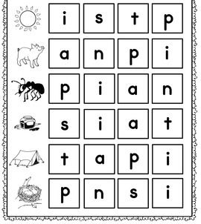

English
In the Nursery we read many books together, do you remember the Three Little Pigs? There is a short version of the story in your nursery rhyme booklet. In the story, the three little pigs made three different types of houses. Could you create your own story but using different constructions/materials for the pigs’ houses? Maybe you could even have a go at building the houses yourself? You might like to change the characters too, so instead of the pigs who will be your main characters in your story? We can’t wait to hear all about your changed story soon!
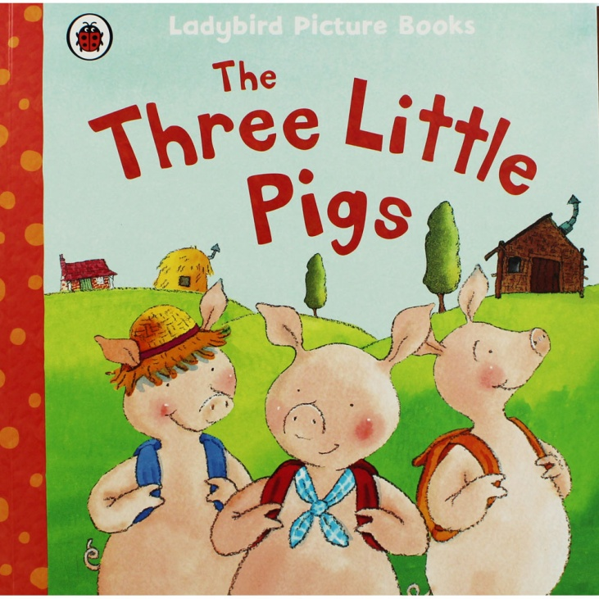

Maths
Dot to dots are a great way to practice spotting and saying your number names in order. There are lots to have a go at on the internet ( here is a good place to start if you have a printer: https://www.thesprucecrafts.com/connect-dots-worksheets-1357606) and we have given you 2 to start off with below. Can you follow and say the numbers and see what the picture is? If you’d like a challenge you could use one with more numbers on, Mrs Patton has been doing dot to dots up to one thousand!

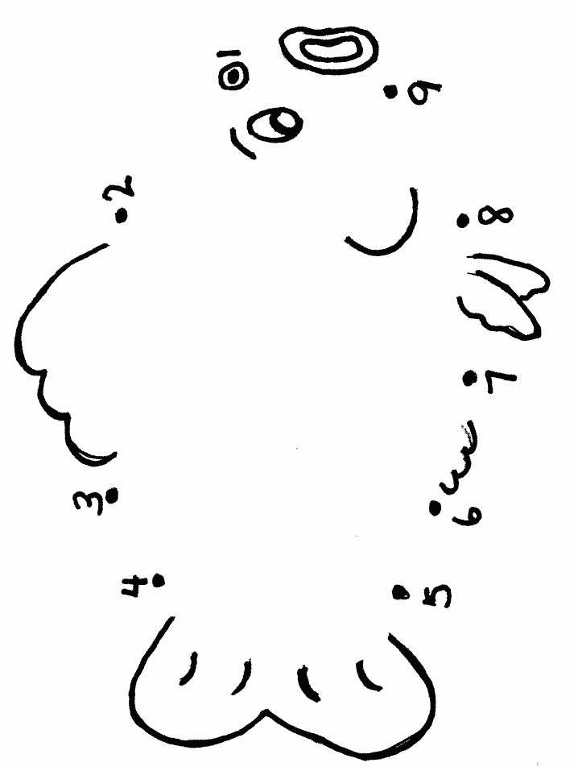

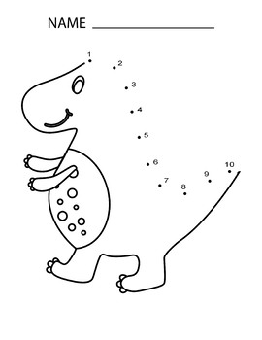

Special Mission
Using your pencil skills can you follow patterns on the lines below? There are lots of other patterns you can try, have a look on Twitter @devnursery for help with Mrs Patton showing you some.

