Reception Home Learning
Week 7
Day 4

A big pat on the back from all your Early Years Teachers!
We all hope that you are working hard and enjoying spending time at home.

Use your noticing potion today and look out of the window say out loud all the things you can see that are green.
Joke of the week. Q. Who granted the fish a wish?
The fairy codmother

Thursday 21st May 2020
Reception Work to support your child at home PHONICS
Below are some examples of how you can support your child at home with their phonics knowledge.
Children learn best with daily practise and by repeating the learning.
Day 4 – Look at the ar words on the board below, read the words and then see if you can make up some funny sentences by putting two of the pictures together.

Challenge yourself to try and write some of your funny sentences. Remember to start with a capital letter, leave finger space after each word and put a full stop at the end of the sentence. Read your sentences to check you have all the words in the right order.

Alphablocks is a great website to support with phonics and with how to pronounce the sounds
https://www.bbc.co.uk/bitesize/topics/zvq9bdm/articles/z4tyt39
https://www.bbc.co.uk/cbeebies/shows/alphablocks
https://new.phonicsplay.co.uk/
You can log into phonics play for free using: Username: march20 Password: home

Thursday 21st May 2020

Work to support your child at home- LITERACY
Day 4- It’s Tricky Word Thursday!
- Use your pencil case tricky words to practise spelling and writing them correctly.
Reminder: Adults- Below are the tricky words that your child has been taught so far in Reception
- Set 1 was taught first, then set 2 and now we are onto set 3 (set 3 is not in your pencil case yet).
- Please make sure your child is confident with spelling the tricky words (without you having to help them) in set 1 before moving onto set 2 and then you can move onto the set 3 words you will find below.
- Please make sure you focus on the tricky words that your child needs more practise with. With the words they need support with, show them the spelling and encourage them to write it. The more practise you do, your child will then no longer have to rely on you showing them the spelling, they will be able to spell it by themselves from memory

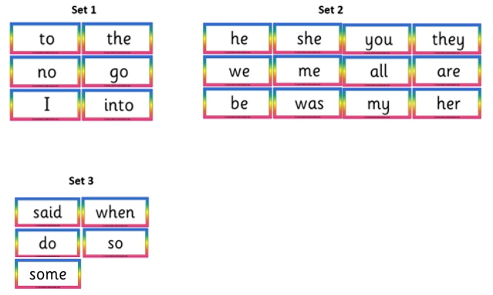

Thursday 21st May 2020
Reception Work to support your child at home MATHS shape
With your grown up. Use either real coins or the paper ones which we have been using all week.

Play exchange. Have 5 x 1p 5 x 2p 3 x 5p. 1x 10p each
Take it in turns to exchange your coins for an equal value coin that your partner has.

For example. You could swap 2 X 1p coins for 1 x 2p coin. Same or equal value.

2 x 1p. is the same value as 1 x 2p

The winner is the one with the fewer coins in their pile left.

https://www.youtube.com/watch?v=VpvKyasjX8U Watch with your grown up.

Free flow – Food from the sea?

Mrs Grinling likes to make Mr Grinling a delicious sandwich for his lunch. Design a sandwich which you would like for a lunch by the sea. Remember to make a healthy lunch box.

