Reception Home Learning
Week 10
Day 5

A big well done from all your Early Years Teachers!
We really are very proud of you for how hard you are working at home. A big thank you to your grown-ups too!
Keep up the good work
Remember, if you want to share any of the busy things you are doing at home with your Teachers, be sure to tag us on Twitter by using: @pinkclass18 and @devrainbow and @redclassdev
We’d love to see them!
Friday 12th June 2020
Reception Work to support your child at home PHONICS

Below are some examples of how you can support your child at home with their phonics knowledge.
Children learn best with daily practise and by repeating the learning.

Day 5 - Go on a hunt around your house and see how many things you can find with these sounds in them, ar, or,ur.

For example you might find a car or a fork, which has the ar sound or the or sound in it, or fur which has the ur sound in it.

Write a list of all the things you found and see how many had the ar, or, or ur sound in them.

Which sound was in most of the things you found?

Have a go at these games on Education City.
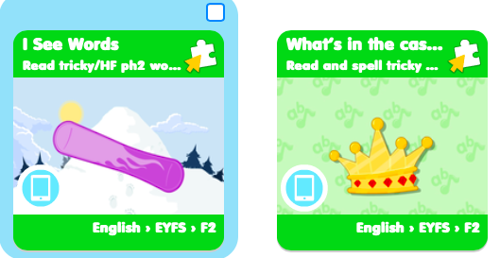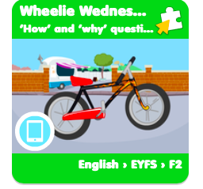

Friday 12th June 2020
Work to support your child at home- LITERACY
Day 5-
- Yesterday you practised spelling and writing the tricky words you find most challenging.
- Today can you have a go at putting those tricky words into sentences?
Reminder:
Adults- Below are the tricky words that your child has been taught so far in Reception
- Set 1 was taught first, then set 2 and now we are onto set 3 (set 3 is not in your pencil case yet).
- Please make sure your child is confident with spelling the tricky words (without you having to help them) in set 1 before moving onto set 2 and then you can move onto the set 3 words you will find below.
- Please make sure you focus on the tricky words that your child needs more practise with. With the words they need support with, show them the spelling and encourage them to write it. The more practise you do, your child will then no longer have to rely on you showing them the spelling, they will be able to spell it by themselves from memory

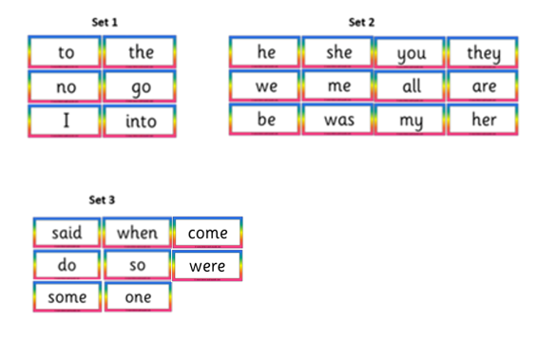

Friday 12th June 2020
Reception Work to support your child at home MATHS
Day 5. https://www.youtube.com/watch?v=imz_xwPgCM4
Watch this clip with your adult
Today we are going to use Education City to help us to use what we have learnt about measure in length and weight.
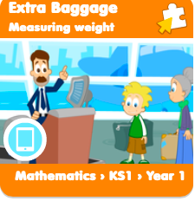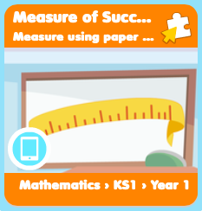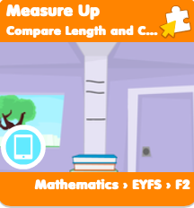
Challenge – Go outside and see how far you can jump. How can you make a long jump?
What weighs the heaviest 16 leaves or 1 stone?
Who in your family has the shortest arms? Who has the longest?
General - Don’t forget to also practise your number formation and counting up to and beyond 20.
Can you now count in 2s up to 20?
Tell your grown up what is 1 less than and more than 6, 11, 17 and 20.

Free-flow- Town and Country- Countryside week
Let’s finish our busy week off with some countryside-themed yoga!

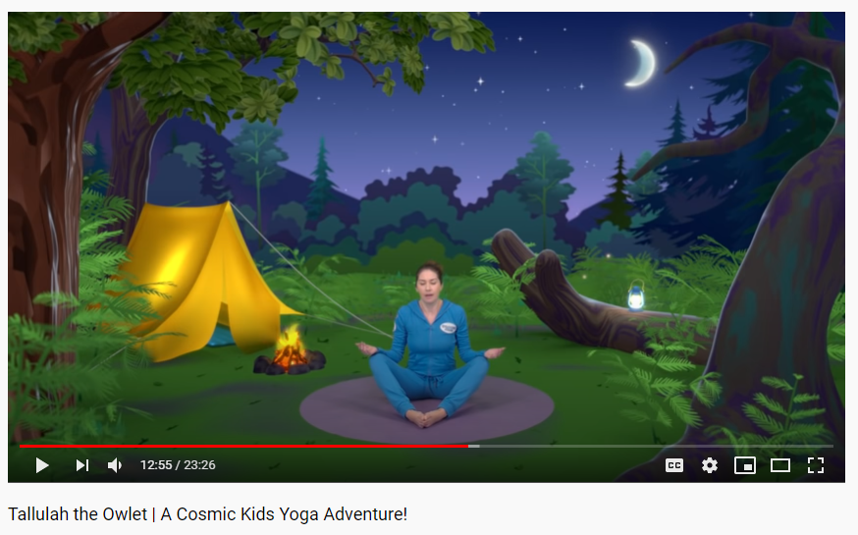
https://www.youtube.com/watch?v=2aje33UPixE

