Nursery Home Learning- Week Beginning 18/5/2020
Tuesday
Hello children and your grown-ups, we hope you are all well and staying safe at home. Below are your Nursery home learning tasks for today, including a special mission at the end for you to have a go at, if you want to. It’s great to see that some of you have been sharing your work on Twitter so if you’d like to share any examples of your work for your teachers or friends to see you can do this on Twitter by tagging @devnursery. Have another great day!
Phonics - Here is a great game you can play with your sounds. All you need is a dice or a spinner. Roll and count the number, then say the sound, find it on the board and colour it in or write over the top of it. If you play with a grown up or your brother or sister you can take turns and see who finds and says the most sounds, have fun!
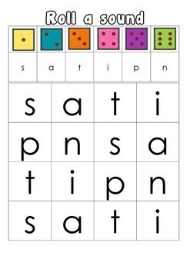
English
Here is one of our favourite stories in the nursery The Very Hungry Caterpillar. You can watch the author himself (that’s the person who wrote the book!) Eric Carle, reading it here: https://www.youtube.com/watch?v=vkYmvxP0AJI.
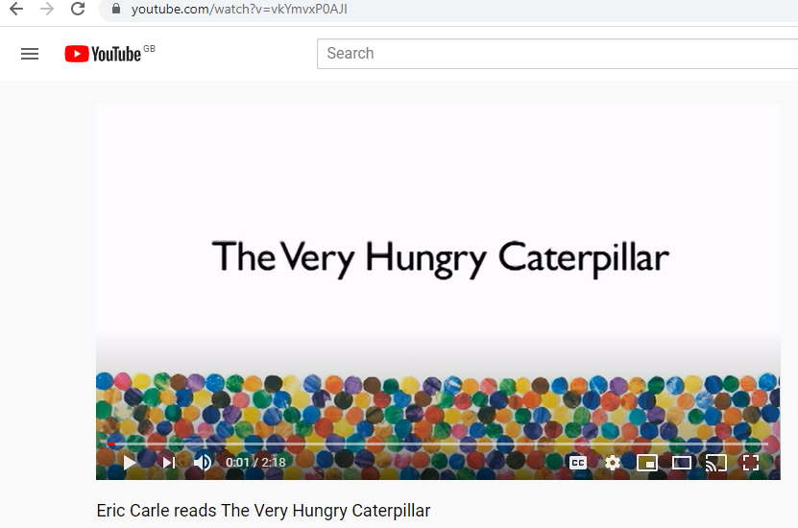
In the story the caterpillar had different fruits and foods. Below is the list of the foods, if you were the caterpillar what would you eat? Could you re tell the story but with your favourite food? Use the list below to help you and then practice saying the story aloud, you could even tell it to a family member (or make a video and share it on Twitter @devnursery, if your grown-up says you can)
Monday- 1 apple
Tuesday- 2 pears
Wednesday- 3 plums
Thursday- 4 strawberries
Friday- 5 oranges
Saturday- Chocolate cake, ice cream cone, pickle, slice of swiss cheese, slice of salami, lollipop, piece of cherry pie, sausage, cupcake and a slice of watermelon.
Sunday- 1 nice green leaf.

Maths
Can you finger print or add coloured blobs/circles to the caterpillars to make their bodies according to numbers?
1

2
3
4
5

Special Mission
Can you and your grown up make up our own fruit ice lollies? You could use the fruits from the Very Hungry Caterpillar story, or just use what you have at home, or your favourites!
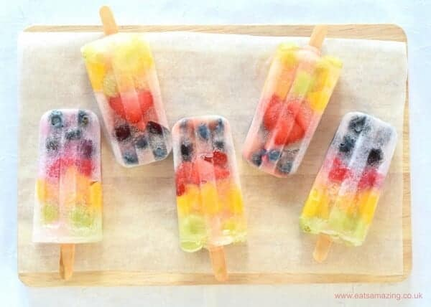
There are some recipes you could try here: https://www.bbcgoodfood.com/howto/guide/5-best-ice-lollies-kids or you could just cut up some fruit, put it in a mould (plastic cups would work, just make sure they don’t fall over in the freezer) add some juice or squash and a lolly stick or handle and put them in the freezer to set. Then you can be like the Very Hungry Caterpillar and eat them all up (but don’t forget to share!)

