Reception Home Learning
Week 12
Day 4

A big well done from all your Early Years Teachers!
We really are very proud of you for how hard you are working at home. A big thank you to your grown-ups too!
Keep up the good work

Remember, if you want to share any of the busy things you are doing at home with your Teachers, be sure to tag us on Twitter by using: @PinkClass18 and @devrainbow and @redclassdev

Thursday 25th June 2020
Reception Work to support your child at home PHONICS
Below are some examples of how you can support your child at home with their phonics knowledge.
Children learn best with daily practise and by repeating the learning.
Day 4 – Have a spelling competition using the words you have learnt this week. How many words can you think of that have the oi sound?
The ow sound? The ur sound?
Get your grown up to put a 5 minute timer to see how many you can say.
Challenge yourself and see how many of the words that your remembered and write them all down in five minutes.

Now try and write all your tricky words in five minutes.

How did you do?

How many words did you remember?

How many did you write in five minutes?

How many tricky words can you now write independently?

Can you say a sentence using the tricky word ‘have’ and some of the Oi words that you have wrote?
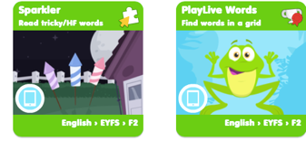 Use Education City. Tricky Word Homework.
Alphablocks is a great website to support with phonics and with how to pronounce the sounds
https://www.bbc.co.uk/bitesize/topics/zvq9bdm/articles/z4tyt39
https://www.bbc.co.uk/cbeebies/shows/alphablocks
https://new.phonicsplay.co.uk/
You can log into phonics play for free using: Username: march20 Password: home

Thursday 25th June 2020
Work to support your child at home- LITERACY
Day 4- It’s Tricky Word Thursday!
- Practise spelling the tricky words you find most challenging
Reminder: Adults- Below are the tricky words that your child has been taught so far in Reception
- Set 1 was taught first, then set 2 and now we are onto set 3 (set 3 is not in your pencil case yet).
- Please make sure your child is confident with spelling the tricky words (without you having to help them) in set 1 before moving onto set 2 and then you can move onto the set 3 words you will find below.
- Please make sure you focus on the tricky words that your child needs more practise with. With the words they need support with, show them the spelling and encourage them to write it. The more practise you do, your child will then no longer have to rely on you showing them the spelling, they will be able to spell it by themselves from memory

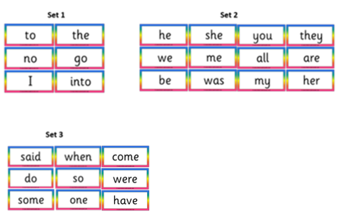

Thursday 25th June 2020
Reception Work to support your child at home MATHS - recap

https://www.topmarks.co.uk/ordering-and-sequencing/shape-patterns Play while a grown up watches.
Activity - Hidden Items
Place five small items/cubes on to a tray or table.
Ask “how many items there are?”
Encourage your child to use their fingers to represent the amount of item/cubes are in front of them.
Model counting while they represent the amount of items on their fingers.
Ensure they know the correct amount of items hidden under the cloth.
Cover completely the items/cubes with a cloth.
Then as they watch you place two more items under the cloth.
Ask your child to show you using their fingers to show many items were under the cloth to start with and how many have been added.
How many cubes are there altogether now?”
Repeat the exercise using different amounts under 10.
If your child is confidently working with number beyond 10 extend the amount hidden encourage them to make marks to represent the amount.

Free Flow Activity -Town and Country
Thursday 18th June 2020

https://www.youtube.com/watch?v=pZw9veQ76fo sing Five Little Ducks

Today you will need to draw a line from the mother animals to their babies.

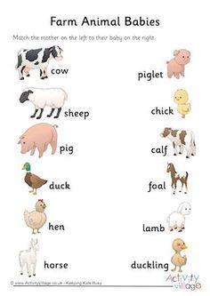

https://www.youtube.com/watch?v=2NabxmEj5GE watch with your grown up

