Reception Home Learning
Week 4
Day 4

A big Hi from all your Early Years Teachers!

We all hope that you are working hard and enjoying spending time at home.

Thursday 30th April 2020
Reception Work to support your child at home PHONICS
Below are some examples of how you can support your child at home with their phonics knowledge.
Children learn best with daily practise and by repeating the learning.
Day 4 – Have a spelling competition using the words you have learnt this week. How many words can you think of that have the oa sound?
The igh sound? The ee sound?

Get your grown up to put a 5 minute timer to see how many you can say.

Challenge yourself and see how many of the words that your remembered and write them all down in five minutes.

Now try and write all your tricky words in five minutes.

How did you do?

How many words did you remember?

How many did you write in five minutes?

How many tricky words can you now write independently?

Can you say a sentence using the tricky word ‘do’ and some of the oa words that you have wrote.

Alphablocks is a great website to support with phonics and with how to pronounce the sounds
https://www.bbc.co.uk/cbeebies/shows/alphablocks
https://new.phonicsplay.co.uk/

Thursday 30th April 2020
Work to support your child at home: LITERACY
Day 4
- Use your pencil case tricky words to practise spelling and writing them correctly.
Adults- Below are the tricky words that your child has been taught so far in Reception
- Set 1 was taught first, then set 2 and now we are onto set 3 (set 3 is not in your pencil case yet).
- Please make sure your child is confident with spelling the tricky words (without you having to help them) in set 1 before moving onto set 2 and then you can move onto the set 3 words you will find below.
- Please make sure you focus on the tricky words that your child needs more practise with. With the words they need support with, show them the spelling and encourage them to write it. The more practise you do, your child will then no longer have to rely on you showing them the spelling, they will be able to spell it by themselves from memory

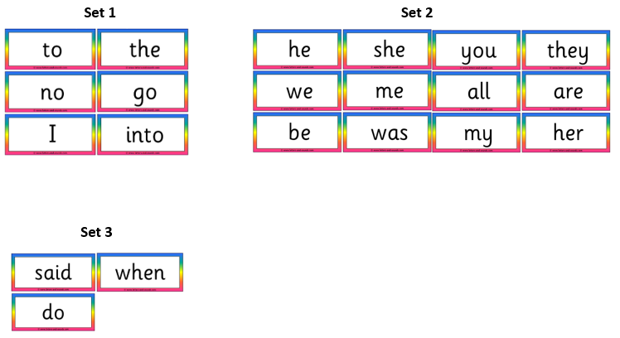

Thursday 30th April 2020
Reception Work to support your child at home MATHS
Day 4 – We have been working on halving amounts fairly and unfairly.
Today I would like you to take a look around your house and garden.

Find 6 pebbles or stones. Can you halve them equally?

Find 4 pencils or pens. Can you halve them equally?

Find 5 spoons. Can you halve them equally?

Challenge- Find other items around the house and see if you can halve them equally.
Find 9 books. Can you halve them equally?

Free flow – Over the Hills and Faraway
- So yesterday, we thought about how we can travel around the UK.
- Today your challenge is to think about how you can travel (safely) around your garden/a space in your house! Can you create an obstacle course? Make it as simple as you like- it could be walk in and out of the leaves placed on the floor, jump forward 5 times, throw the ball up and catch it then run to the bottom of the garden!
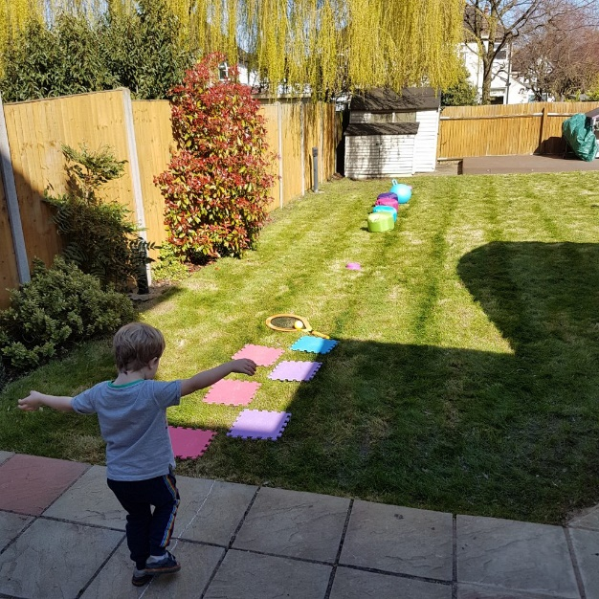
Here’s another idea to get you going:
- Walk across the chalk tightrope on the patio (feet touching).
- Step on the puzzle pieces.
- Bounce the ball with the tennis racket three times.
- Do three star jumps.
- Run in and out of the beanbag stools.
- Bounce on the space hopper.
- Run as fast as you can back to the start!

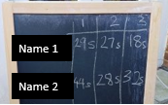
You can even take it in turns with your grown up and time each other using your grown-up’s phone timer. Try and beat your own previous times.
Which number is bigger/smaller? What was your fastest time?

Example:

