Nursery Home Learning- Week Beginning 27/4/2020
Thursday
Hello children and your grown-ups, we hope you are all well and staying safe at home. Below are your Nursery home learning tasks for today, including a special mission at the end for you to have a go at, if you want to. Don’t forget to check Twitter for helpful tips and ideas @devnursery. Have another brilliant day!

Phonics
Today we would like you to have a go at playing I spy. You can play this in lots of different ways. You could do it with colours and shapes. You could do the classic “something beginning with” or you could even do it with sounds. Sound I spy works especially well with an animal picture, like the ones below and then you can have lots of fun making the animal sounds and matching them to the pictures.
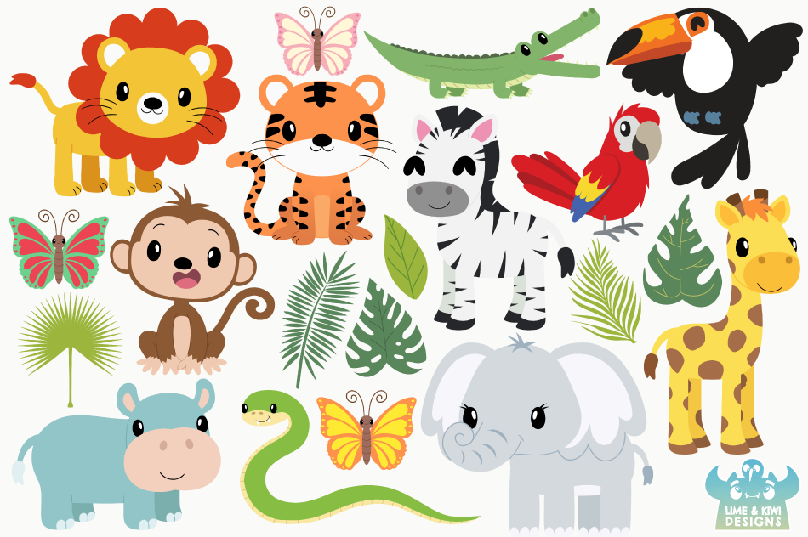
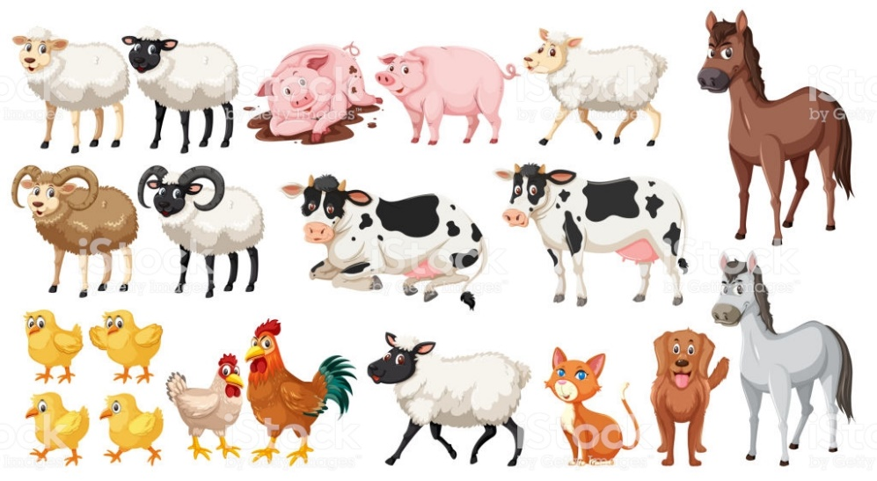
English
Today we are going back to our story, Oliver’s Vegetables, you can watch it on YouTube here: https://www.youtube.com/watch?v=BTYoaJY7k-Q
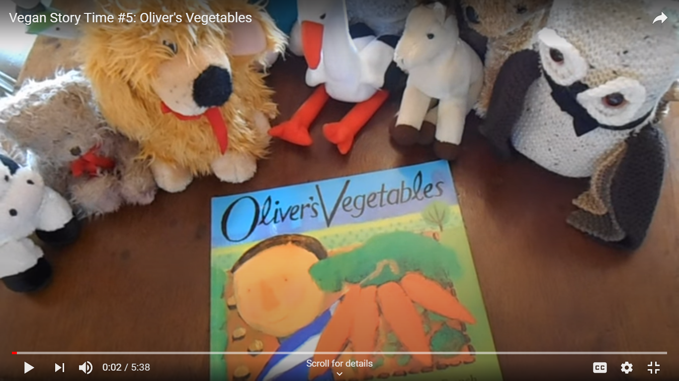
Today we would like you to try and make a story map, which will help you to tell the story for yourself. The best way to do this is to start with a large s shape on a piece of paper then add small pictures for each part of the story as you follow the s shape. (Mrs Patton has given her example below)
When you have finished your story map, see if you can tell the story to a grown up or family member yourself.

Maths
Today we are going back to the number 3. You can start by listening to the number 3 song by number blocks here: https://www.bbc.co.uk/cbeebies/watch/numberblocks-the-three-song . Then we would like you to practice counting to 3 using your body so you can do 3 claps, 3 twirls, 3 jumps etc. Remember to count each action as you do it and stop when you reach 3.

Special Mission
With the weather improving there’s lots more wildlife out and about, can you keep a lookout and record what you spot in your garden or out of your window, this could be bugs, birds or maybe even next door’s cat! If you see anything you don’t recognise you can use https://www.wildlifetrusts.org/ to find out what it is and learn more about it in the wildlife section. If you can’t see anything out the window try their webcams page to see some really fascinating wildlife up close and personal all over the UK.
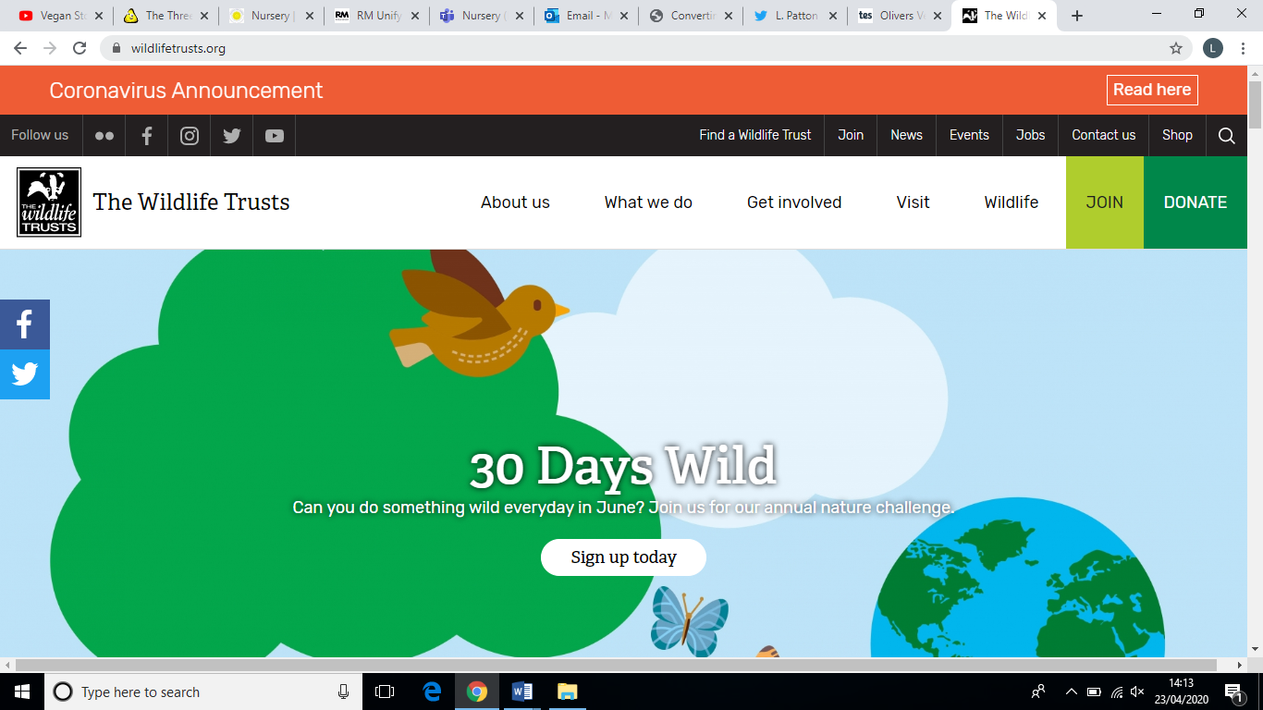
For information about local wildlife and national webcams, click here.

