Reception Home Learning
Week 2
Day 4

A big Hi from all your Early Years Teachers!

We all hope that you are working hard and enjoying spending time at home.
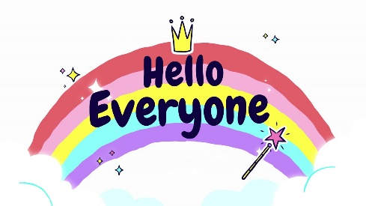
Thursday 2nd April 2020

Thursday’s Reception work to support your child at home- PHONICS
Day 4 – Have a spelling competition using the words you have learnt this week.

How many words can you think of with the ee sound?

The ai sound?

The th sound?

Go around your house and see if you can find objects that have these sounds in them and write them down.

Phonics websites to support learning:
Alphablocks is a great website to support with phonics and with how to pronounce the sounds
https://www.bbc.co.uk/cbeebies/shows/alphablocks

Phonics Play has lots of fun phonics games. You can log into phonics play for free using:
Username: march20
Password: home
https://new.phonicsplay.co.uk/
Thursday’s Reception work to support your child at home- LITERACY
Day 4 -
Please draw some lines in your child’s writing book and encourage them to sit their writing on the line
Today, your writing task is to:
- Can you write your sentences from yesterday?

Remember to choose your favourite character from the Dear Zoo story to write about. The below is just an example. The example shows you the words in green are tricky words and children are expected to spell these correctly.
For example:
The zoo sent me a lion but he was fierce. He had a long tail and sharp teeth. I sent him back.

Remember your actions to help you know what word comes next. Use your sounds to spell the words. Remember: form letters correctly, capital letters, finger spaces and full stops.
*Adults please let the children use their own phonics knowledge, please do not spell the words for them. Your role is to remind them about capital letters, to say their words slowly to hear each sound they need to write, finger spaces and full stops. You can support children with spelling the tricky words correctly if they need support*
Thursday’s Reception work to support your child at home- MATHS

Day 4 – Go to cbeebies for the following activities:
Addition: https://www.bbc.co.uk/cbeebies/puzzles/numberblocks-adding-up-quiz

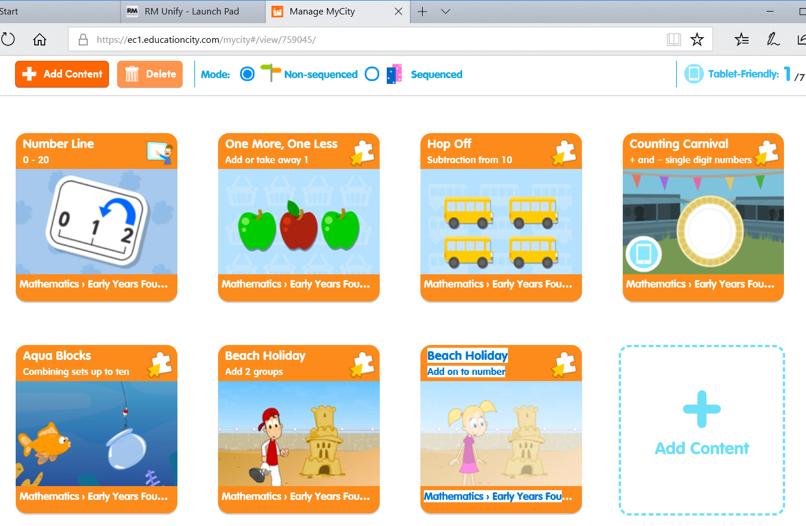
Addition and Subtraction: https://www.bbc.co.uk/cbeebies/puzzles/numberblocks-number-magic-adding-and-subtracting
Here are some additional games on Education City that we have set for you play to help with your learning.
Another useful website for all subjects:
Use the search bar on twinkl’s website to search for resources to support what your child has been learning:
Twinkl is offering a free 1 month period for parents to use all of their resources. Log onto the website below to access a wide range of Reception work.
www.twinkl.co.uk/offer
Sign up by using your email address, create a password and then use the code CVDTWINKLHELPS to gain free access.

