Reception Home Learning
Week 4
Day1

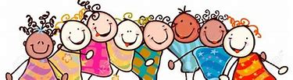

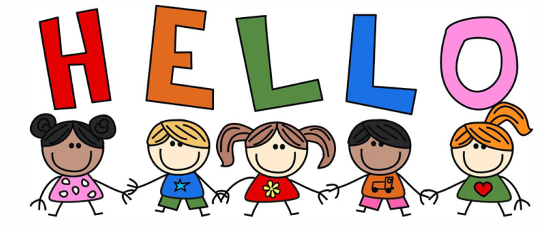
A big Hi from all your Early Years Teachers!

We all hope that you are working hard and enjoying spending time at home.

Monday 27th April 2020
Reception Work to support your child at home PHONICS
Below are some examples of how you can support your child at home with their phonics knowledge. We have set this out into daily activities.
Children learn best with daily practise and by repeating the learning.
You will need your phonic cards that were sent home in your pencil case.

Day 1 – Recap on sounds we have learnt before – th (the, that, this, then, thing, think) ng (ring, king, string, bring, thing) ai (rain, train, pain, wait, mail, sail, nail, main, again. ee (bee, see, tree, feet, sweet, greet, street, seen, deep) igh (night, tight, fright, sight, right, light, might fight fight

Learn the new sounds – oa (oak, soak, boat, goat, coat, float, toast, load, toad) This oa sound can be at the beginning of a word but is usually in the middle of the word, never at the end of a word.

Practise the tricky word – do (also practise words we have learnt before – they, I, me, to, you, go, he, she, her, we, are, all, said, when)

What does each word mean? Do you notice any patterns? (oa sound comes at the beginning or in the middle of the word, never at the end). Remember we don’t use the capital letter O if we hear it in the middle of the word.
Read one of your favourite books and write the tricky words you find.
Tell a grown up what happened in the book and what was your favourite part
Alphablocks is a great website to support with phonics and with how to pronounce the sounds
https://www.bbc.co.uk/cbeebies/shows/alphablocks
https://new.phonicsplay.co.uk/
You can log into phonics play for free using:
Username: march20
Password: home

Monday 27th April 2020
Work to support your child at home: LITERACY
This week we are going to continue to focus on the story ‘Mr Gumpy’s Outing’. Remember, you can find this story by typing into youtube: Mr Gumpy’s Outing or following this link: https://www.youtube.com/watch?v=Mi_DV_DWN8M
Last week’s sentences were:
One day the man went out on his boat. He let everyone come with him.

Day 1-
This week, we are going to write similar sentences, but this time we would like you to add in your own ideas to change the story!
Here are some examples:
One … day | the man went out… | He let … come with him.
sunny | on his bike. | the dog
rainy | in his car. | the cat
hot | on his tractor. | the rabbit
cloudy | on his scooter. | the mouse

So, it may be that your new sentence is something like this:
One hot day the man went out on his scooter. He let the dog and the cat come with him.
What are your new sentences?
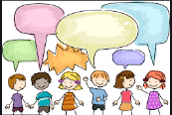
Today, your talking task is to:
- Practise saying your sentences- Put your actions to your sentences as we do in class. Act out the sentences.
- Once you have practised saying the sentences together, see if your child can now remember the sentences and say them without your support. If they can, it means they are ready to write them tomorrow!

Monday 27th April 2020
Reception Work to support your child at home MATHS - halving
Day 1 -Guidance -Your child will probably already have some experience of sharing and will be quick to point out when groups are not shared fairly.
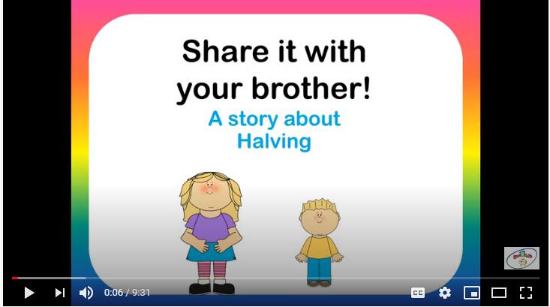
Share this youtube halving story with your child by typing into youtube ‘learn to half- halving story’ or following this link: https://www.youtube.com/watch?v=663FhDCwhkY
Tomorrow we will be halving using our part, part whole.
Extension – use a square, circle and a rectangle to fold into 2 equal halves, edges to edges, corners to corners to explain 2 equal halves.

Free flow Over the Hills and Faraway
Last week we started to learn a little bit about the United Kingdom. The United Kingdom is made up of one main island and several smaller islands, because of this we have quite a lot of beaches and coastline.
Below are three pictures of beaches around the United Kingdom. Pick your favourite and draw a picture of it, add yourself and your family into your picture. Talk to your grown up about what you can see in your picture. You could even write a sentence or story to go with your picture.
