Nursery Home Learning- Week Beginning 20/7/2020
Summer Holidays!
Happy holidays to all of you! We hope you are all still staying safe and well at home, remember whatever you do this summer to stay safe and make the right choices about where you go and what you do.
As we are heading into the 6 weeks’ holidays, we’ve tried to come up with some ideas that will help you to practice all the skills you have learnt in Nursery ready for Reception. These activities are starting points, have a go at them and if you like them, there are lots of other ways to do similar activities, so explore the things you enjoy most to practice what you have learnt. There are also some website links, stories and activity packs to explore together.
Have a look at all the different options below and whatever you choose take lots of pictures to share on Twitter @devnursery or to show your teachers when we are back at school, learn lots and above all HAVE FUN!

Starting point… Exploring the senses
If you are going out and about over the summer, it’s a great chance to talk about the 5 senses- touching, tasting, smelling, seeing and hearing. While you’re at it, why not try something new with a taste test too, it may be delicious!
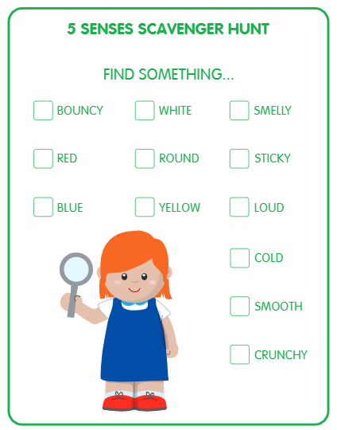
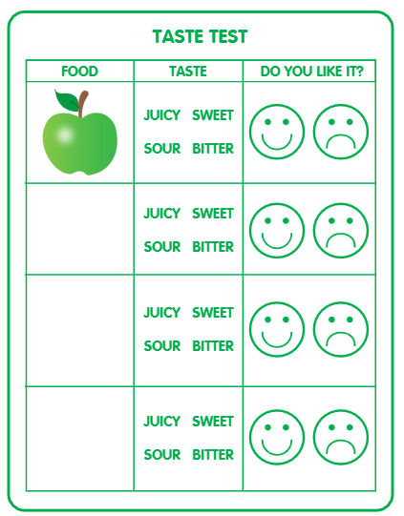
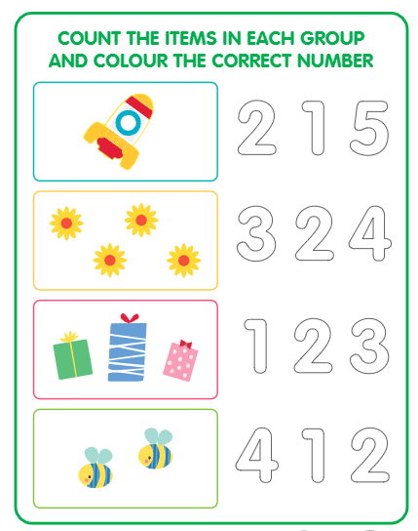
Starting point… Numbers
Start with the numbers your child is confident with, then try and work all the way up to 10. Remember this will include recognising, writing and counting out that many. Your child should also be able to put the numbers in order.

Starting point… Exploring Emotions
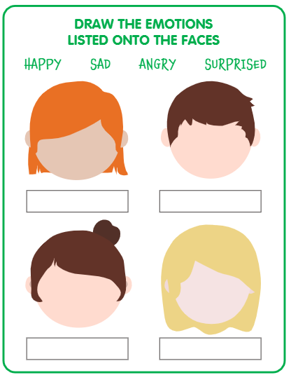

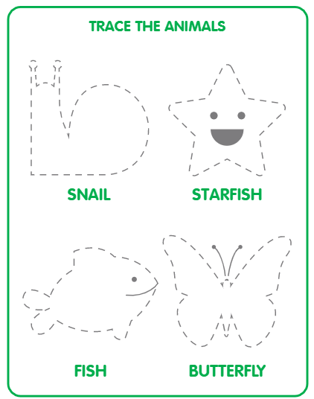
Starting point… Fine motor skills and pencil control
Tracing and drawing are great for pencil
control, you could do dot-to-dots or
practice writing letters. Writing your name
is a key skill for Reception, can you write
yours yet?

Starting point… Imaginative Play
Why not create an imagination café? Design your own menu, then why not try and make the food, you could use playdough or toys or even do some real life cooking.
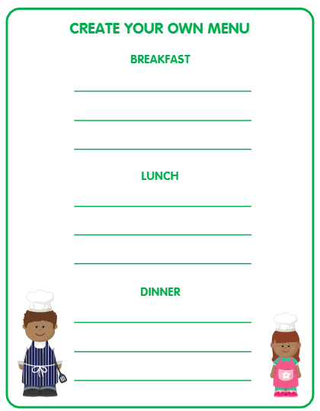
Starting point… Being helpful
The holidays are a great time to get children involved in the day-to-day routine of looking after the house. Giving them simple chores they can do lets them feel useful and gives them some independence. Here are some age-appropriate chores for 4-5 year olds:
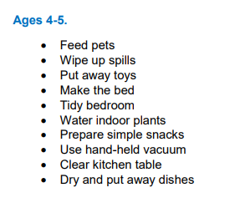
Other Ideas
Why not get involved with the cBeebies and Blue Peter 6 badges of summer? You can find all the information here: https://www.bbc.co.uk/cbeebies/joinin/six-badges-of-summer-wall-chart?collection=6-badges-of-summer with 6 areas to cover, you could look at 1 a week for the whole holiday! There’s lots to choose from and this could be a great place to start, or somewhere to return to if you’re feeling bored or uninspired.
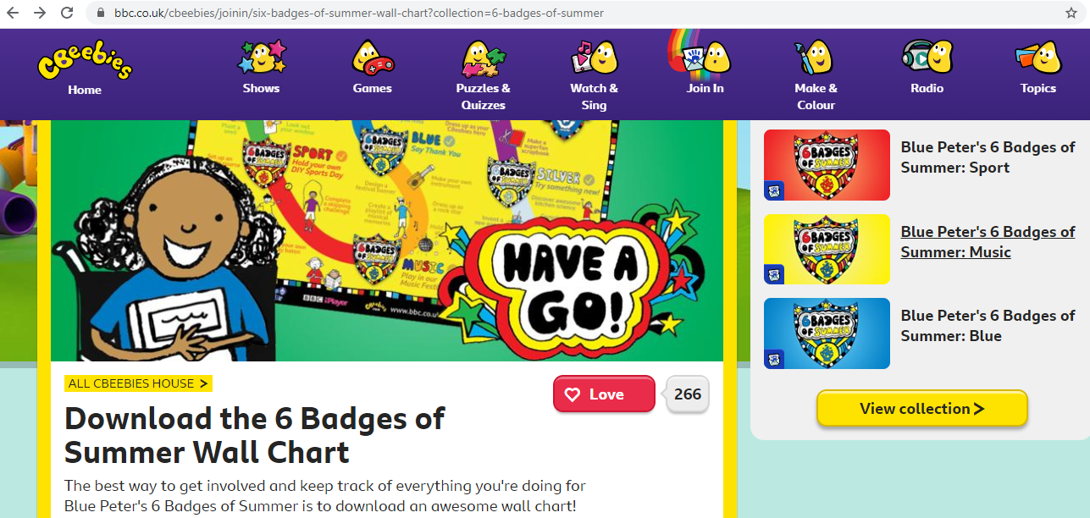
Another great website to start you off is https://www.bbc.co.uk/tiny-happy-people there are activities for all age groups here, and lots of lovely rhymes to sing along to too.
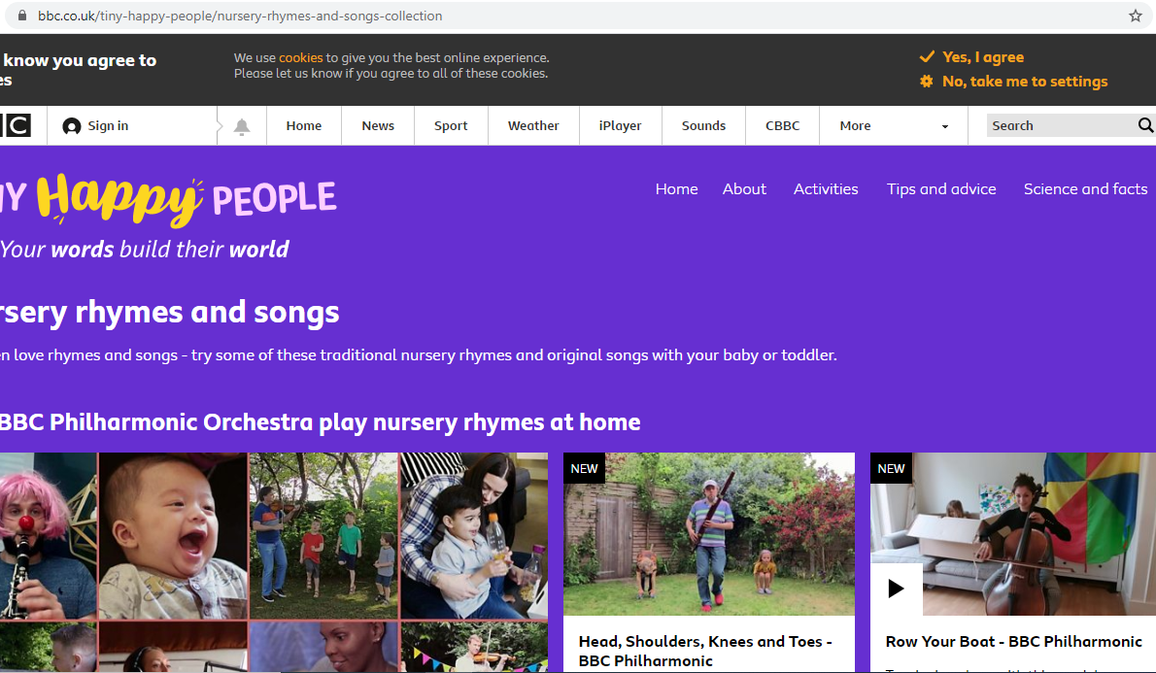

On the Nursery web page (where you downloaded this from) you will also find links to 2 activity booklets from TTS, one is all about spring (a bit late, but with some lovely ideas to try, all based around different spring creatures) and a more general one which is BURSTING with ideas around songs and rhymes we all know and love. Take a look, they’re great!

Finally… a note on preparing for the return to school.
We know that by the time children return to school, most of them will have been out of the setting for 25 weeks!! And we understand that this will cause anxiety and concern for many (children and grown-ups alike!) The best thing you can do is to talk about this and to discuss what going back to school will look like. Use the school’s website www.devonshireinfantacademy.org/early-years to look at the different classes and staff and to talk about how it will be different from Nursery.
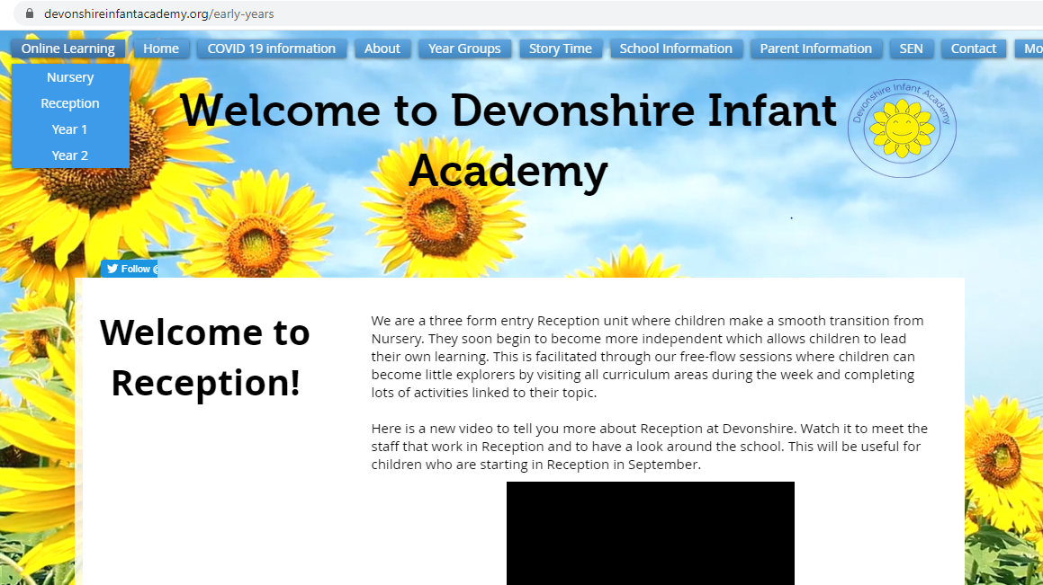
There are also 2 lovely books to help with the transition. Firstly, Everybody Worries by Jon Burgerman, which you can read for free on Oxford Owl and also Sammy Sloth Goes Back to School by Rachel Cook, which you can read as a PDF on the school’s website (this is all about school during COVID times so it is perfect!) Talk together and know that when you do come back we will be here to greet you with a smile and a wave! Have a great Summer, stay safe and we will see you soon.
