Reception Home Learning
Week 7
Day 5

A big pat on the back from all your Early Years Teachers!
If you want to share any of the busy things you are doing at home with your Teachers, be sure to tag us on Twitter by using: @pinkclass18 and @devrainbow and @redclassdev

Today we would like you to think about how you can show the people in your house you care. It may be through a hug or just by saying thank you.
Take care and stay safe!!

Friday 22nd May 2020
Reception Work to support your child at home PHONICS

Below are some examples of how you can support your child at home with their phonics knowledge.
Children learn best with daily practise and by repeating the learning.

Day 5 - Read the story ‘Mark’s Barn’
Make a list of all the ar words you saw in the story. Try and find out what the word barn means ask a grown up to help you.

Use your sounds to sound out words and ask a grown up to help you sound out words that you are finding a little hard to read, but keep on trying you can do it!
When you have finished reading tell your grown up what happened in the story.

Where did Mark march down to?

Where was the barn?

What was inside the barn?

Why did he not need his car?

What did Mark want to make?

What did he fill up and take back to the farm?

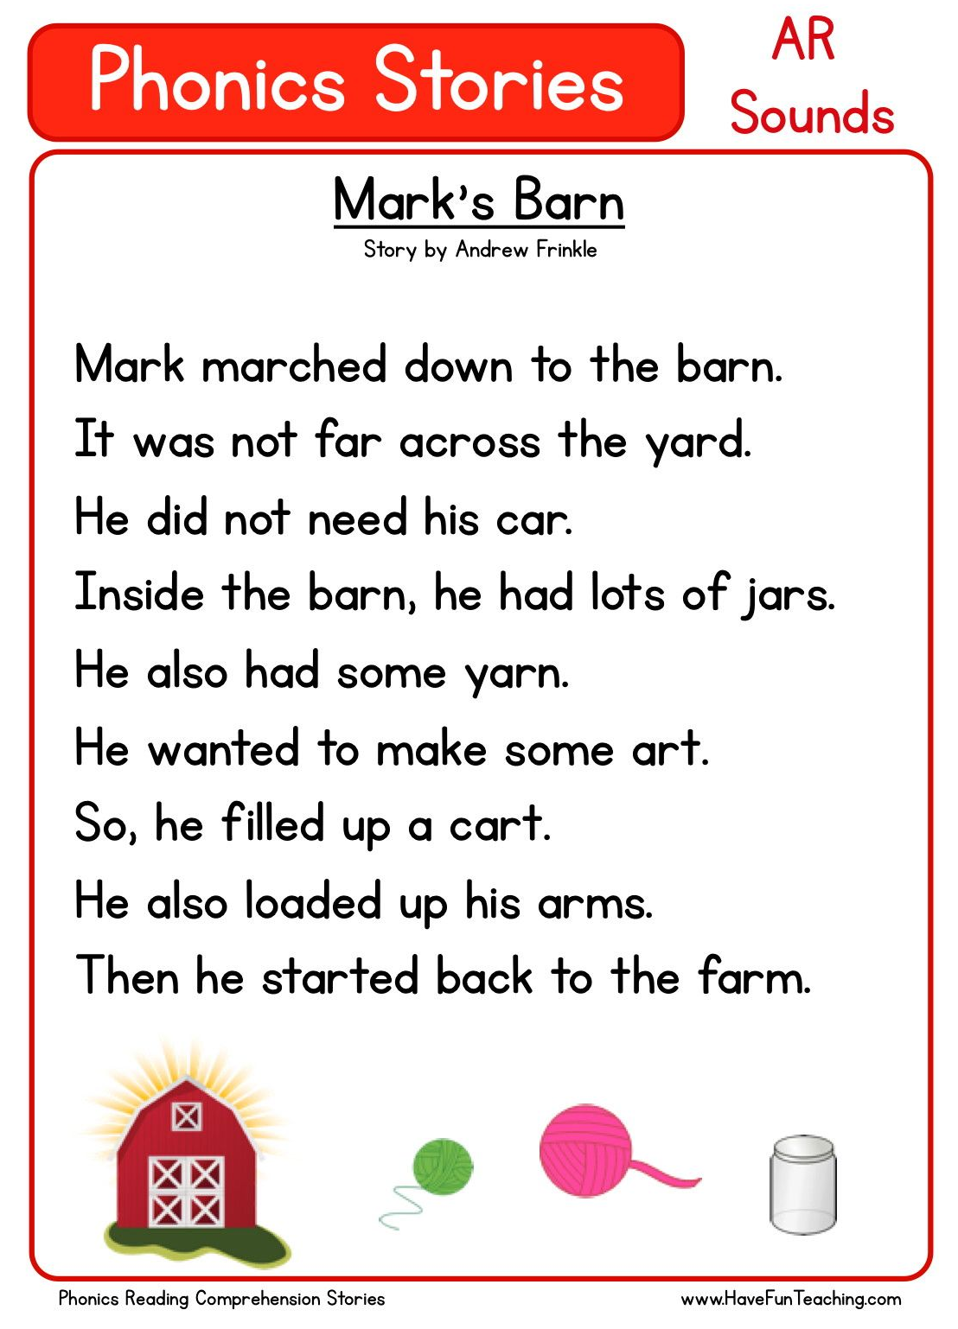
Challenge yourself can you make up your own short story with ar words.

Friday 22nd May 2020
Work to support your child at home- LITERACY
Day 5-
- Yesterday you practised spelling and writing the tricky words you find most challenging.
- Today can you have a go at putting those tricky words into sentences?
Reminder:
Adults- Below are the tricky words that your child has been taught so far in Reception
- Set 1 was taught first, then set 2 and now we are onto set 3 (set 3 is not in your pencil case yet).
- Please make sure your child is confident with spelling the tricky words (without you having to help them) in set 1 before moving onto set 2 and then you can move onto the set 3 words you will find below.
- Please make sure you focus on the tricky words that your child needs more practise with. With the words they need support with, show them the spelling and encourage them to write it. The more practise you do, your child will then no longer have to rely on you showing them the spelling, they will be able to spell it by themselves from memory

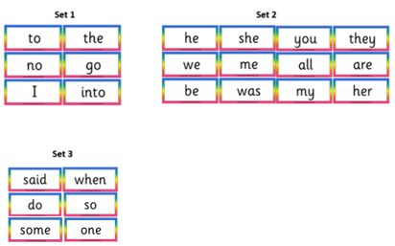

Friday 22nd May 2020
Reception Work to support your child at home MATHS shape
https://www.topmarks.co.uk/money/toy-shop-money work with your grown up.

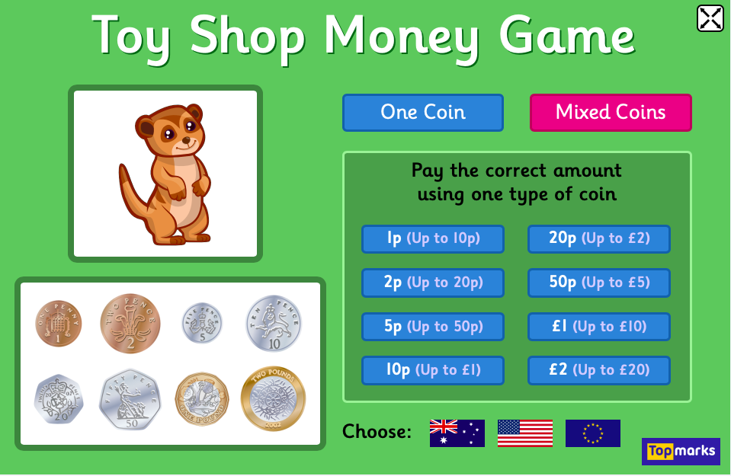

Work first on the 1p up to 10p. Use 1 coin first then if you want to have a go at mixed coins. challenge yourself 2p up to 20p.

To finish off the week watch number time https://www.youtube.com/watch?v=p-sOpKUcRE0

Free flow – food from the sea

Follow these instructions on how to make a paper boat. See if it floats. How many 1ps will it carry before it sinks.
