Reception Home Learning
Week 12
Day 5

A big well done from all your Early Years Teachers!
We really are very proud of you for how hard you are working at home. A big thank you to your grown-ups too!
Keep up the good work

Remember, if you want to share any of the busy things you are doing at home with your Teachers, be sure to tag us on Twitter by using: @PinkClass18 and @devrainbow and @redclassdev

Friday 26th June 2020
Reception Work to support your child at home PHONICS
Read this story with your grown up then answer the questions.
Challenge how many Oi word can you underline
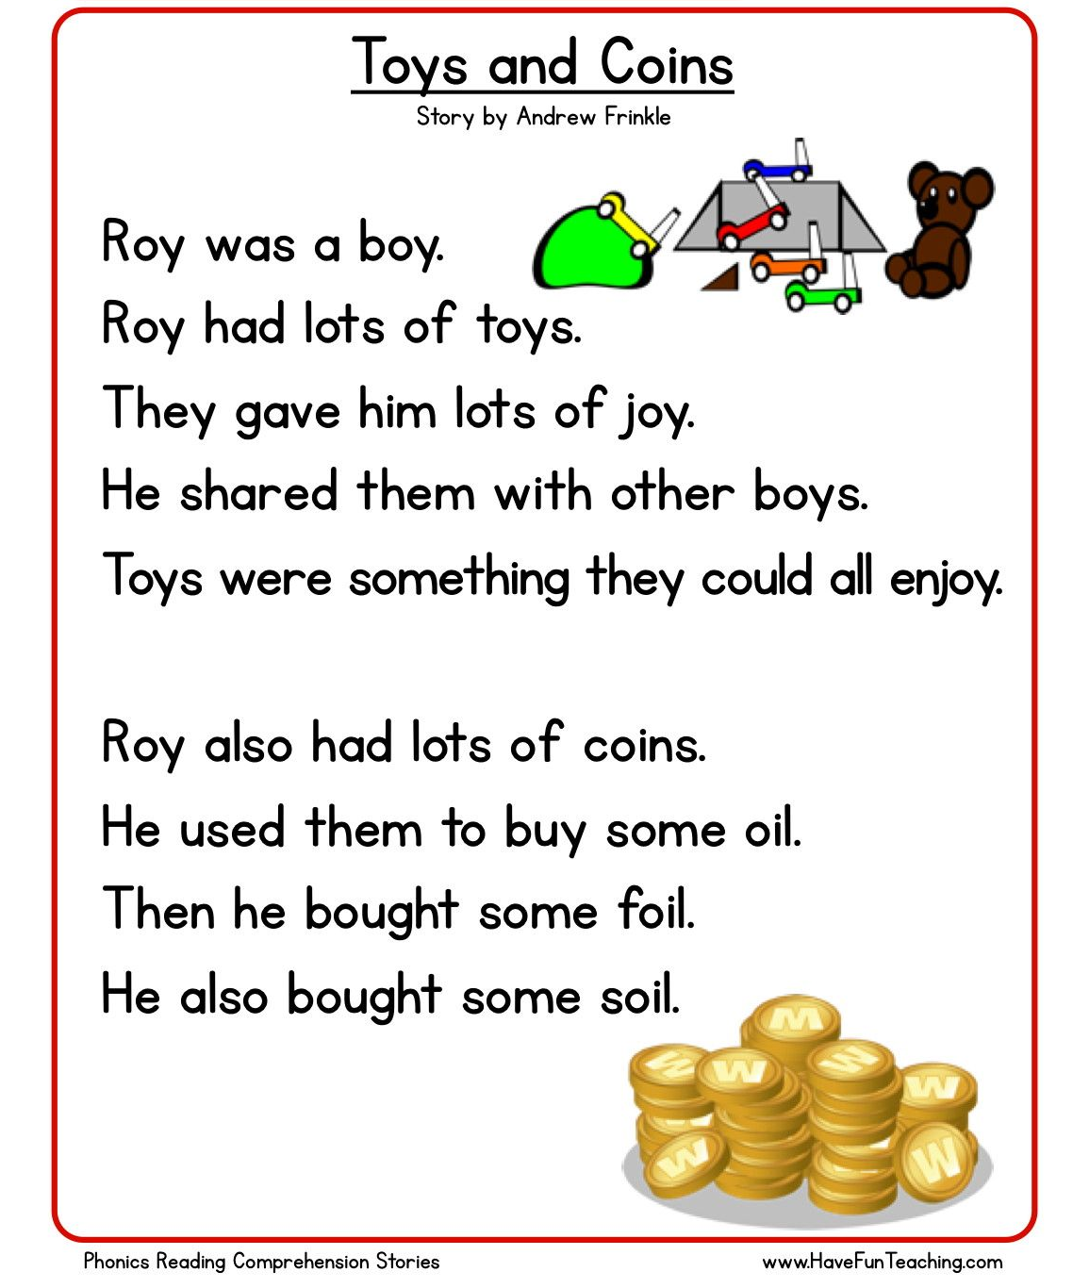

Comprehension questions
Listen to the question then tell your grown up your answer.

- Who was Roy?

- What did he have lots of?

- Who did he share his toys with?

- What did he buy?

- What did he use to buy things with?

- What three things did he buy with the oi sound?

- Can you think of something you could buy with the oi sound?

Friday 26th June 2020
Work to support your child at home- LITERACY
Day 5-
- Yesterday you practised spelling and writing the tricky words you find most challenging.
- Today can you have a go at putting those tricky words into sentences?
Reminder:
Adults- Below are the tricky words that your child has been taught so far in Reception
- Set 1 was taught first, then set 2 and now we are onto set 3 (set 3 is not in your pencil case yet).
- Please make sure your child is confident with spelling the tricky words (without you having to help them) in set 1 before moving onto set 2 and then you can move onto the set 3 words you will find below.
- Please make sure you focus on the tricky words that your child needs more practise with. With the words they need support with, show them the spelling and encourage them to write it. The more practise you do, your child will then no longer have to rely on you showing them the spelling, they will be able to spell it by themselves from memory

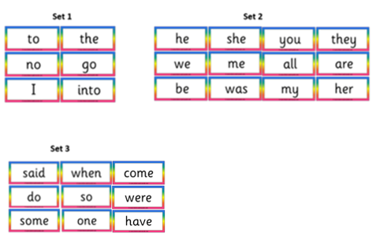

Friday 26th June 2020
Reception Work to support your child at home MATHS

Activity - Hidden Items- subtraction
Place five small items/cubes on to a tray or table.
Ask “how many items there are?”
Encourage your child to use their fingers to represent the amount of item/cubes are in front of them.
Model counting while they represent the amount of items on their fingers.
Ensure they know the correct amount of items hidden under the cloth.
Cover completely the items/cubes with a cloth.
Then as they watch while you take away two items from under the cloth.
Ask your child to show you using their fingers to show many items were under the cloth to start with and how many have been taken away.
How many cubes did we start with?
How many did I take away?
How many items will be under the cloth now?
How did you work it out?
Extension – take ten items place them in a line. Then take it in turns to take 1, 2, or 3 pebbles. The winner is the one who avoids taking the last pebble.

Free Flow Activity Town and Country
Friday 19th June 2020
For the last day of this week why not finish with making your own farm animal puppets.
You can write the animal names by using your phonic knowledge. Colour them in using the correct colour for the animals and then cut them out [your grownup can help you cut the animals out]

