Reception Home Learning
Week 9
Day 5

A big smile from all your Early Years Teachers!
If you want to share any of the busy things you are doing at home with your Teachers, be sure to tag us on Twitter by using: @pinkclass18 and @devrainbow and @redclassdev

Friday 5th June 2020
Reception Work to support your child at home PHONICS

Below are some examples of how you can support your child at home with their phonics knowledge.
Children learn best with daily practise and by repeating the learning.
Day 5 - Read the story ‘Mort’
Make a list of all the or words you saw in the story. Try and find out what the word ‘normal’ means ask a grown up to help you.

Use your sounds to sound out words and ask a grown up to help you sound out words that you are finding a little hard to read, but keep on trying you can do it!
When you have finished reading tell your grown up what happened in the story.

What did Mort only eat soup with?

Which way did Mort sit facing?

What month of the Year did Mort like?

What instrument did Mort play?

Name one thing Mort would eat?

Was Mort weak or strong?

Friday 5th June 2020
Work to support your child at home- LITERACY
Day 5-
- Yesterday you practised spelling and writing the tricky words you find most challenging.
- Today can you have a go at putting those tricky words into sentences?
Reminder:
Adults- Below are the tricky words that your child has been taught so far in Reception
- Set 1 was taught first, then set 2 and now we are onto set 3 (set 3 is not in your pencil case yet).
- Please make sure your child is confident with spelling the tricky words (without you having to help them) in set 1 before moving onto set 2 and then you can move onto the set 3 words you will find below.
- Please make sure you focus on the tricky words that your child needs more practise with. With the words they need support with, show them the spelling and encourage them to write it. The more practise you do, your child will then no longer have to rely on you showing them the spelling, they will be able to spell it by themselves from memory

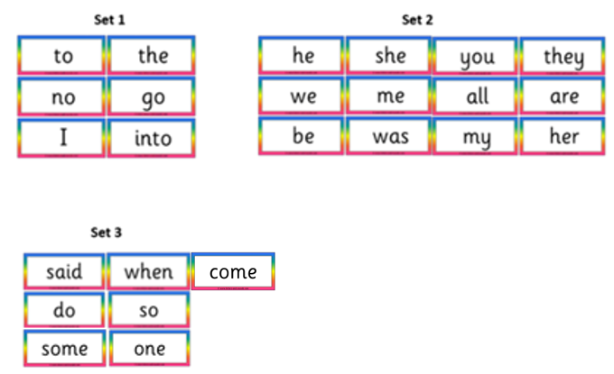

Friday 5th June 2020
Reception Work to support your child at home MATHS - number bonds to 10 then 20
Learning number bonds to 10 and then to 20 is an easy way to help your child understand easy pairs for when they are using addition. Let them see the pattern between number bonds to 10 and 20.
https://www.youtube.com/watch?v=RmuWMyBSE1A Watch with your grown up.

Using your Numicon shapes first order them from 1 to 10

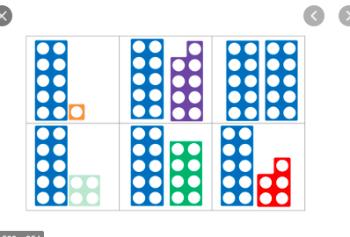

Ask your grown up to help. Learning number bonds to 10. Then to 20. Do you see a pattern?

Free-flow- Town and Country- Town week
Today, can you complete a special mission to help somebody in your Town?
Choose one from the following:
- Helping somebody in your house; for example, helping your grown-up with jobs around the house.
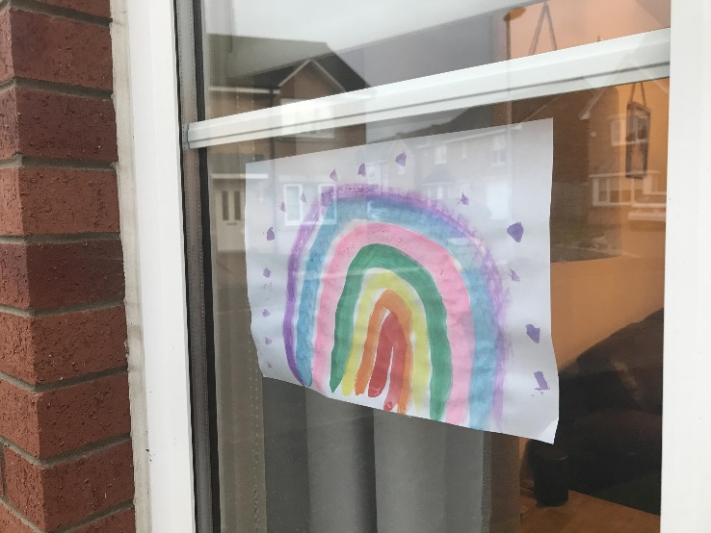
- Creating a picture for your window to make people smile as they pass by your house.

- Making a bird feeder to help your Town’s wildlife. Follow this link for ideas: https://www.bbc.co.uk/cbeebies/makes/bird-feeder
