Reception Home Learning
Week 6
Day 1

A thumbs up from all your Early Years Teachers!

We all hope that you are working hard and enjoying spending time at home.

Monday 11^{h} May 2020
Reception Work to support your child at home PHONICS
Below are some examples of how you can support your child at home with their phonics knowledge. We have set this out into daily activities.
Children learn best with daily practise and by repeating the learning.
You will need your phonic cards that were sent home in your pencil case.

Day 1 – Recap on sounds we have learnt before – ee (bee, see, tree, feet, sweet, greet, street, seen, deep) igh (night, tight, fright, sight, right, light, might fight fight. oa (oak, soak, boat, goat, coat, float, toast, load, toad). long oo (boot, moon, spoon, hoof, shoot, pool, cool, food, tool)

Learn the new sounds – short oo (book, took, good, wood, foot, wool, look) The short oo sound is usually in the middle of the word, never at the beginning or end of a word.

Practise the tricky word – some (also practise words we have learnt before – they, I, me, to, you, go, he, she, her, we, are, all, said, when, do, so)

What does each word mean? Do you notice any patterns? (oo sound comes in the middle of the word, never at the beginning or end of a word).
Can you read these words and then put them into a sentence? Challenge yourself and make up a story with all these words in them?
and, get, big, him, his, not
Alphablocks is a great website to support with phonics and with how to pronounce the sounds
https://www.bbc.co.uk/bitesize/topics/zvq9bdm/articles/z4tyt39
https://www.bbc.co.uk/cbeebies/shows/alphablocks
https://new.phonicsplay.co.uk/
You can log into phonics play for free using:
Username: march20
Password: home

Monday 11th May 2020
Work to support your child at home- LITERACY
This week we are going to focus on the new story ‘Oliver’s fruit salad’. You can find the story by typing into youtube ‘Oliver’s fruit salad’ or by following this link: https://www.youtube.com/watch?v=FpR26kPqpHc
Last week when we focused on vegetables, our sentences were:
Oliver was hungry so he went to the garden. First he found some carrots. Next he found some spinach. Then he found some rhubarb. He thought everything was yummy.
Day 1-
This week, we are going to write similar sentences, but this time we would like you to add in your own ideas- Oliver now wants to find some fruit from the garden!
Here are some examples:
Oliver was hungry so he went to the garden.
First he found… | Next he found… | Then he found… | He thought everything was…
some apples. | some pears. | some strawberries. | tasty.
some blueberries. | some cherries. | some grapes. | good.
some blackcurrants. | some peaches. | some plums. | nice.
 |  |  | delicious.
So, it may be that your new sentence is something like this:
Oliver was hungry so he went to the garden. First he found some apples. Next he found some pears. Then he found some strawberries. He thought everything was tasty.
Note to grown-ups:
If your child chooses different fruits to the examples given, make sure you explain to your child that some fruits like bananas, oranges, lemons, pineapples, melons etc. need warmer weather than the United Kingdom can provide them with.
It just means Oliver’s garden in their story must be set in a warmer country- how exciting!
What are your new sentences?
Today, your talking task is to:
- Practise saying your sentences- Put your actions to your sentences as we do in class. Act out the sentences.
- Once you have practised saying the sentences together, see if your child can now remember the sentences and say them without your support. If they can, it means they are ready to write them tomorrow!

Monday 11th May 2020
Reception Work to support your child at home MATHS shape 3-D
Note to grown-up. Last week we focused on 2-D shapes which are flat shapes. This week we are going to be focusing on 3-D shapes. These shapes are solid shapes known as 3 dimensional this means that they have width, length and height. 3-D shapes are solid.

On YouTube play the 3-D shape song 3D Shapes Song | Shapes for kids | The Singing Walrus.
https://www.youtube.com/watch?v=guNdJ5MtX1A
This song will help you remember the name of each 3-D shape. Watch it with your grown up.
Last week we were learning about 2-D shapes which are flat. This week we are learning about 3-D shapes which are solid, (fat) shapes. 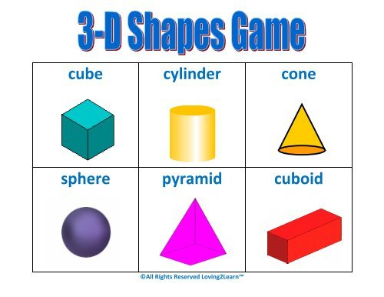
Find two pieces of paper or card. Fold the paper into 6 equal rectangles, cut along the folds to make 12 flash cards. Draw or stick on each card the shape and name of each 3-D shape. Turn them over so that they are face down. Play pairs with your grown up. Choose a card try to find the same one. If you get it wrong place it down in the same place. If you pick the matching shape keep the two cards. Take it in turns the one with most pairs is the winner. Play again see if you can name the shape.
rns

Free flow – What food do we grow in the United Kingdom?

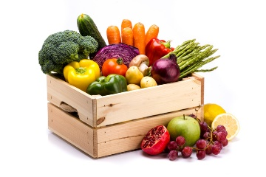
This is your 2 week free-flow challenge- do a little bit each day!
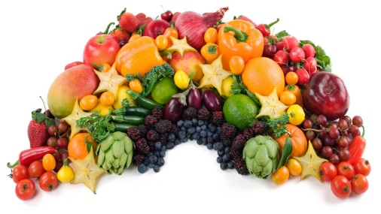

Think about the different fruit and vegetables we eat.
How much of these are we able to grow in the United Kingdom?
What is the difference between a fruit and a vegetable?
What vegetables and fruit grow on top of the ground and what fruit and vegetable grows underneath the ground?

Can you make a poster for your grown up on what food we grow in the United Kingdom. Group all the vegetables together and then all the fruit together on your poster. Add pictures and captions or your own sentences to give it a personal touch. Use the questions above to help you.

REMEMBER: This is a 2 week challenge so don’t rush it. Use what you have in your home and be as creative as you like. Enjoy!!

