30.6.2020 Work to support your child at home
Maths
Today we are going to learn about ordinal numbers like 1st 2nd 3rd. We can also write these as words e.g. first, second and third. We often use these words if people are lining up or if they are having a race. These number words tell us about the order. Think about lunchtimes at school. Sometimes your class is first in and sometimes you are fourth. Notice that after the number there is either st, th or nd. These are the last two letters of the word.
We also use ordinal numbers when we are talking about the date. Today is
Tuesday 30th June 2020. What will the date be tomorrow?

Can you match the numbers to the number words?

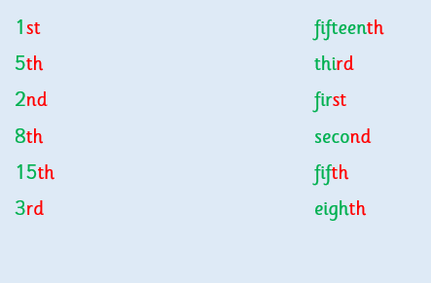

Here is an online game you can play to put people or animals in the correct order of the race.
http://resources.hwb.wales.gov.uk/VTC/ordinal_numbers/eng/Introduct/mainsession1.htm
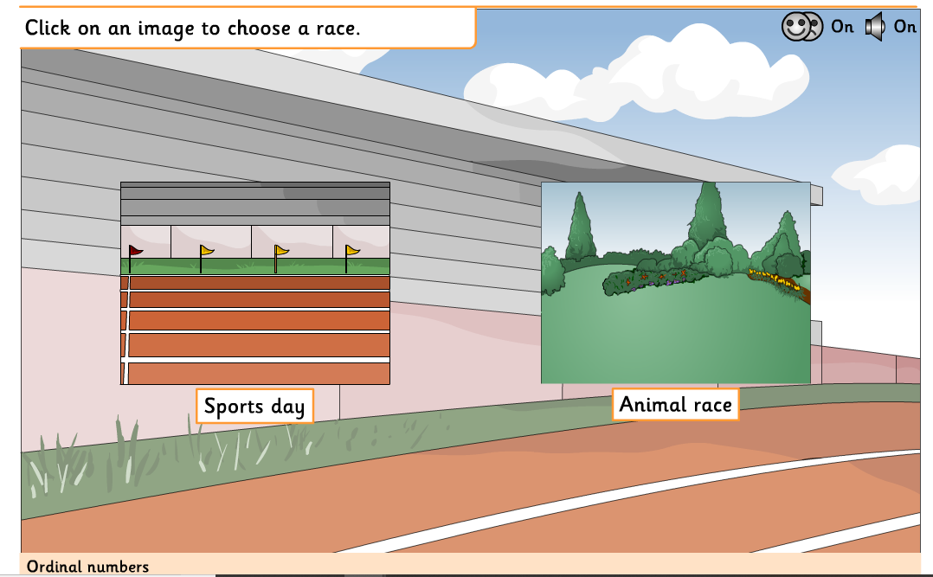

When people are lining up you have to decide which is the front of the line and which is the back. Here the line starts at the left hand side. Can you read the instruction and colour the correct superhero?
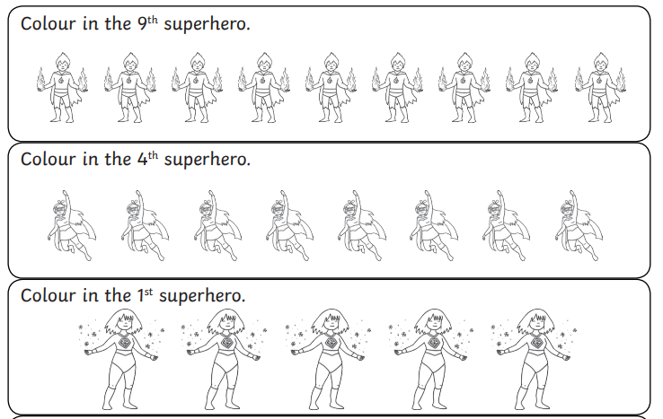
You could line your toys up and take turns to ask questions like “Which toy is third?” You could also play the true and false game like the activity below.

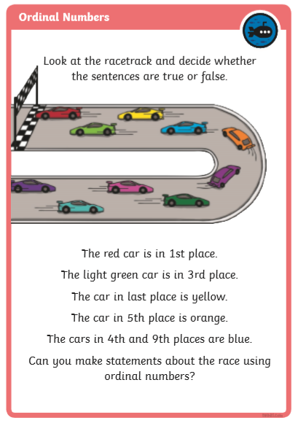

RED HOT CHALLENGE
Can you work out the secret code below? |The ordinal numbers are describing the letters in the order of the alphabet e.g. a = 1st b = 2nd
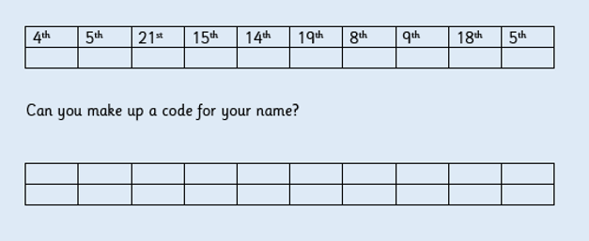
ENGLISH – Tuesday 30.6.2020
This week we are going to learn how to write a letter.
Yesterday, your challenge was to ask your grown up when they might have written a letter to someone. Here is my list. Did you have any of the same answers as me?
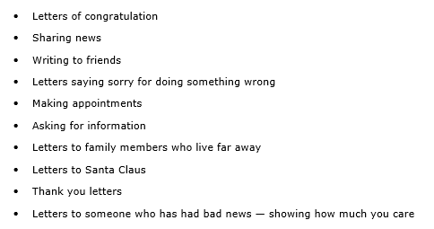
Letters are usually written to tell someone their news and to ask a question, which is then usually responded to. We read a book in class at the beginning of the Spring Term that was filled with letters. Do you remember this?: https://www.youtube.com/watch?v=0Bfh37iJRpU
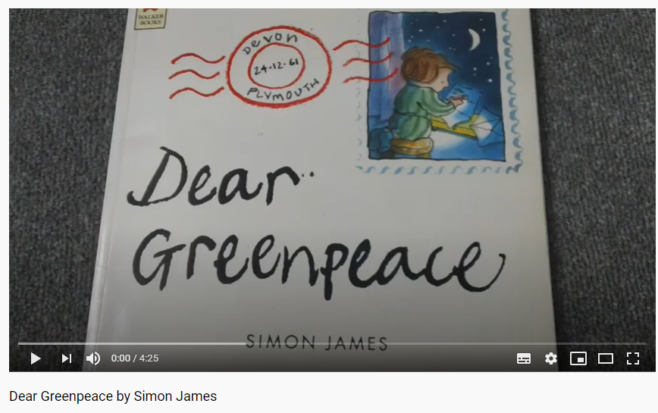
Yesterday, I asked you to look at the letters and see how much you noticed. Here is my list. Did you notice all of these? Did you notice more than me?

*Address on the top right of the page
*The name of the person we are writing to
*Who the letter is from
*The date
*Love
*Yours Sincerely (Did you know what these words meant? Yours Sincerely is a very grown up way of ending a letter, we don’t need that this week, we will use From instead)
*Some letters were funny, some letters were giving information.
*There were questions in the letter
Main task:
Before we write anything, we always plan out what we would like to write about or who we are writing to. Writing letters is the same. We need to think about what we would like to write.
*In your home learning book (or special school book), can you copy this grid and fill in the blanks, so that you are ready to write your letter on Thursday? (Do not copy any blue writing – that is there to help you, not to copy)

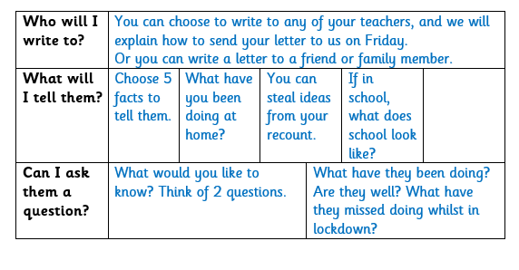

PHONICS
Nonsense words

Can you remember the work we have done in class about nonsense words?
That’s right they just don’t make any sense. They are not real words but we still need to sound them out by spotting any sticky sounds they have.

Here are some nonsense words.

Floom’s shurlp’ll crale’s thipe’s jerty’ll droosh’ll stropen’t

Write the words out on a piece of paper or the back of a cereal box or with chalk on the path (remember always check with a grown up first).
Did you notice they are all contractions and have an apostrophe to show a letter has been taken away?
Can you make up some nonsense words of your own that are contractions too?

New phonics games on Education City this week.
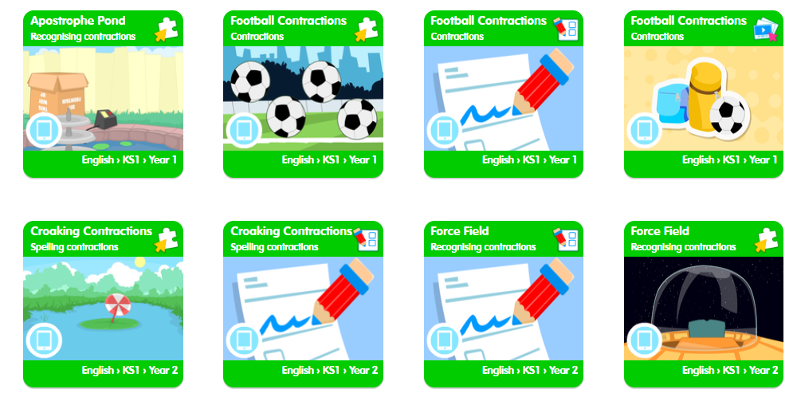
Topic – Geography
Today you are going to think about the place that you live. With your grown up I would like you to talk about your address.
What is it? Why is it important? You do not need to write it down.
REMEMBER – You MUST NOT give any body your own address! Think back to all the work we have done on Safety and keeping your personal information safe from strangers. Watch this Hector video.
https://www.youtube.com/watch?v=TgaQVlOGkMA

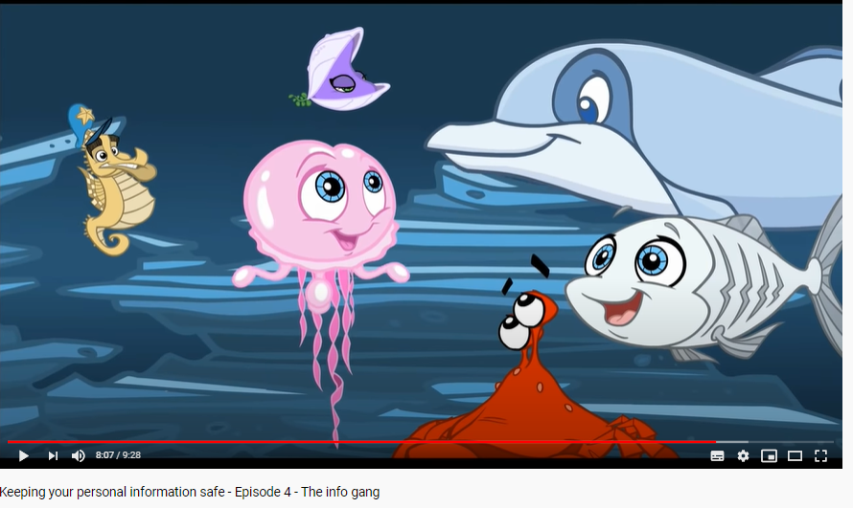

Find out the address for our school. You could ask your grown up or look it up using the school website or google it.
Write down our school address in your Home Learning book.
Remember it needs to be set out correctly. You could look at a letter that has been delivered to your house to see what goes on the first, second and third line.
