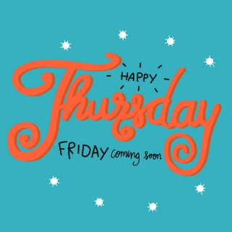

It has been lovely to see some of you tweeting your work on Twitter. Don’t forget to tag us, so we see your tweet!
https://twitter.com/DevonshireInf
@Devonshireinf @MrFlemingDevInf @devOrangeClass
@devcreamclass @MsSandhuDevInf
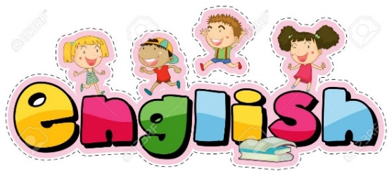

ENGLISH

https://classroom.thenational.academy/lessons/to-identify-the-key-features-of-a-recount/activities/1
Today we are going to be looking at the features of a recount.
They are:
Today you are going to be identifying these features in different pieces of writing.
Work through identifying each of these through reading the different texts.

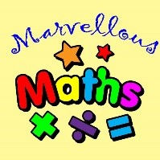
Maths – Money
Warm up
Number bonds to 10 with any number up to 100. Can you beat your time from yesterday?
Addition +
25 + ___ = 30
___ + 72 = 80
56 + ___ = 60
41 + ___ = 50
___ + 89 = 90
___ + 37 = 40
93 + ___ = 100
___ + 14 = 20

Can I find change in pence from £1 by counting on in tens and ones?
Now that we’ve worked out change in whole pounds, we can start to look at calculating change in pence. This will need us to count between in tens and ones.

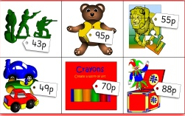

If I buy a board game 72p and pay with £1. I can represent what happened like this.
72p
change
Paid with £1

I’ll need to subtract 72p from £1 (which = 100p)
So 100p – 72p =
Tens jumps ones jumps
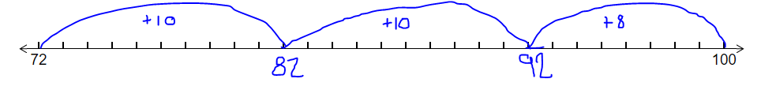
Cost of item | Amount paid | Change and working out
Toy soldier | £1
Teddy | £1
Crayons | £1
Jigsaw | £1
Jack in a box | £1
Toy cars | £1

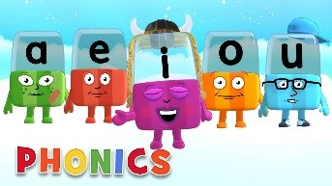
Phonics

Day 4 – Below are the sounds and words that you should know by the end of year 2.

The /j/ sound spelt as ge and dge at the end of words, and sometimes spelt as g elsewhere in words before e, i and y (badge, edge, bridge, dodge, fudge)
The /s/ sound spelt c before e, i and y (race, ice, cell, city, fancy)
The /n/ sound spelt kn and (less often) gn at the beginning of words (knock, know, knee, gnat, gnaw),
The wr sound spelt wr at the beginning of words (write, written, wrap, wrote)
The /l/ or /le/ sound spelt –le at the end of words (table, apple, bottle, little)
The /al/ sound spelt –al at the end of words (metal, pedal, capital, hospital)
The /l/ or el/ sound spelt –el at the end of words (camel, tunnel, squirrel)
Words ending –il (pencil, fossil, nostril)
The /igh/ sound spelt –y at the end of words (cry, fly, dry)

Complete this activity below,
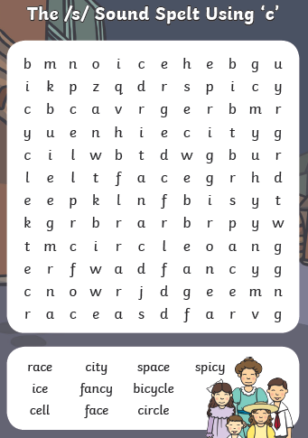
Write sentences using the words above.
For example;
Who won the race?
How fancy that is!
This food is spicy.
Try these quizzes on:
https://www.educationquizzes.com/ks1/english-spelling/
Scroll down to the Year to spelling games.
Read a reading book and write questions about the book.
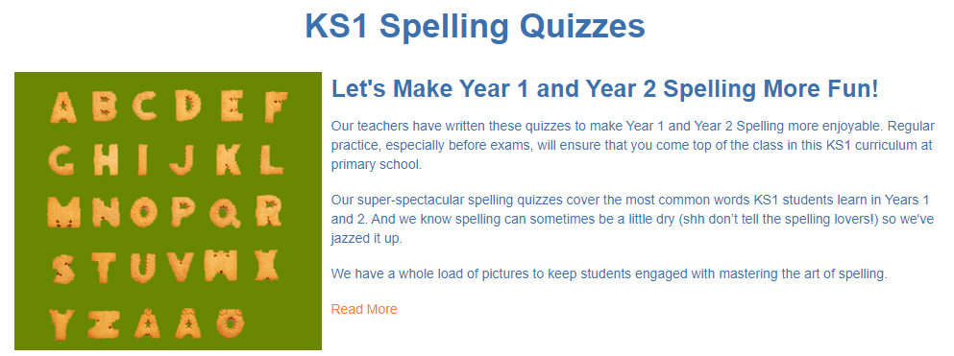
Alphablocks is a great website to support with phonics and with how to pronounce the sounds
https://www.bbc.co.uk/cbeebies/shows/alphablocks
Phonics Play has a range of phonics resources and games
www.phonicsplay.co.uk
Spelling frame has lots of games to practice Year 1 and 2 sounds and common exception words.
https://spellingframe.co.uk/
Education City has games and activities for phonics, some may be set or you can choose your own. After an activity you can print your own certificate too.
www.educationcity.com

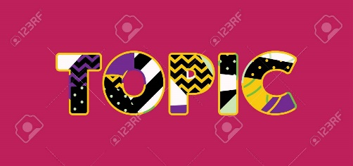
Topic - Day 4

Abstract Art
Abstract art is modern art which does not represent images of our everyday world. It has colour, lines and shapes (form), but they are not intended to represent objects or living things.
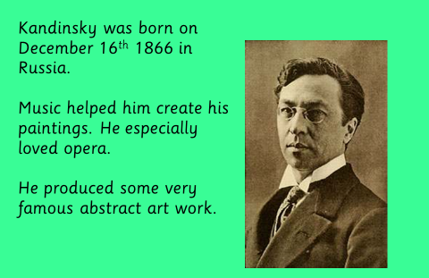

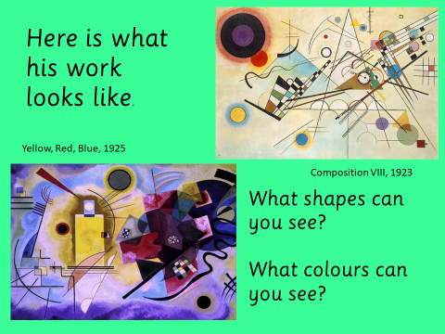
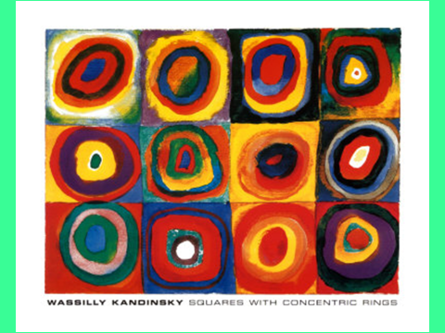

Can you produce your own abstract art ?

Just like Kandinsky listen to your favourite music as you work to inspire you. Does the mood of the music effect your art?
Remember use your imagination to produce colour, lines and shapes.
You could cut out shapes from card or magazines too.

Composition 8
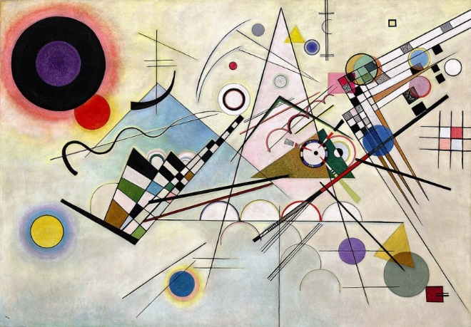

Creating your own piece of art using just lines and circles. They used a black pen to make them stand out and then added lots of bright colours.
